The objective of this tutorial is to get started with Data Viz and Machine Learning on SAS Viya, on small simple cases, using SAS Viya for Learners through SAS Academic Hub.

After registration, we will start by using the Insight Toy case to discover how to use SAS Visual Analytics.

Then, we will then use Organics case to start Machine Learning.

Welcome to the SCYP program: 2

Changing browser language 10

Data Viz with SAS Visual Analytics Hands-On 13

Introduction to Insight Toy Company 13

Connect to Viya for Learners 15

Creating hierarchy and Crosstab 24

Create a geographical hierarchy 28

Create dashboards 33

Save your work 38

Export in pdf your work in pdf 39

Exercises 42

Machine Learning with Visual Analytics Hands-On 43

Big Organics 43

Data 43

Decision Trees 52

Logistic Regression 55

Gradient Boosting 57

Neural Network 58

Model Comparison 59

Score today table 64

Exercises 70

SAS and all other SAS Institute Inc. product or service names are registered trademarks or trademarks of SAS Institute Inc. in the USA and other countries. ® indicates USA registration.   
Other brand and product names are trademarks of their respective companies.

## Welcome to the SCYP program:

To get register on SAS® Software Certified Young Professionals, go to

<https://www.sas.com/sas/training/scyp.html>



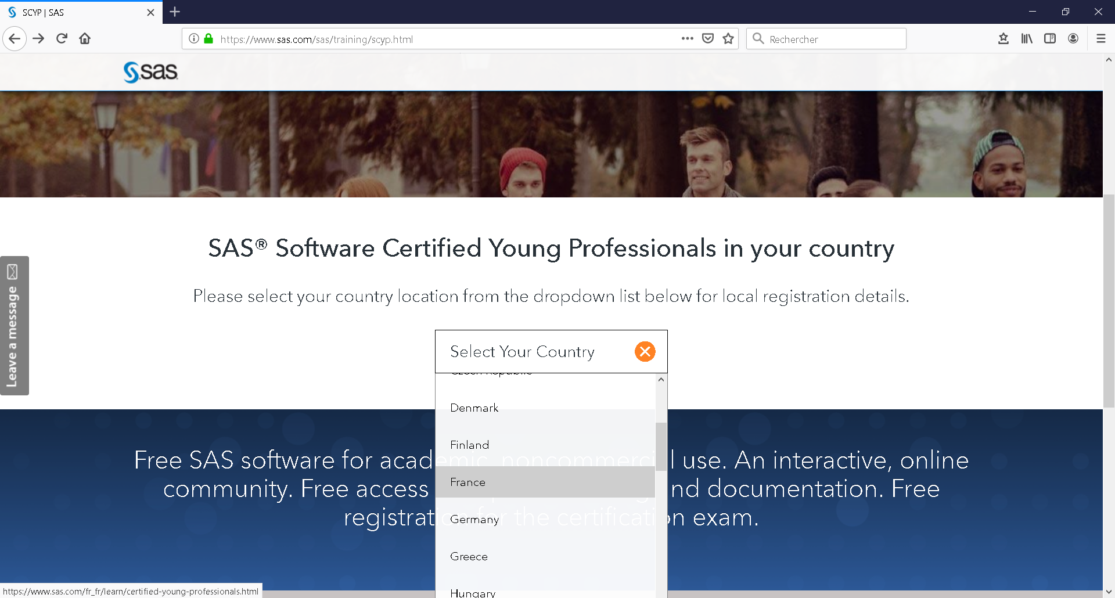

Select your country: France



Sign Up & Get started

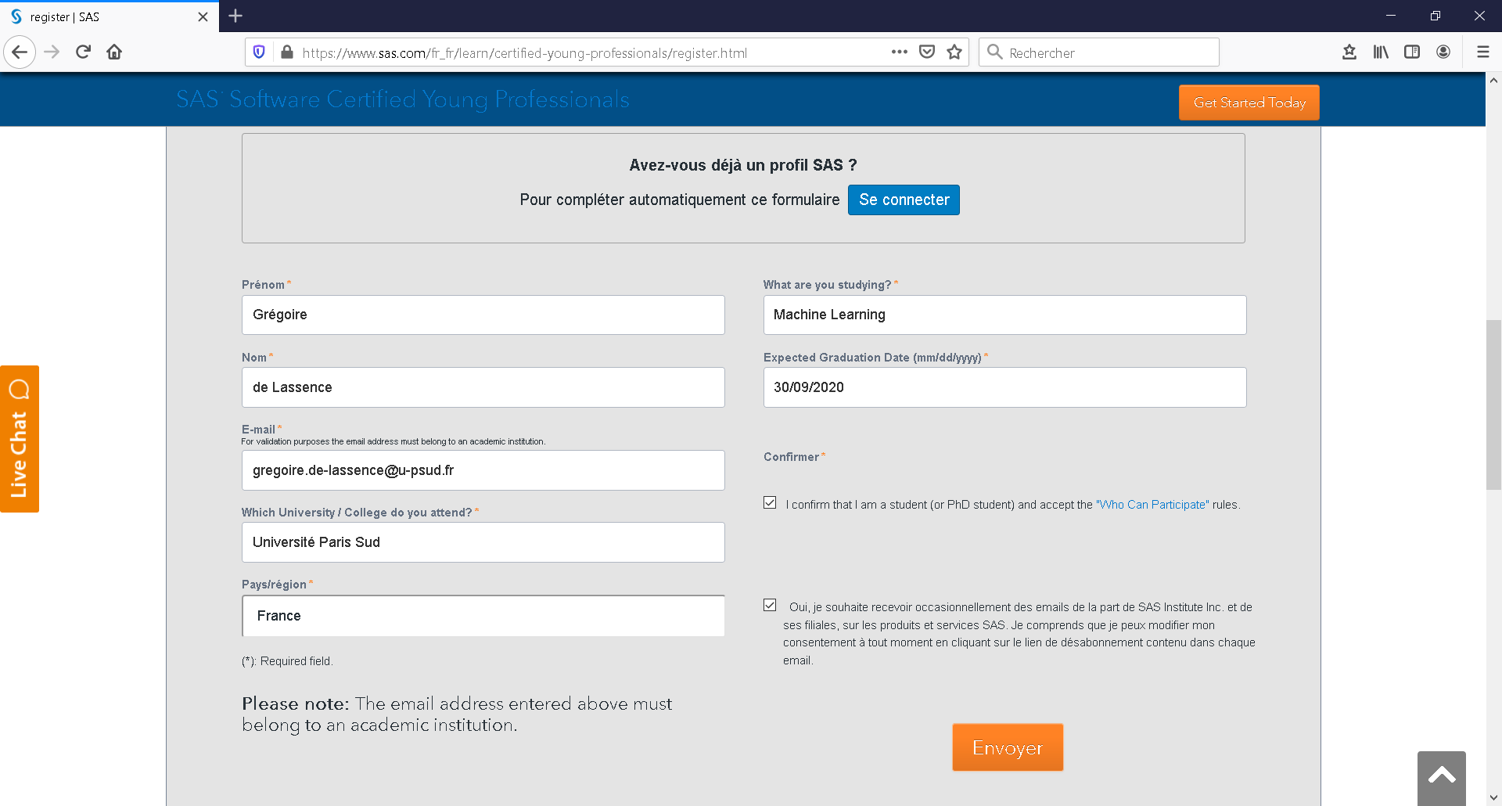

If you don't have a profile with a valid university email address, you need to fill out this form.

You must check the box that confirms that you are a student.

After clicking "Send" you must receive an email like the one below, to validate the address.

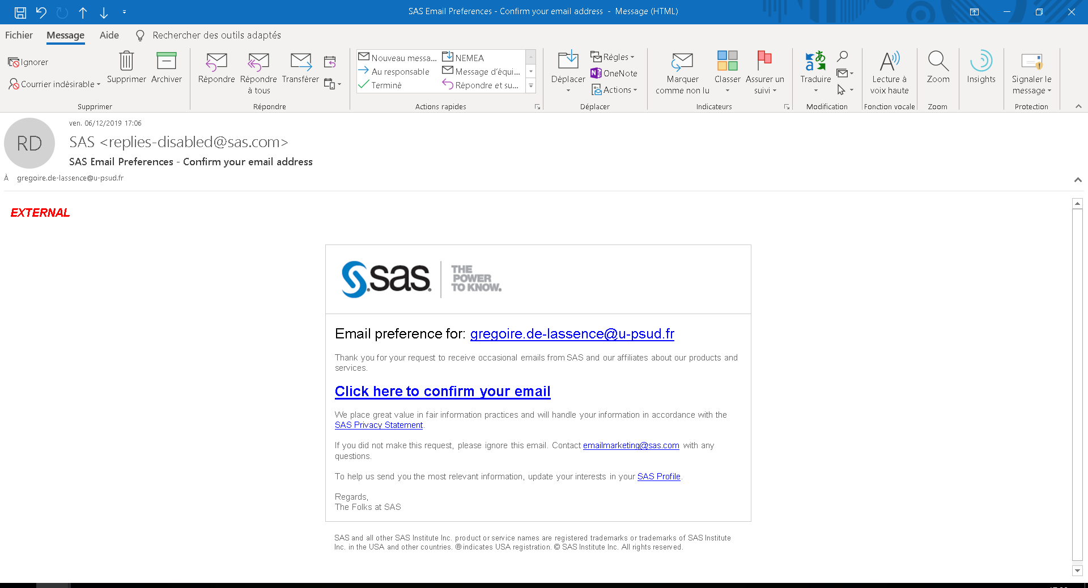

Confirm your email

You will also receive the following information:

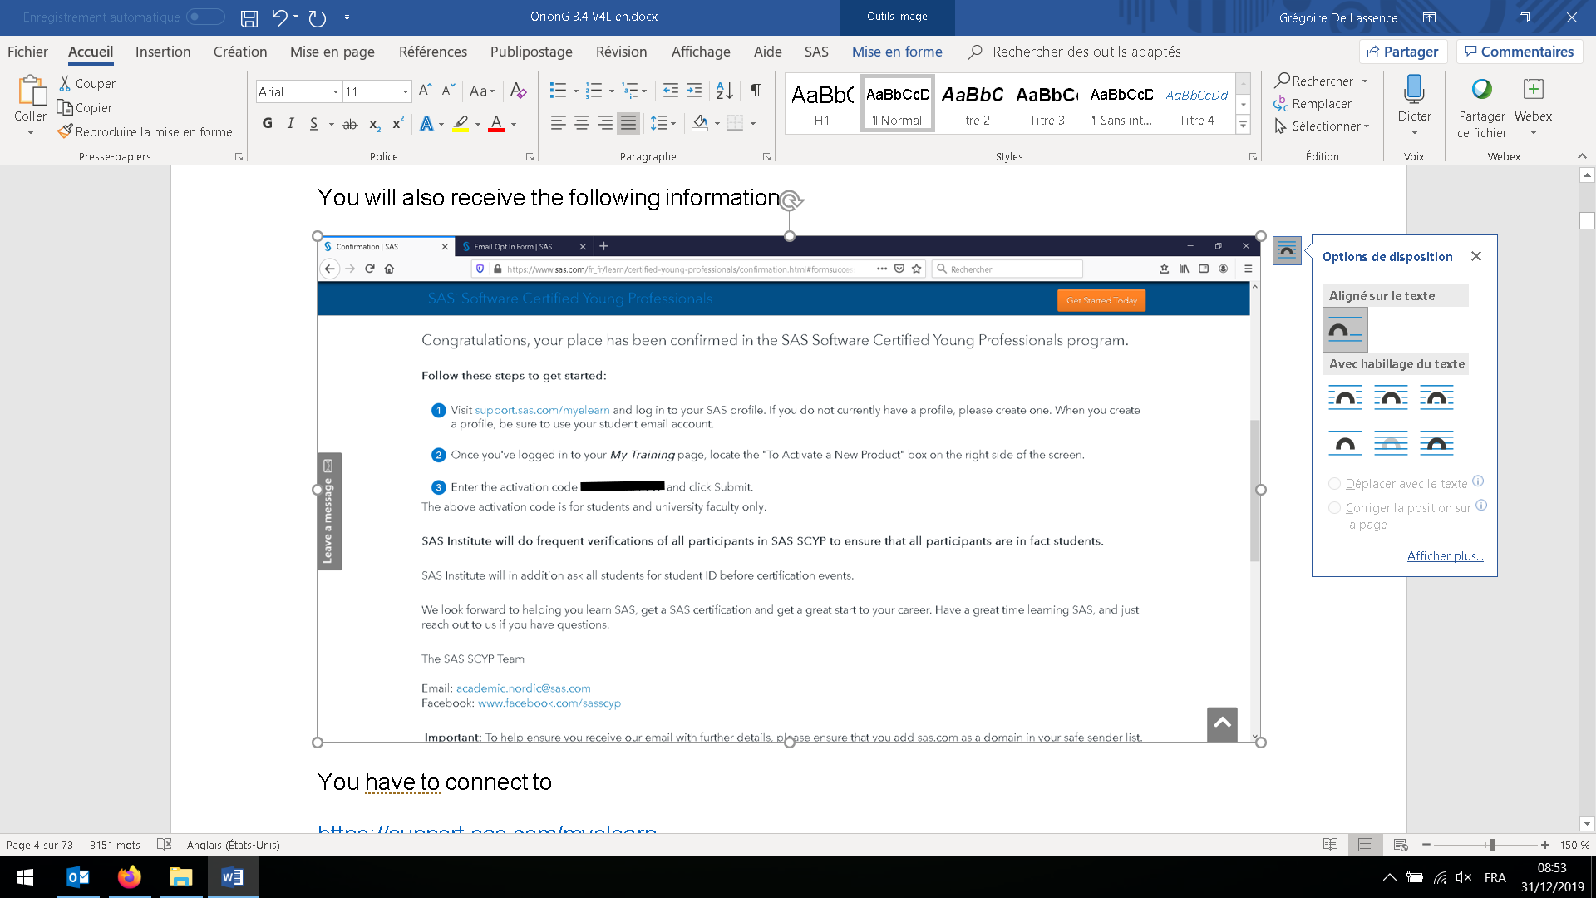

You have to connect to

<https://support.sas.com/myelearn>

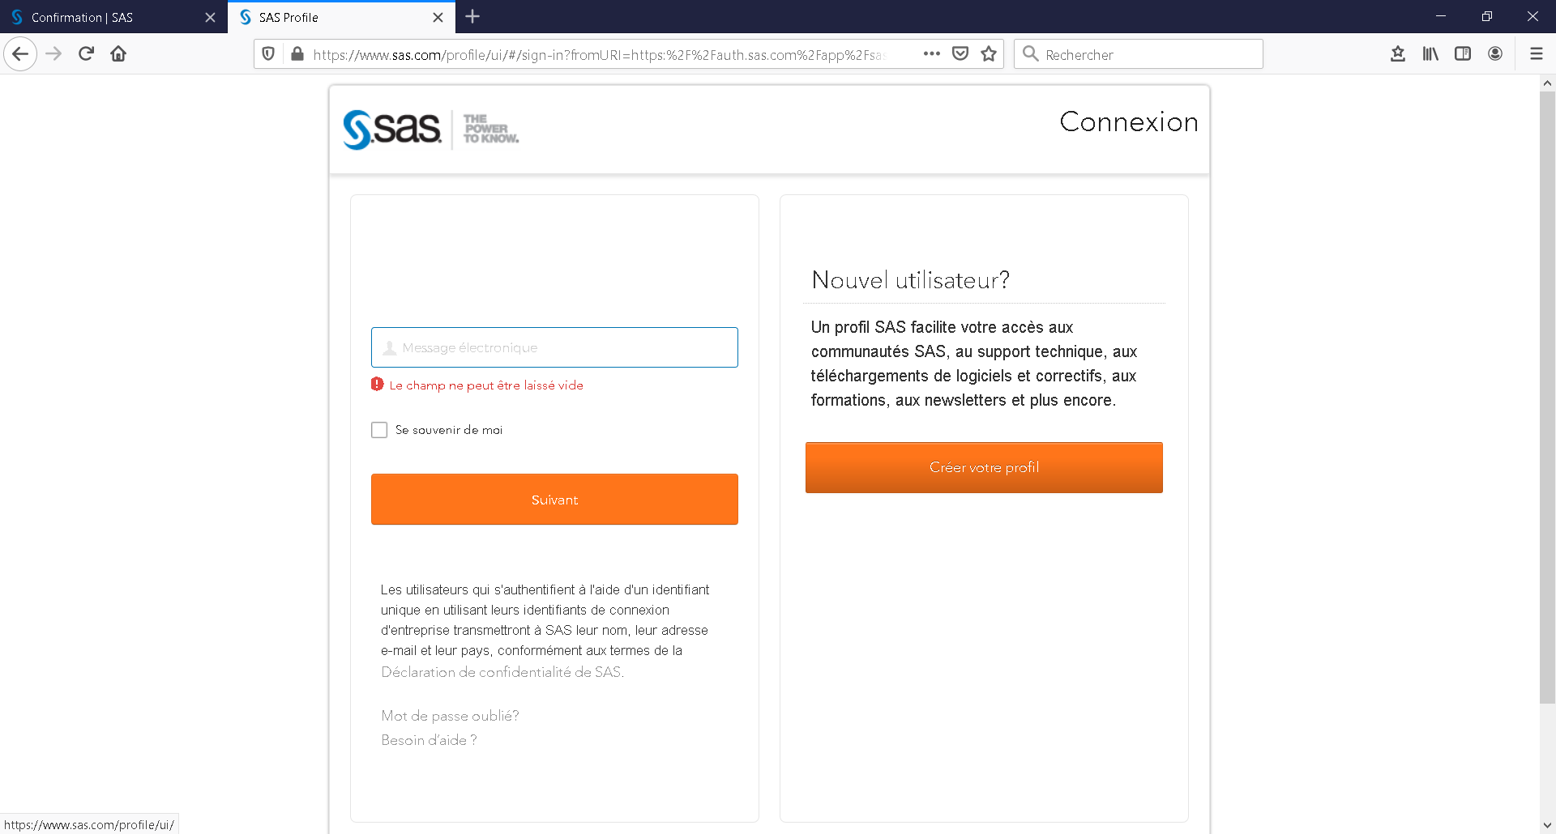

If you don't have a profile yet, you need to create one

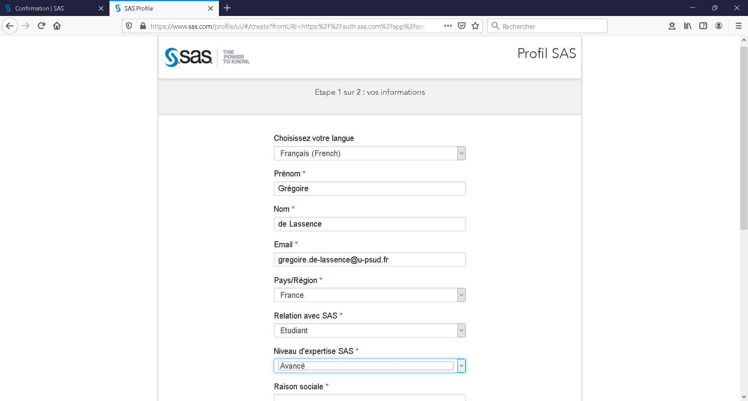

Enter your contact information, with the same academic e-mail.

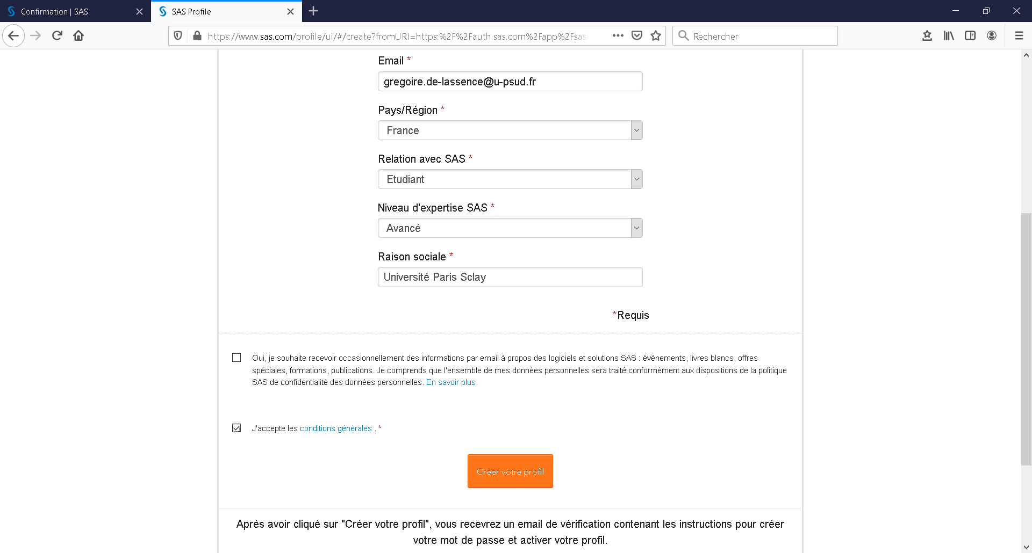

Accept the terms and click to on the box to create your profile

You will receive an email like this one

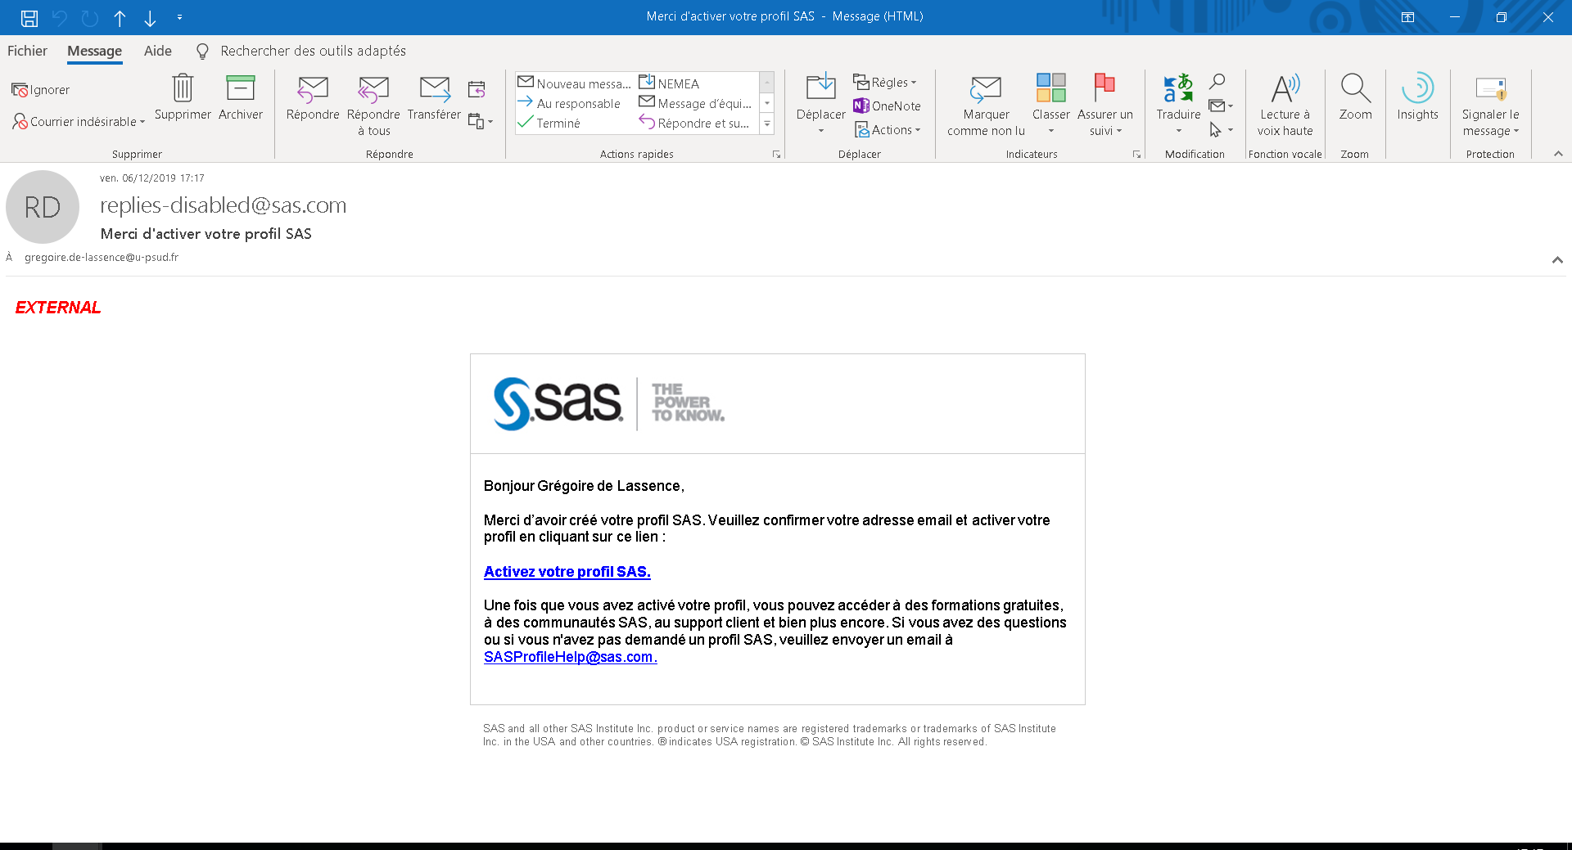

Activate your profile

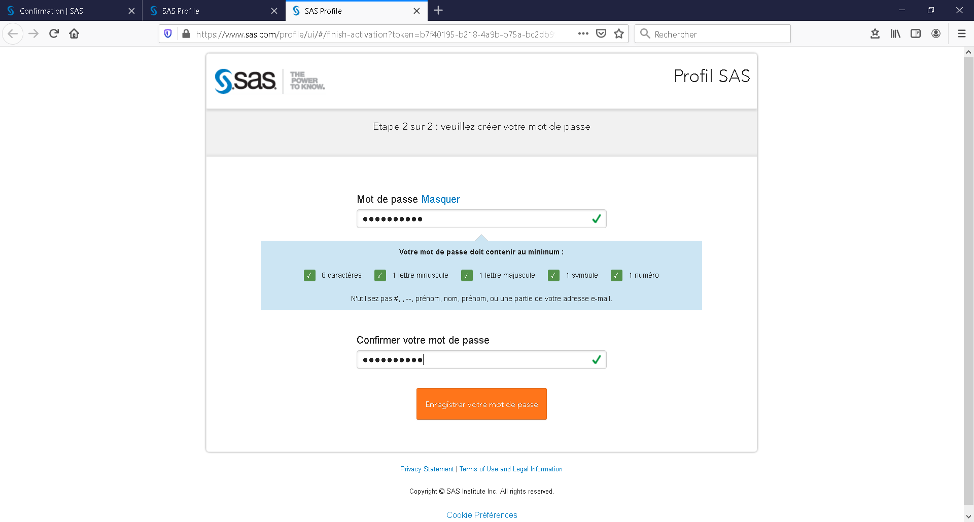

Create a password and save it

Go on <https://support.sas.com/myelearn>

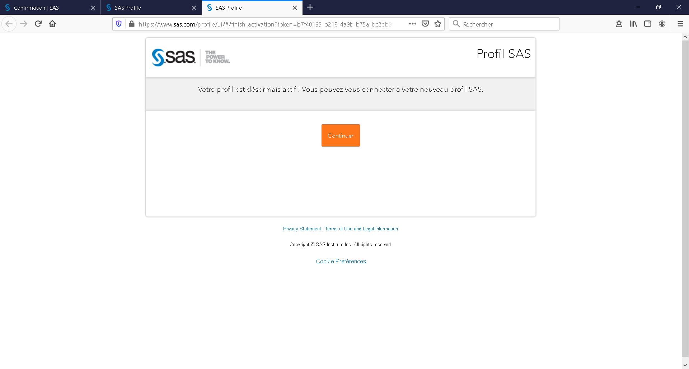

You can now log in to <https://support.sas.com/myelearn> with your email and password

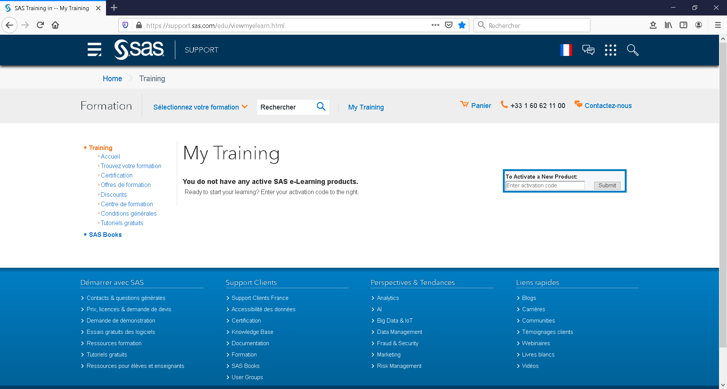

Initially, there is no "training."

You have to enter the promo code to activate SCYP.

Enter the activation code get by e-mail

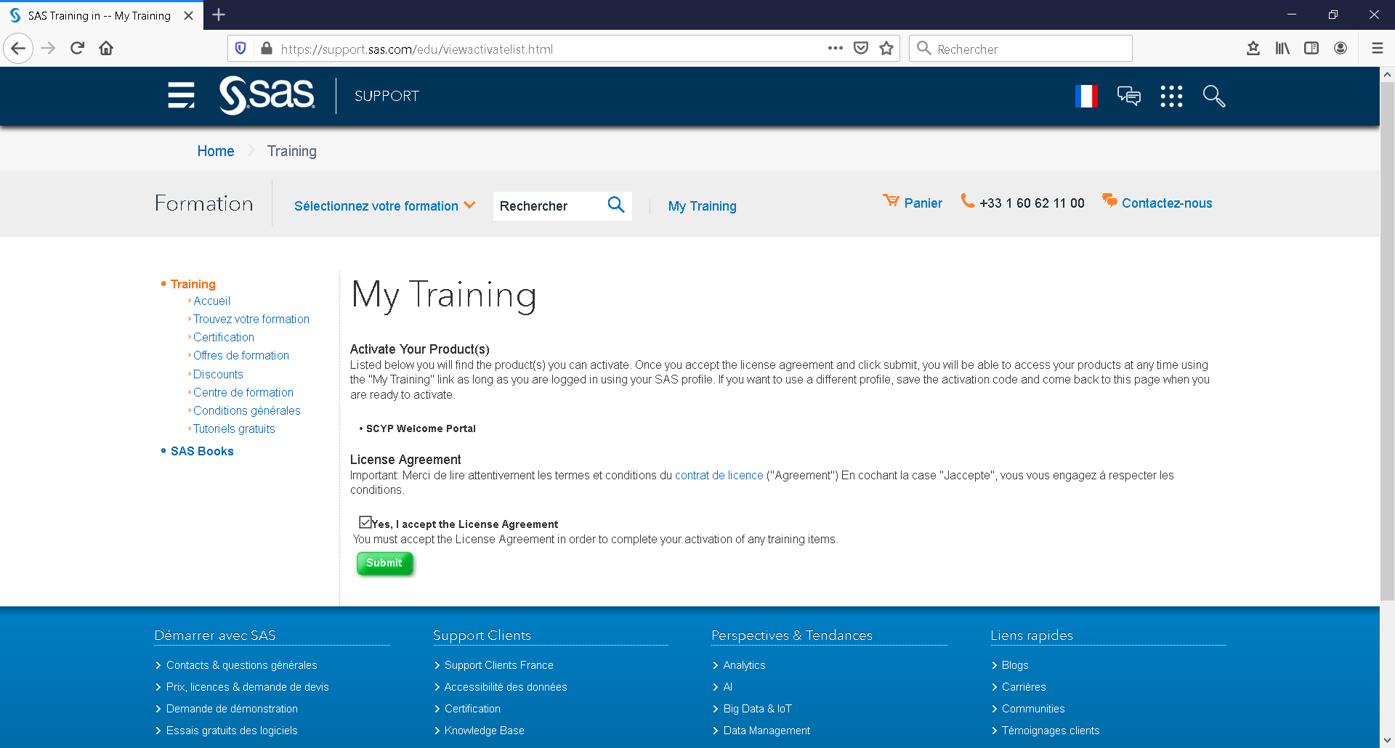

Accept the terms

Welcome to SCYP

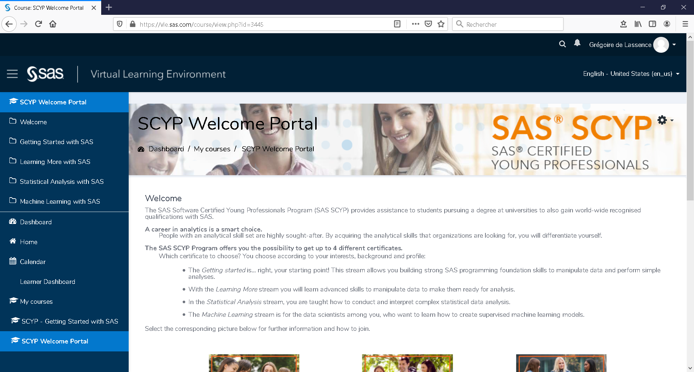

Here is the link to go back to SCYP directly.

<https://vle.sas.com/course/view.php?id=3445>

There are 4 certifications:

SAS/Base programming (getting started)

Advanced programming (you need to have already the base certification)

Statistics (descriptive, ANOVA and Regression, Programming with SAS/STAT)

Machine Learning in Pipeline (process flow) on SAS Viya.

Data Viz with SAS Visual Analytics

## Changing browser language

In order to have the application in English, you can put your browser setting in English.

In Firefox (chrome is presented next page), go to option

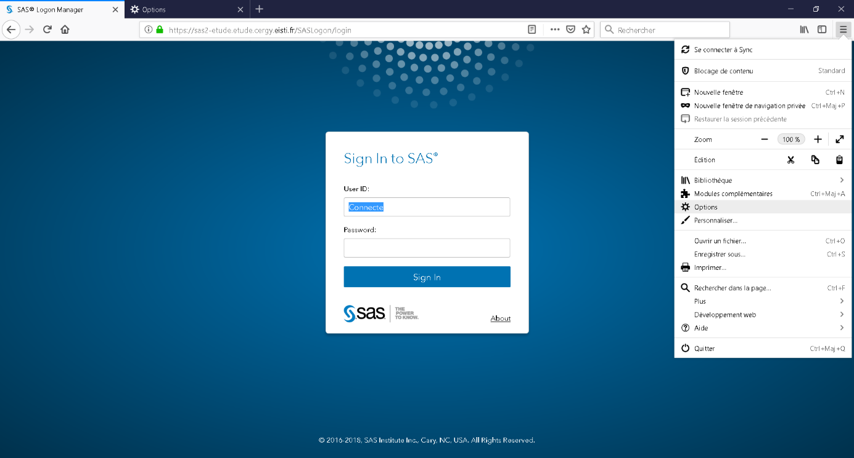

In Language

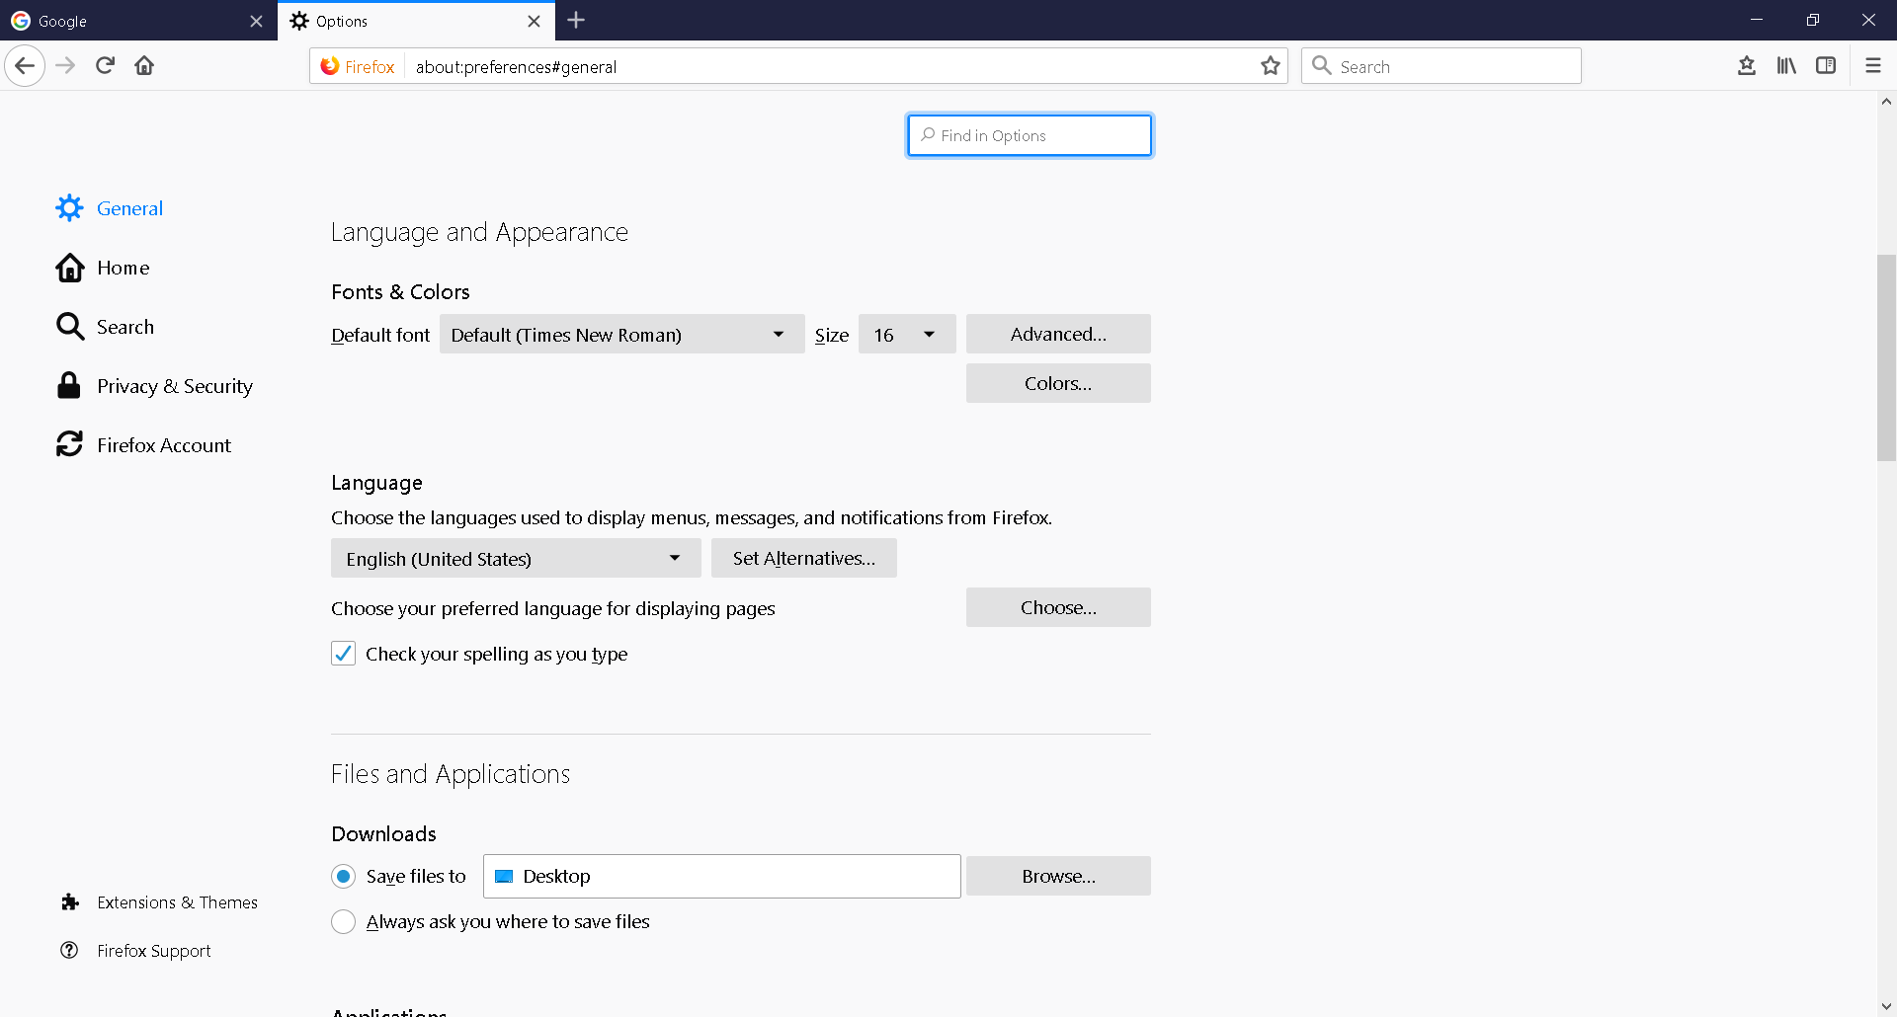

You can choose your preferred language for displaying page, in your browser

Click on **Choose**

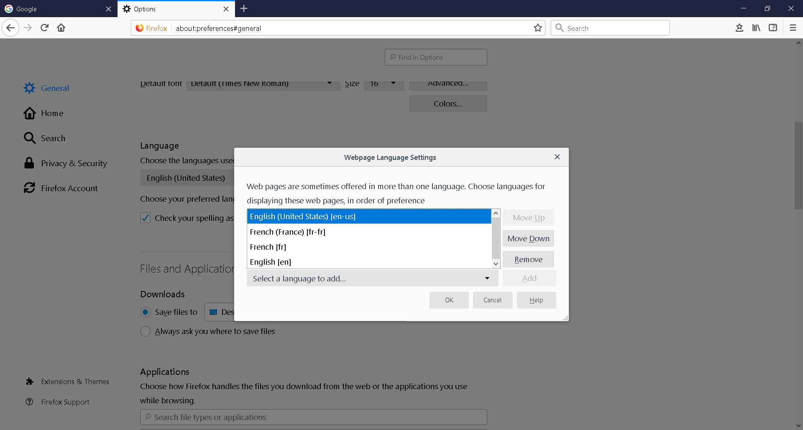

Move English (United States) [en-us] up to the top

OK

In Chrome, go to settings (parameters) and advanced settings (advanced parameters)

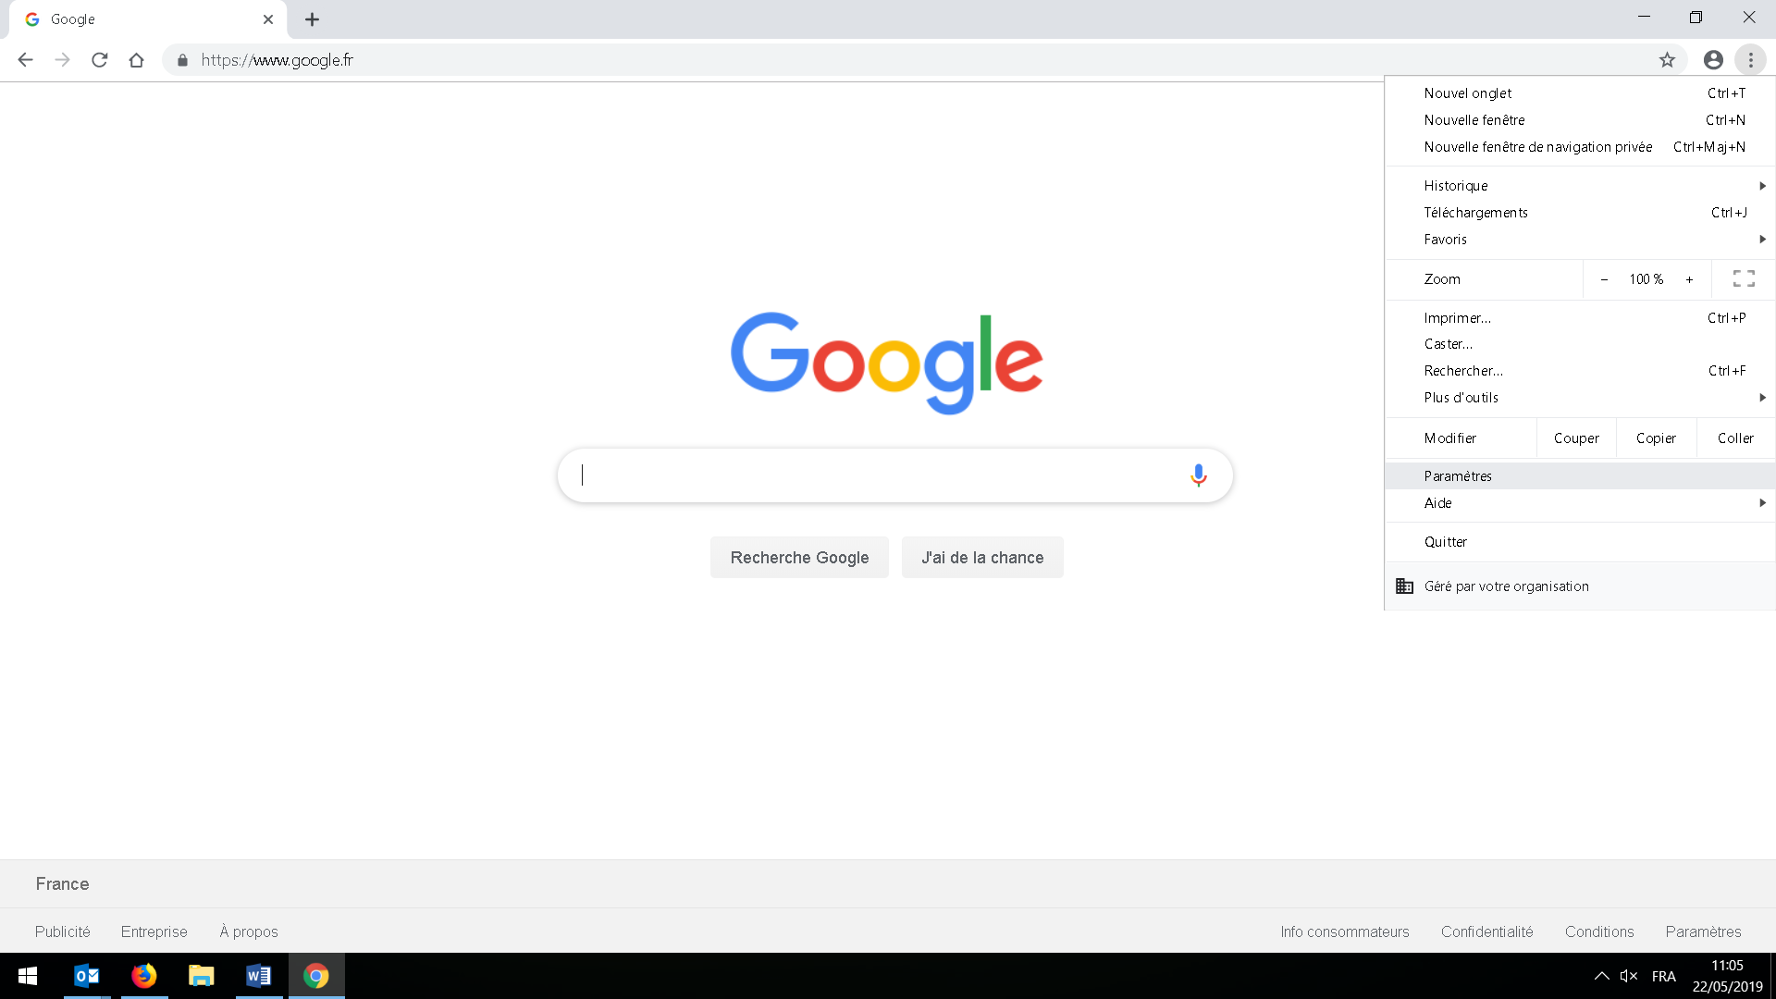

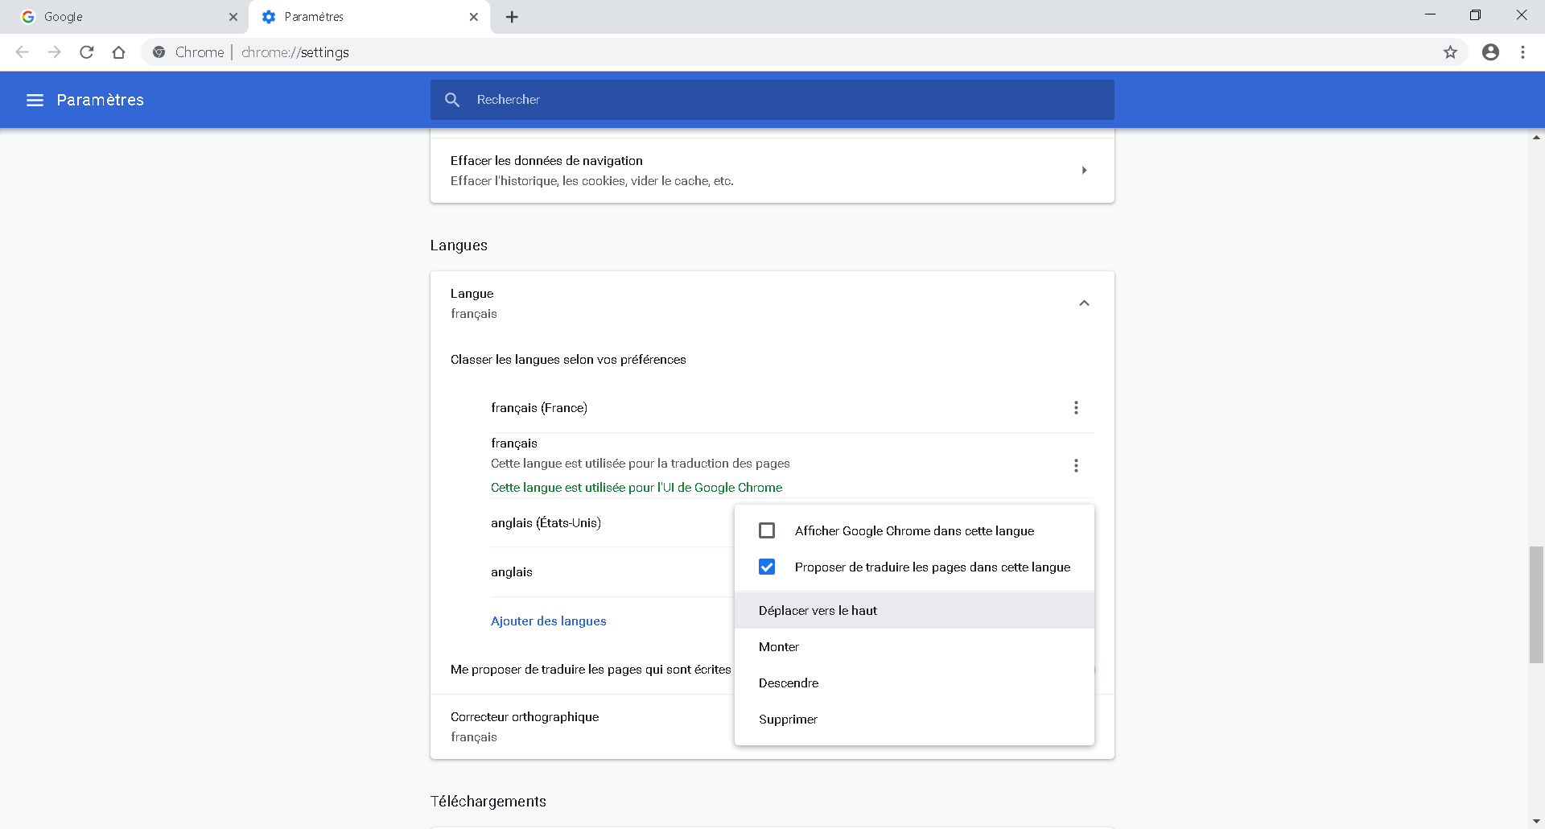

In Language

Move English (United States) [en-us] up to the top

## Data Viz with SAS Visual Analytics Hands-On

### Introduction to Insight Toy Company

We will start with a 1.6 million lines and 57 columns (2GB) table, on the fictitious company "Insight Toy".

This company produces and sells high-tech toys. We have data on 8 years, from 1998 to the end of 2005, on the financial, production, distribution, sales and marketing aspects.

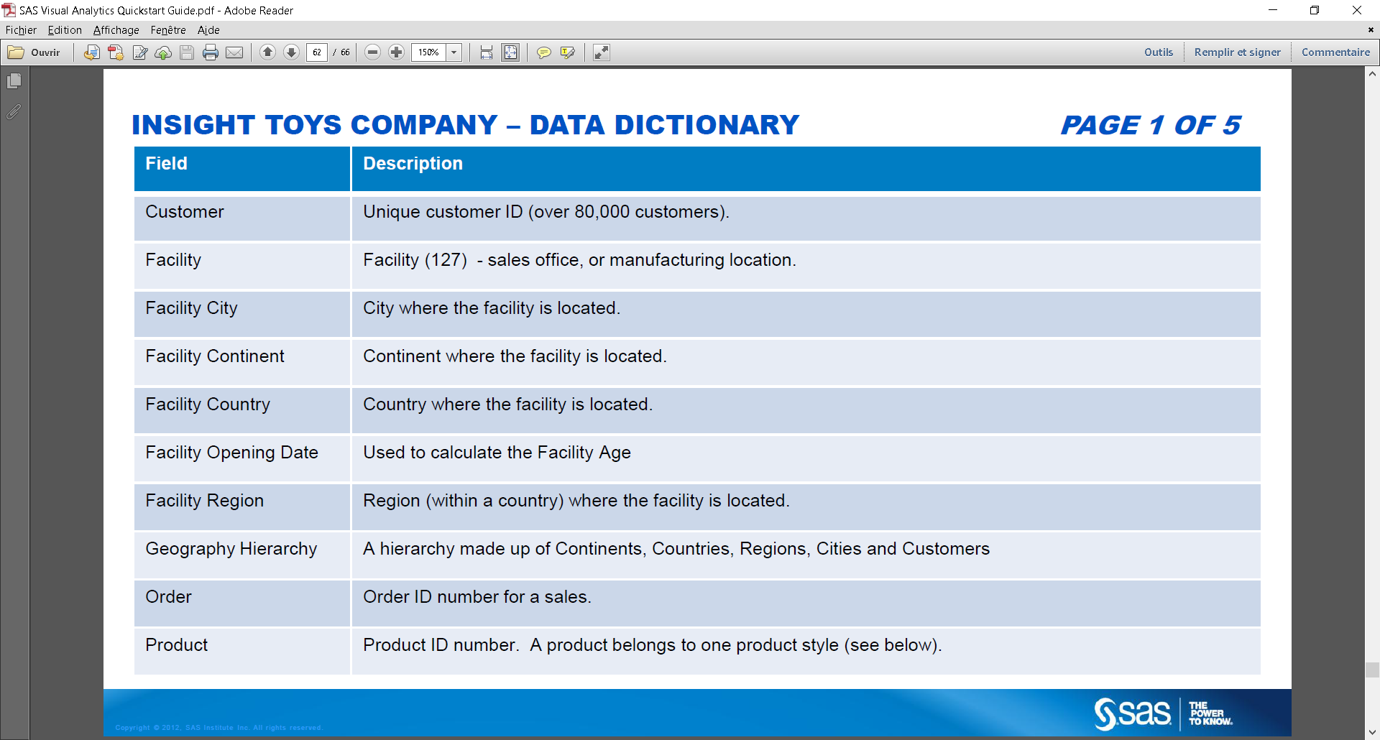

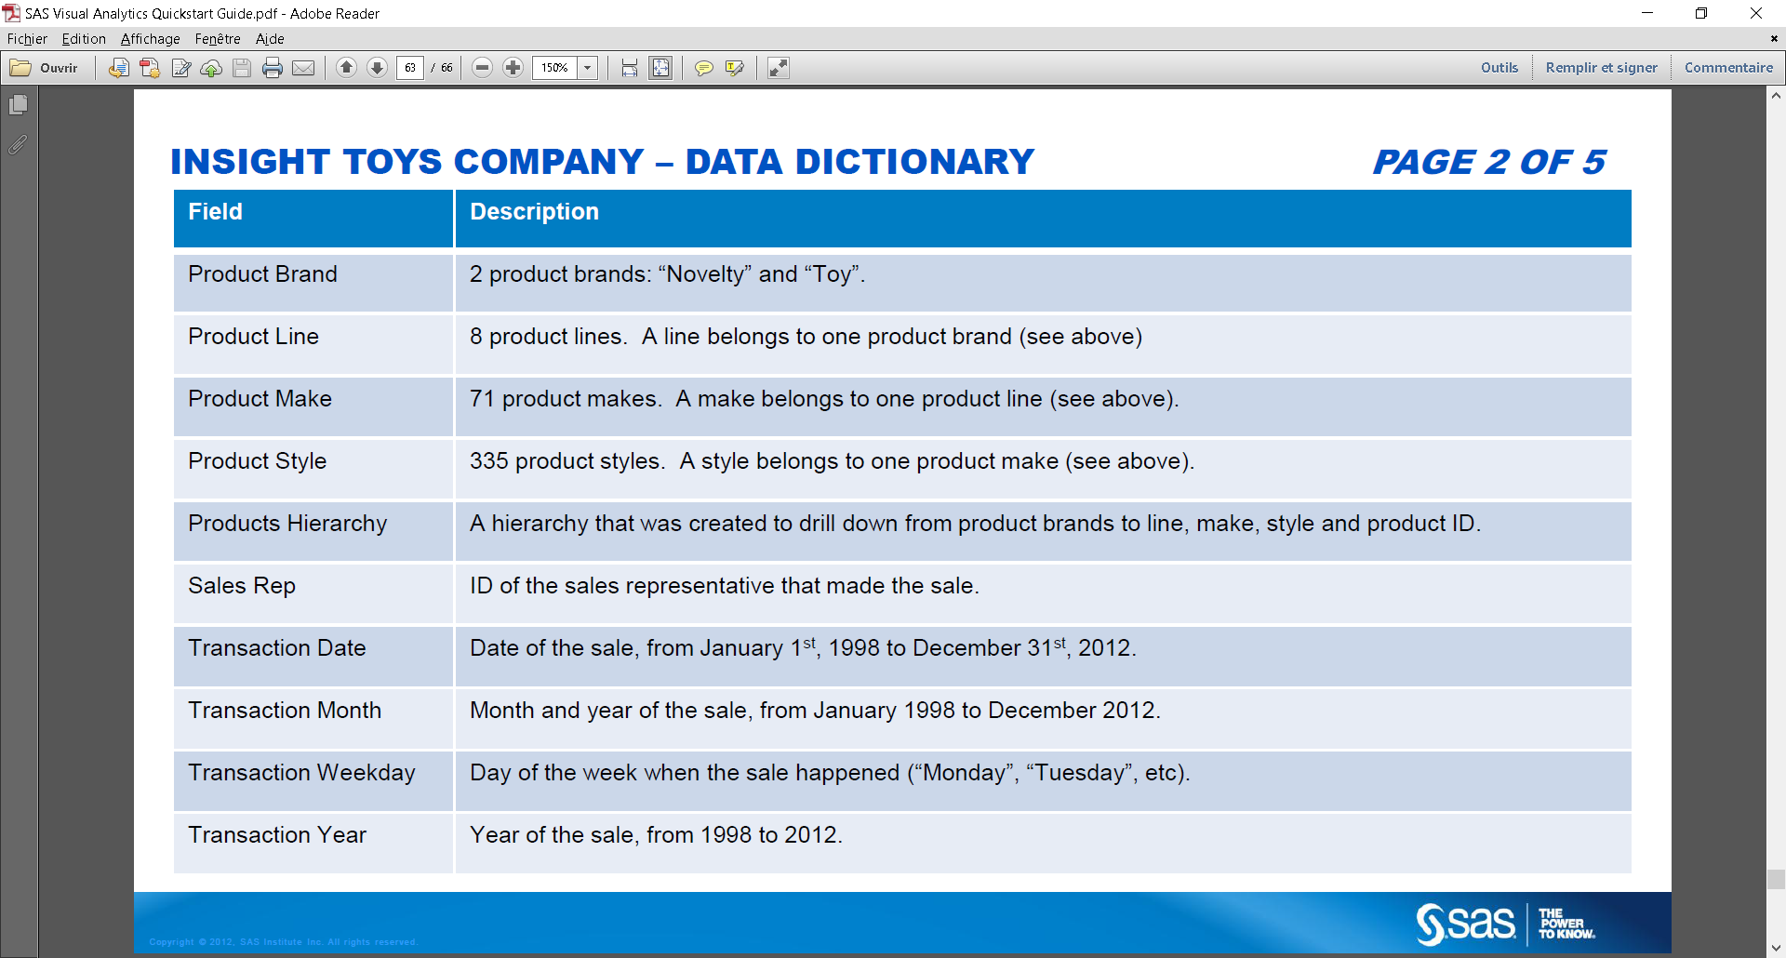

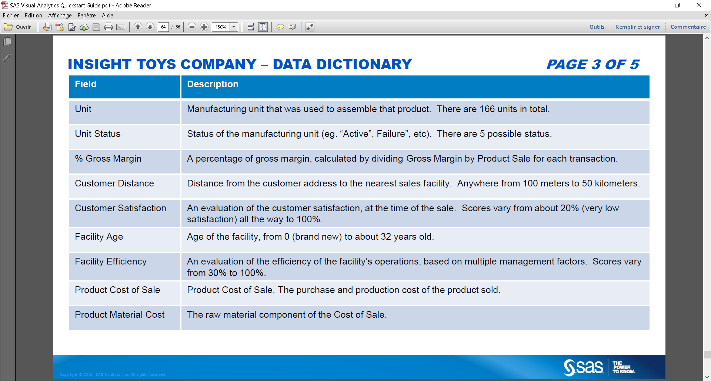

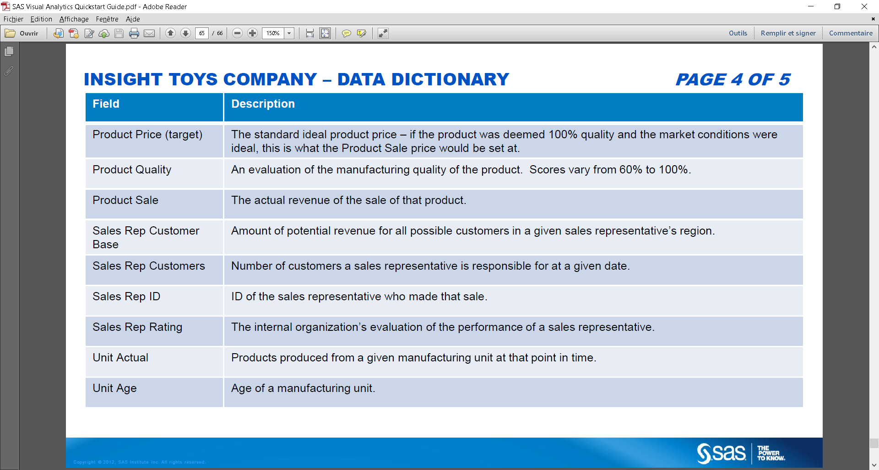

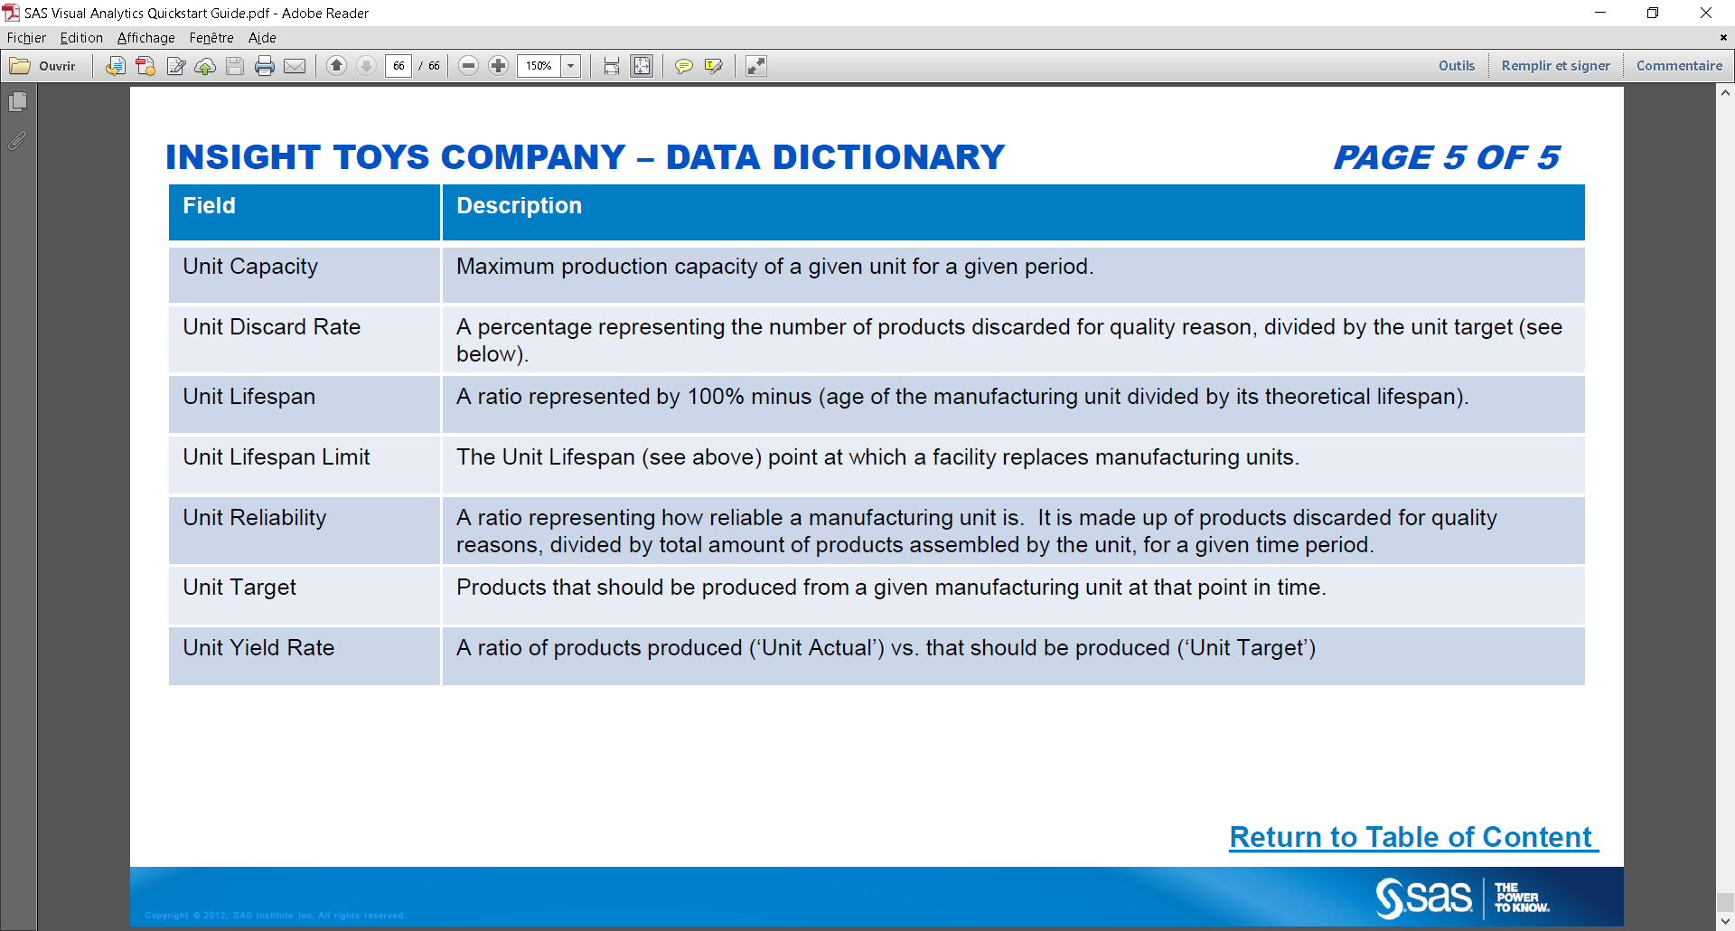

### Connect to Viya for Learners

Got to SCYP :

<https://vle.sas.com/course/view.php?id=3445>

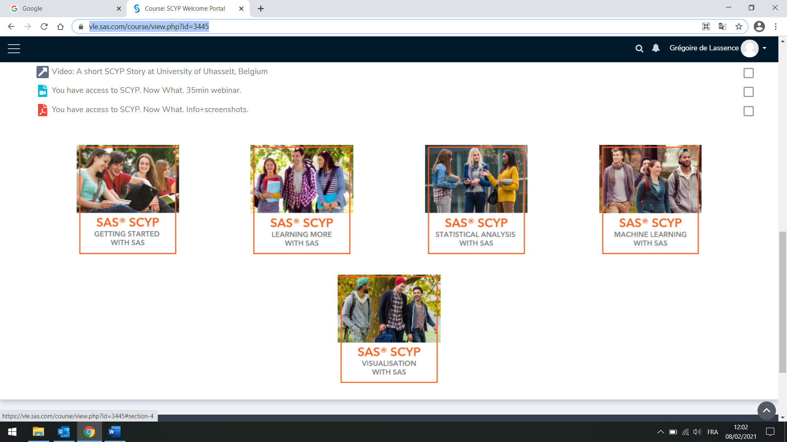

Go to Machine Learning Courses, enroll the courses

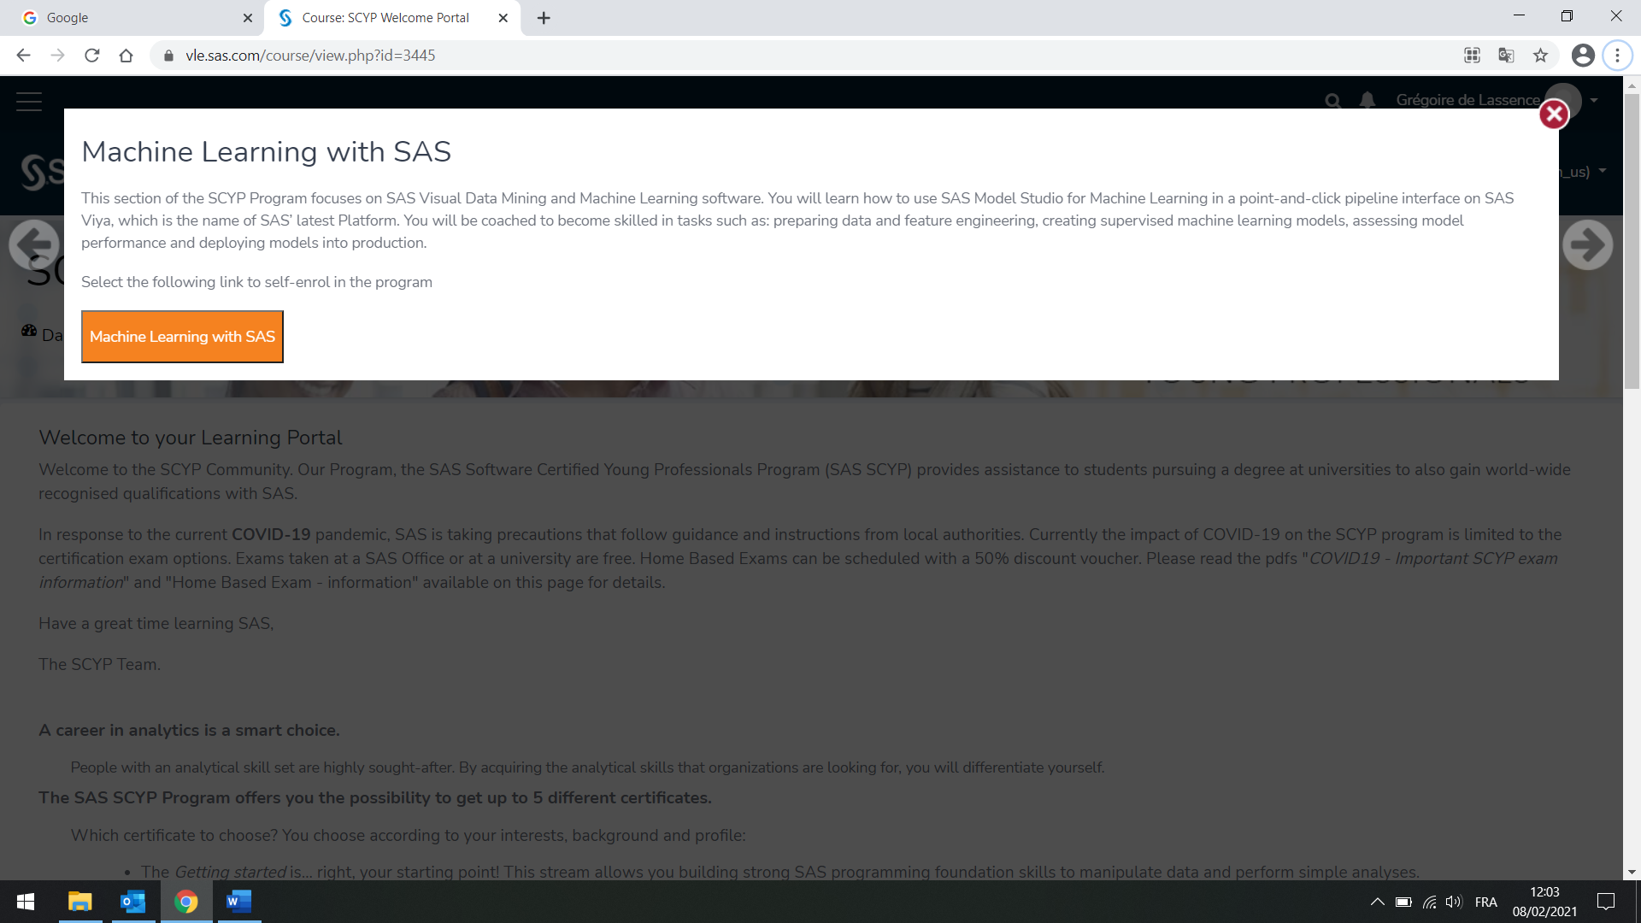

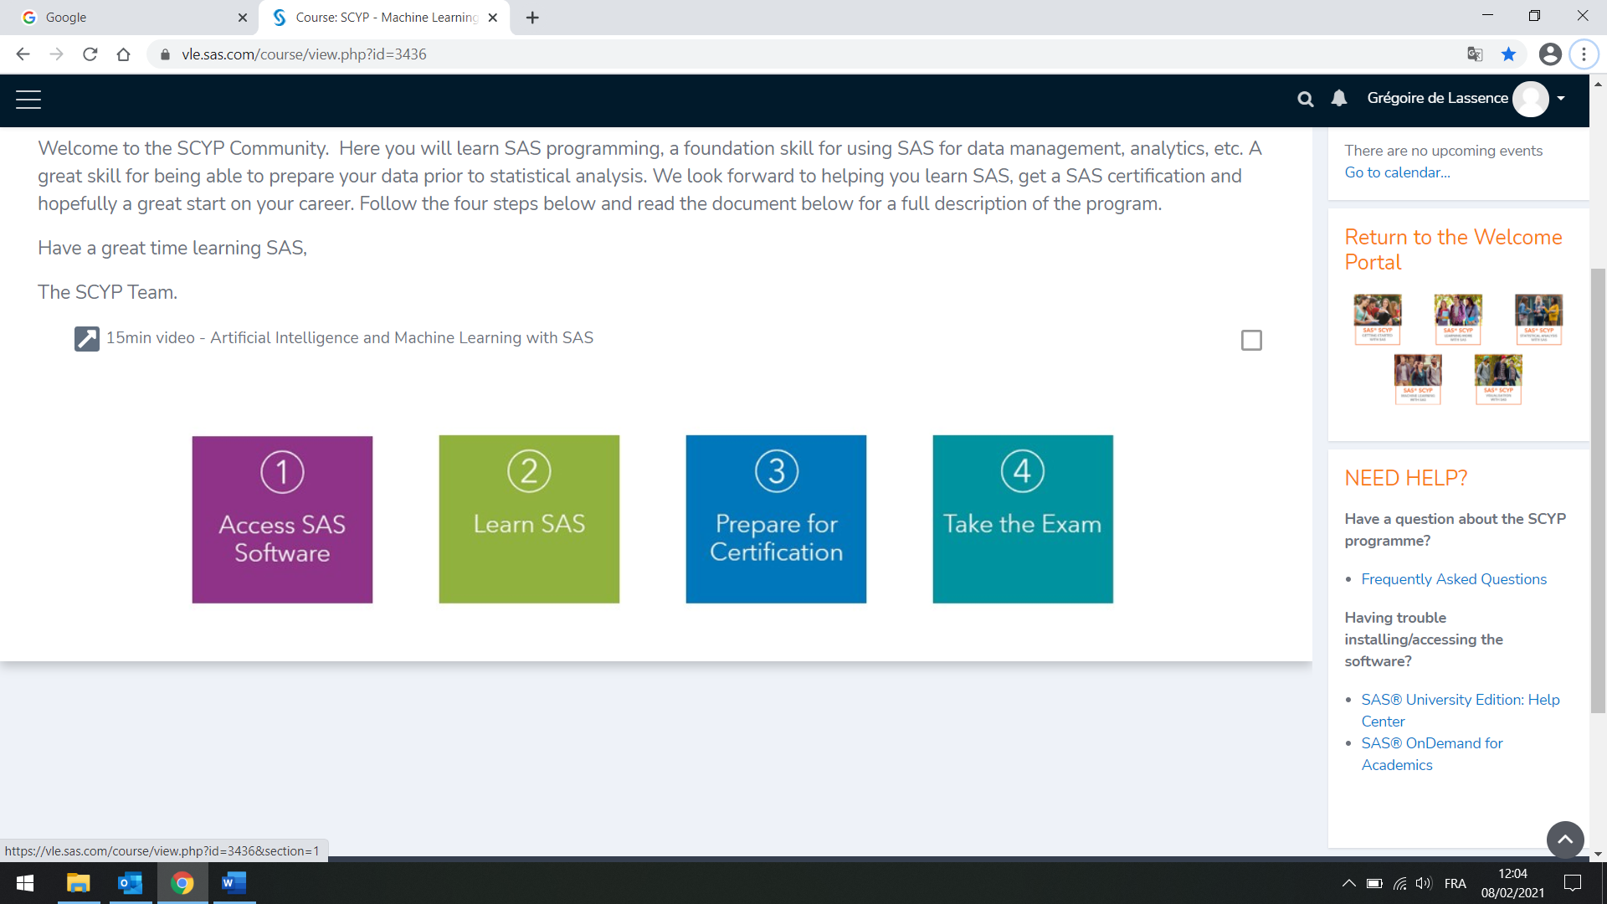

Access SAS Software

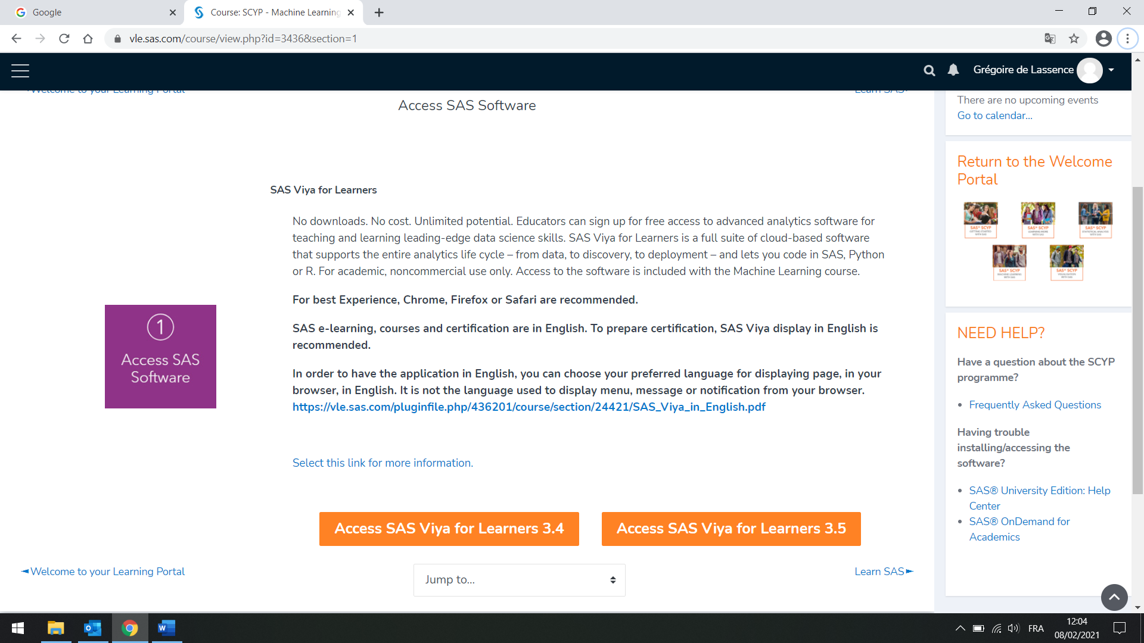

Access SAS Viya for Learners 3.5

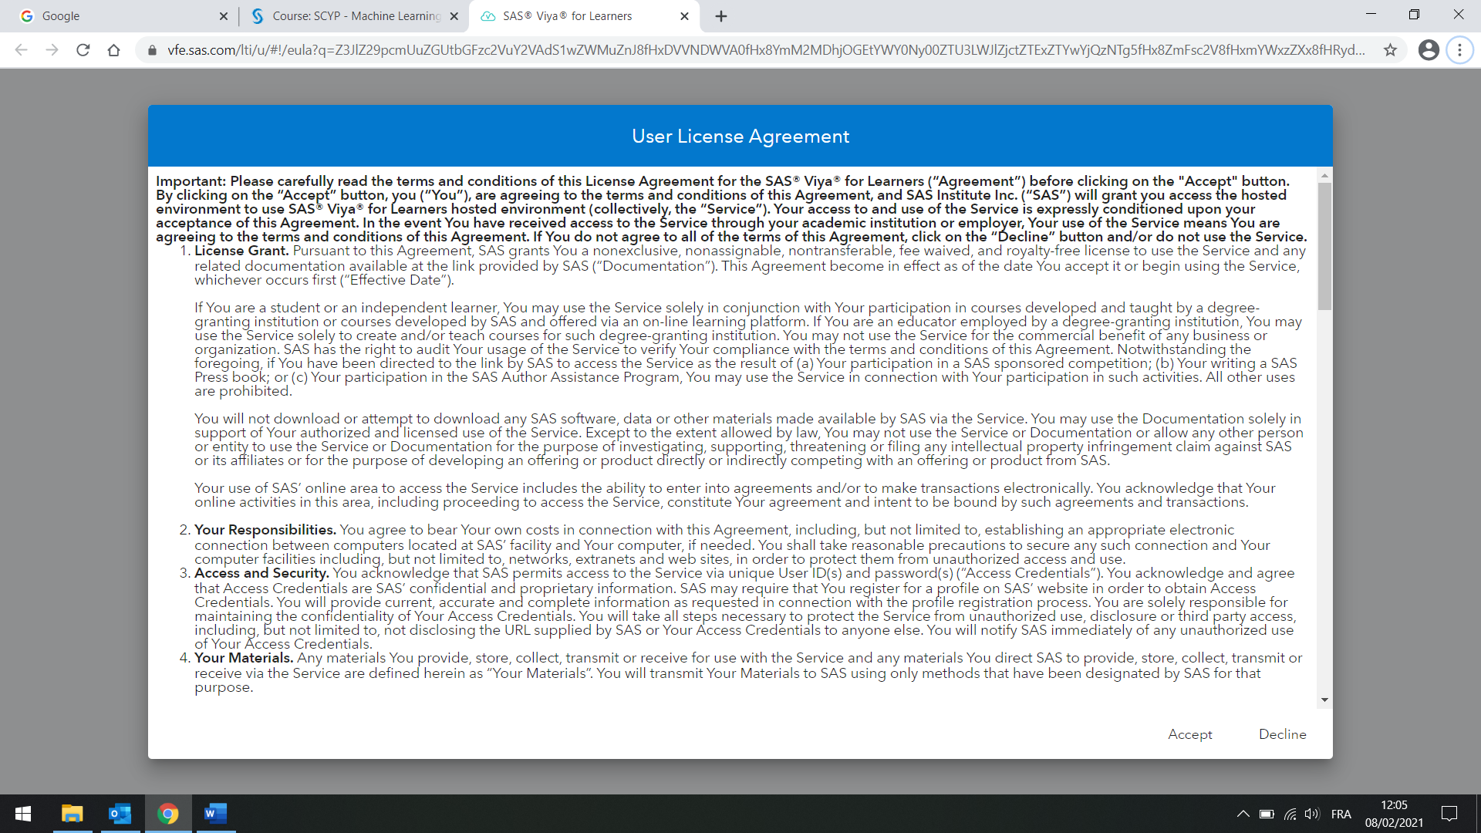

Accept

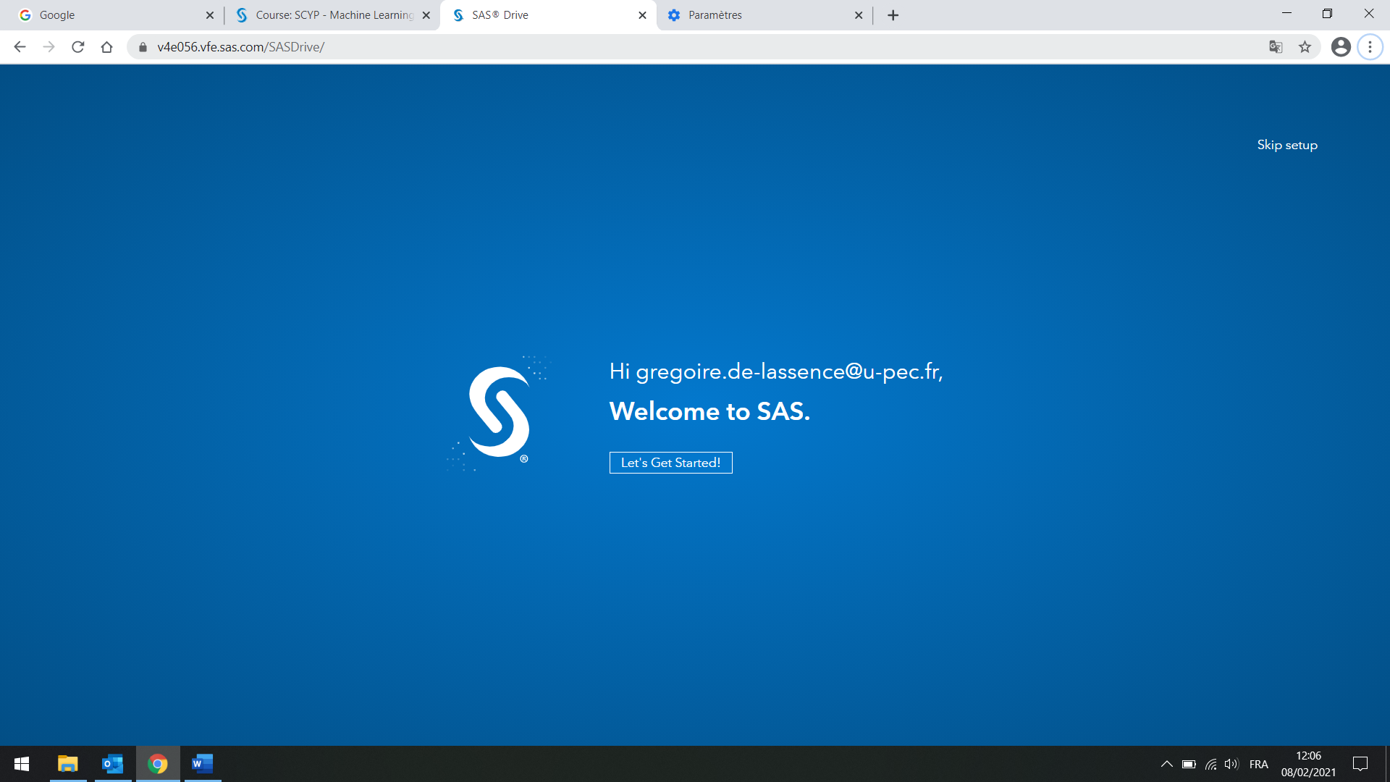

You can ignore the configuration: Skip setup

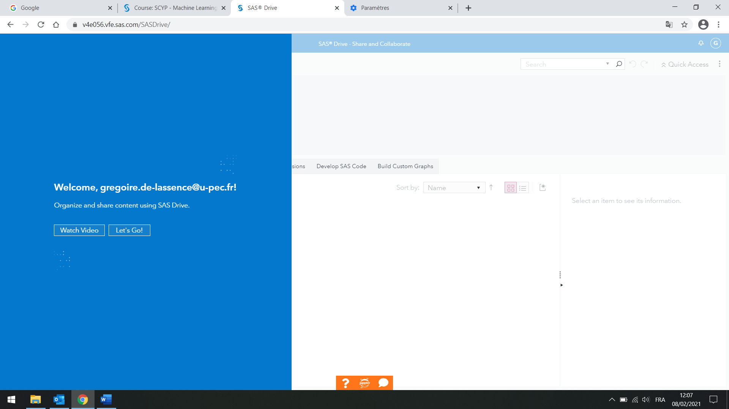

Let’s go!

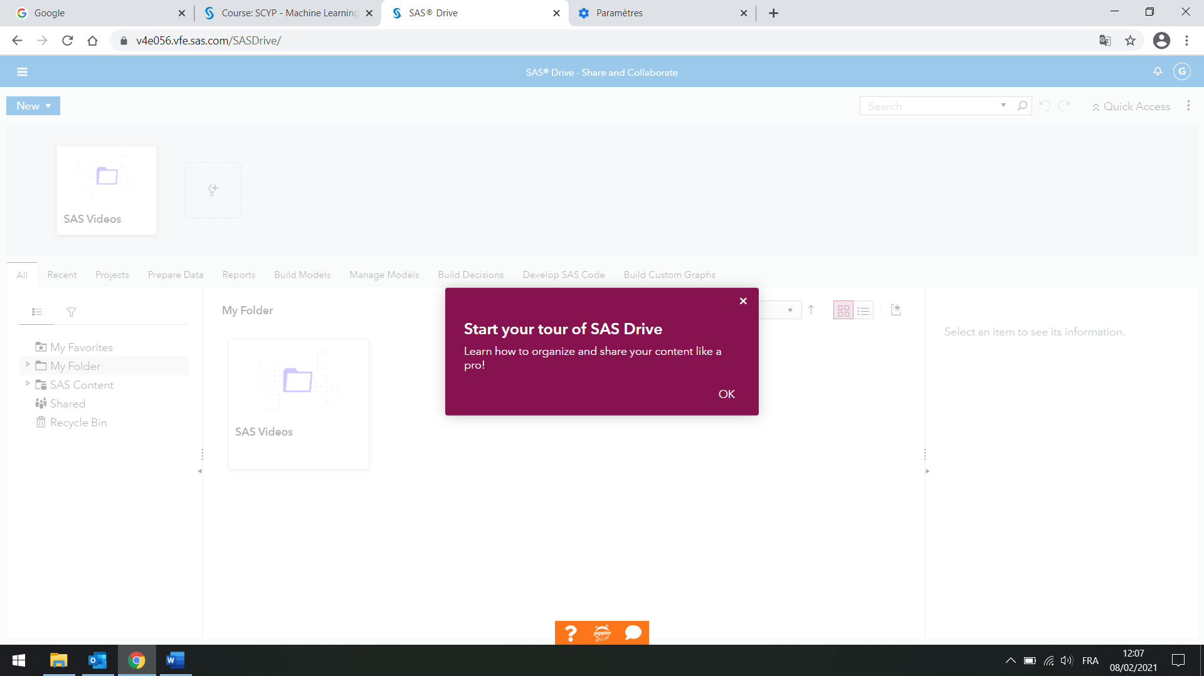

OK

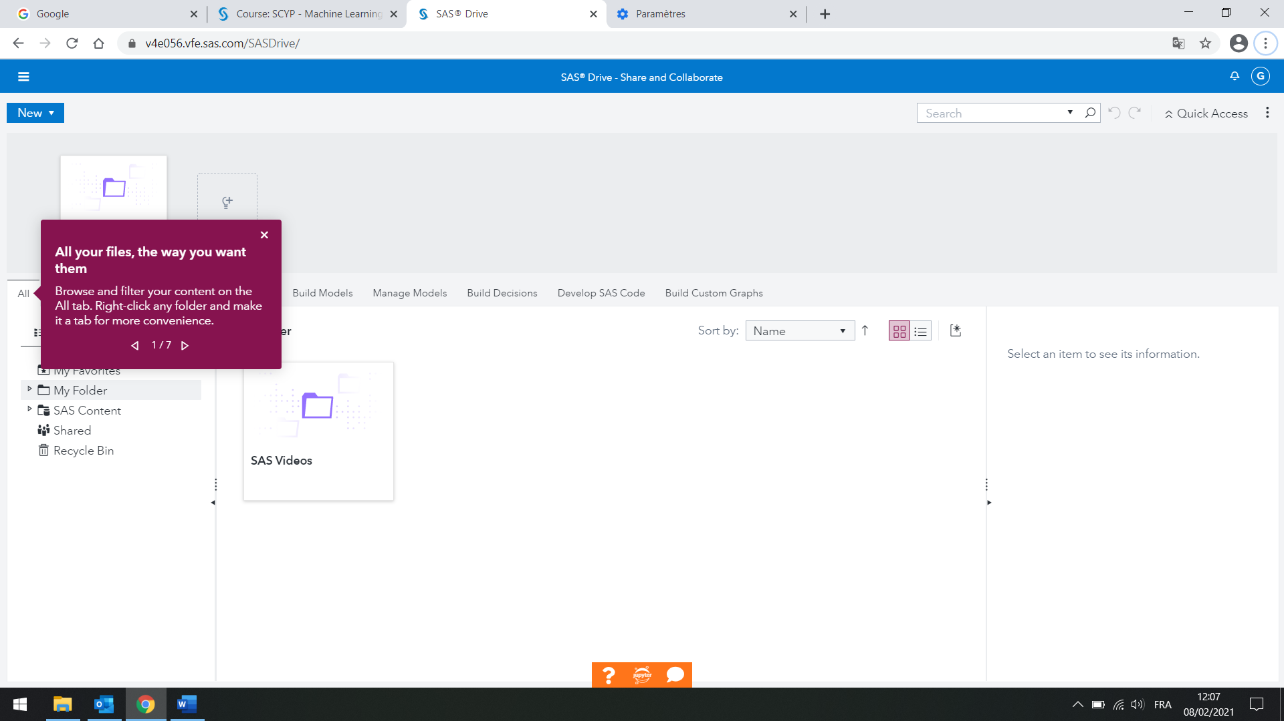

Close

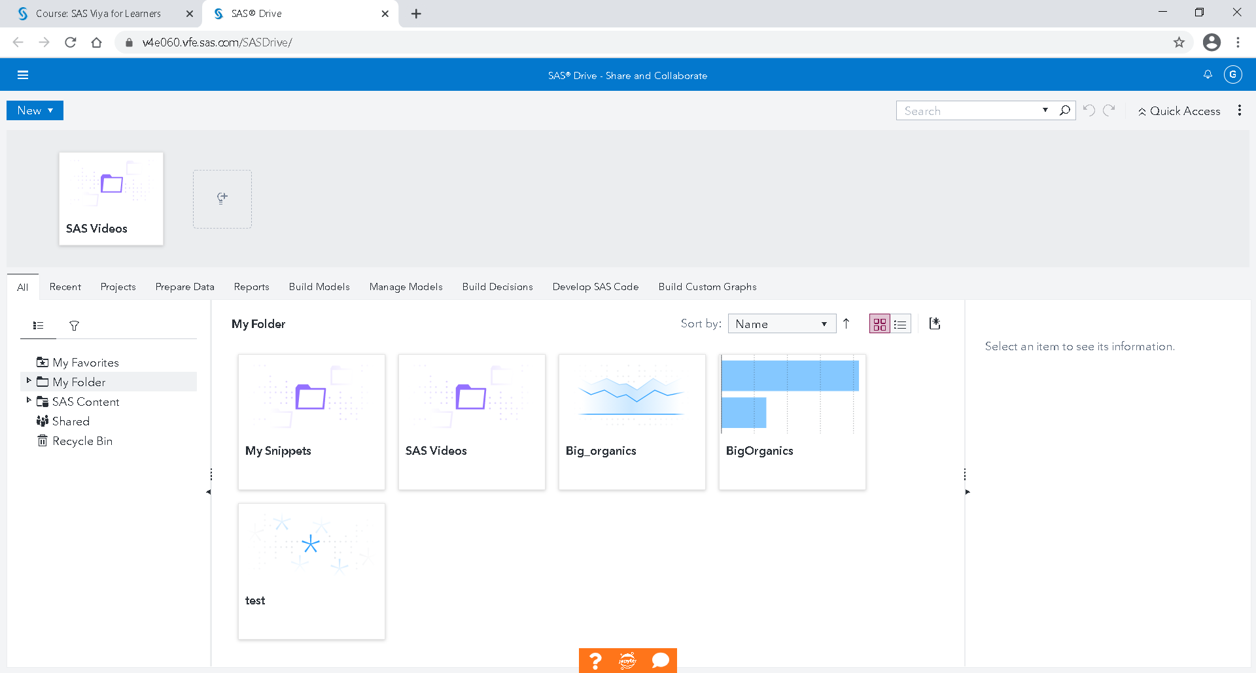

Once in the SAS Viya for Learners - Drive, on the three small lines at the top left, select "Explore and Visualize Data"

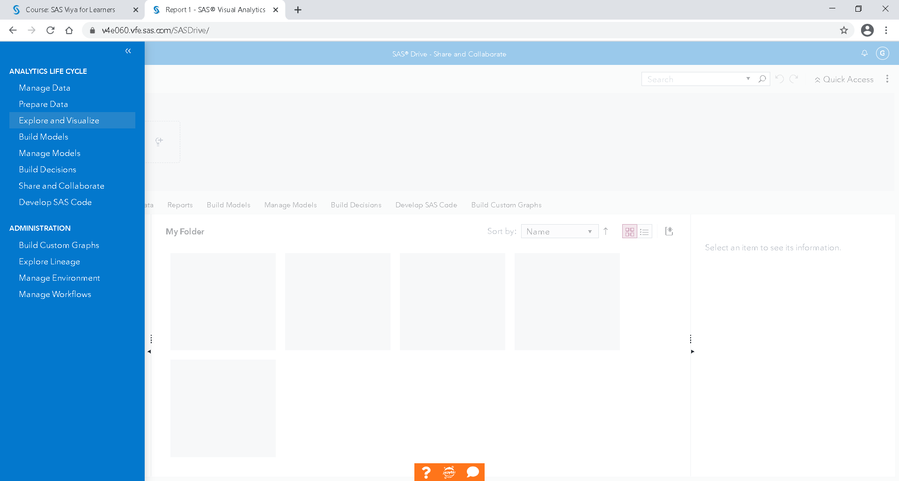

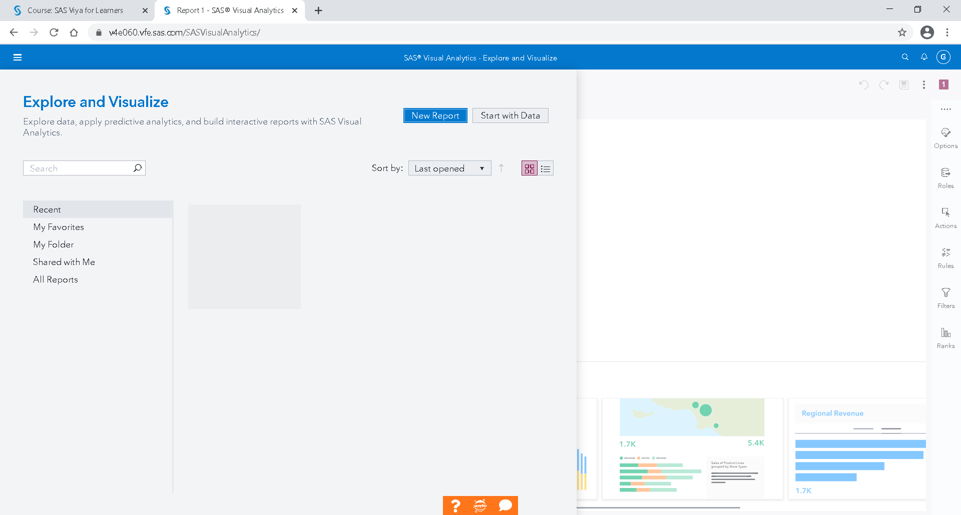

New report

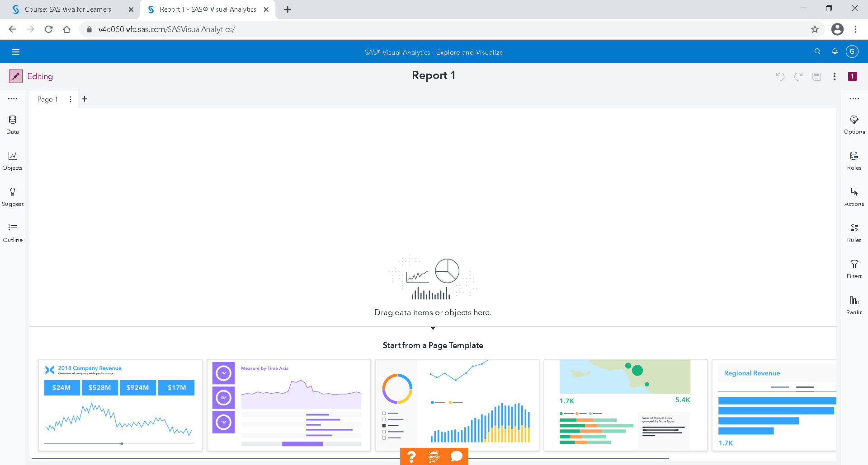

Data

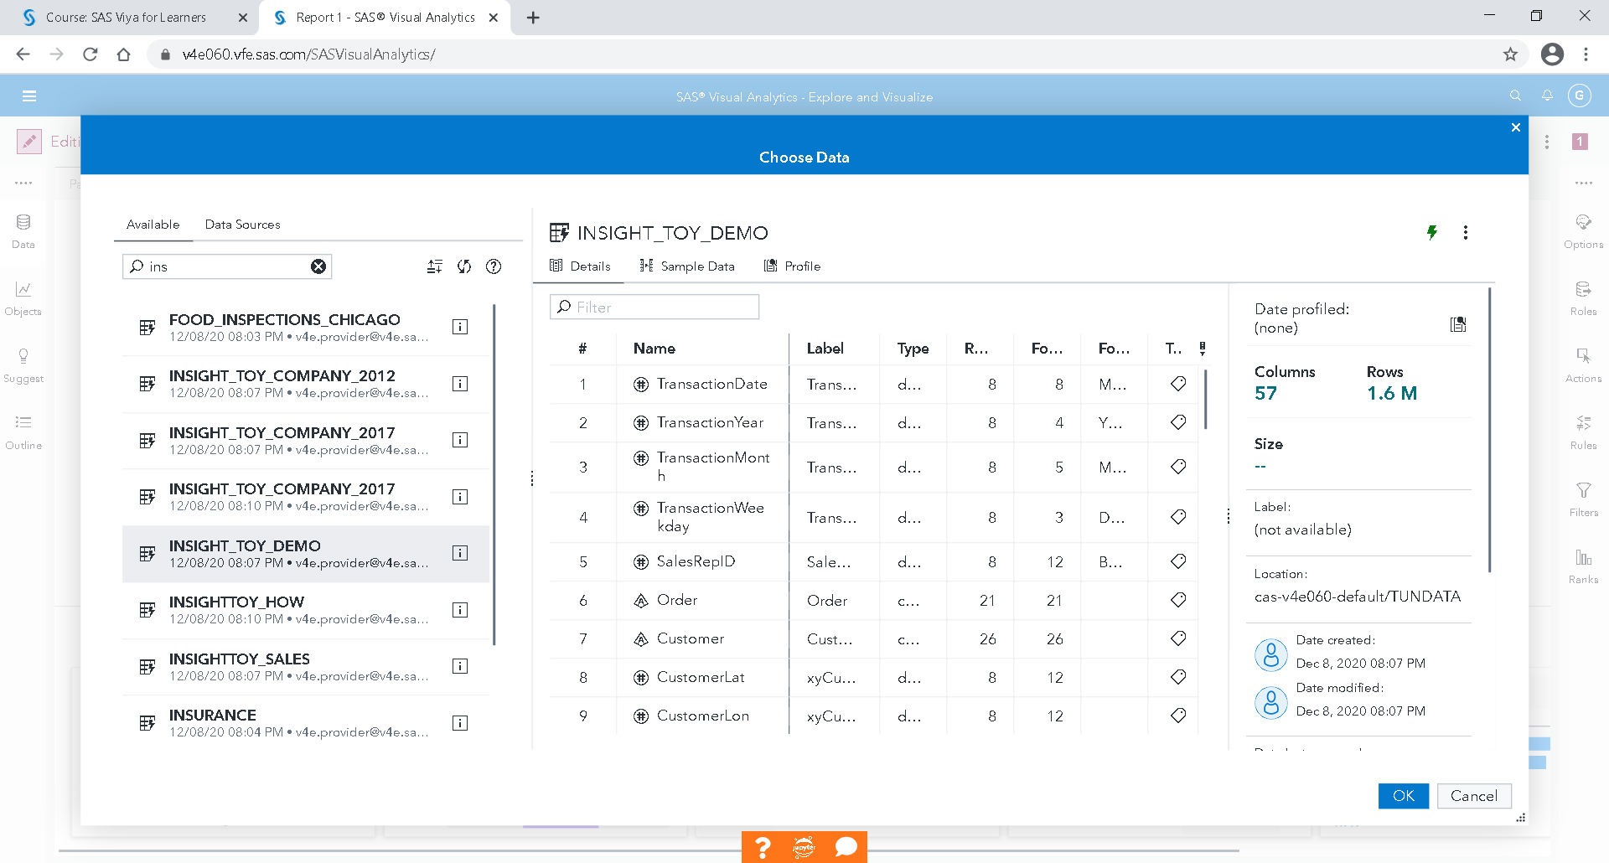

Select the table Insight_Toy_Demo.

OK

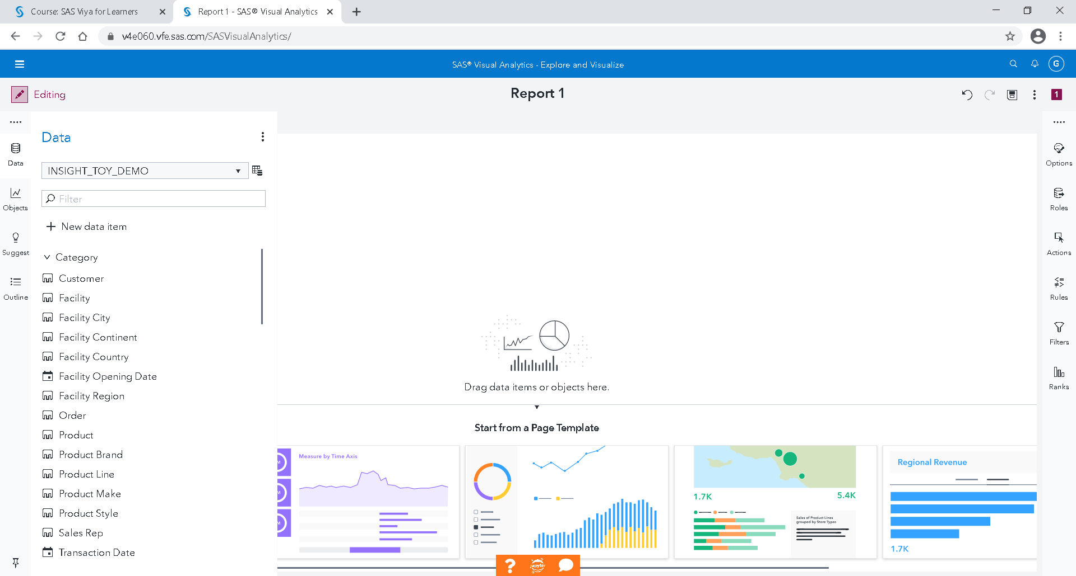

This is the reporting interface.

On the left are data, objects and report content management.

On the right are the parameters of the selected item.

If you don't drop an object, but just a data item, the default most suitable graph will be created.

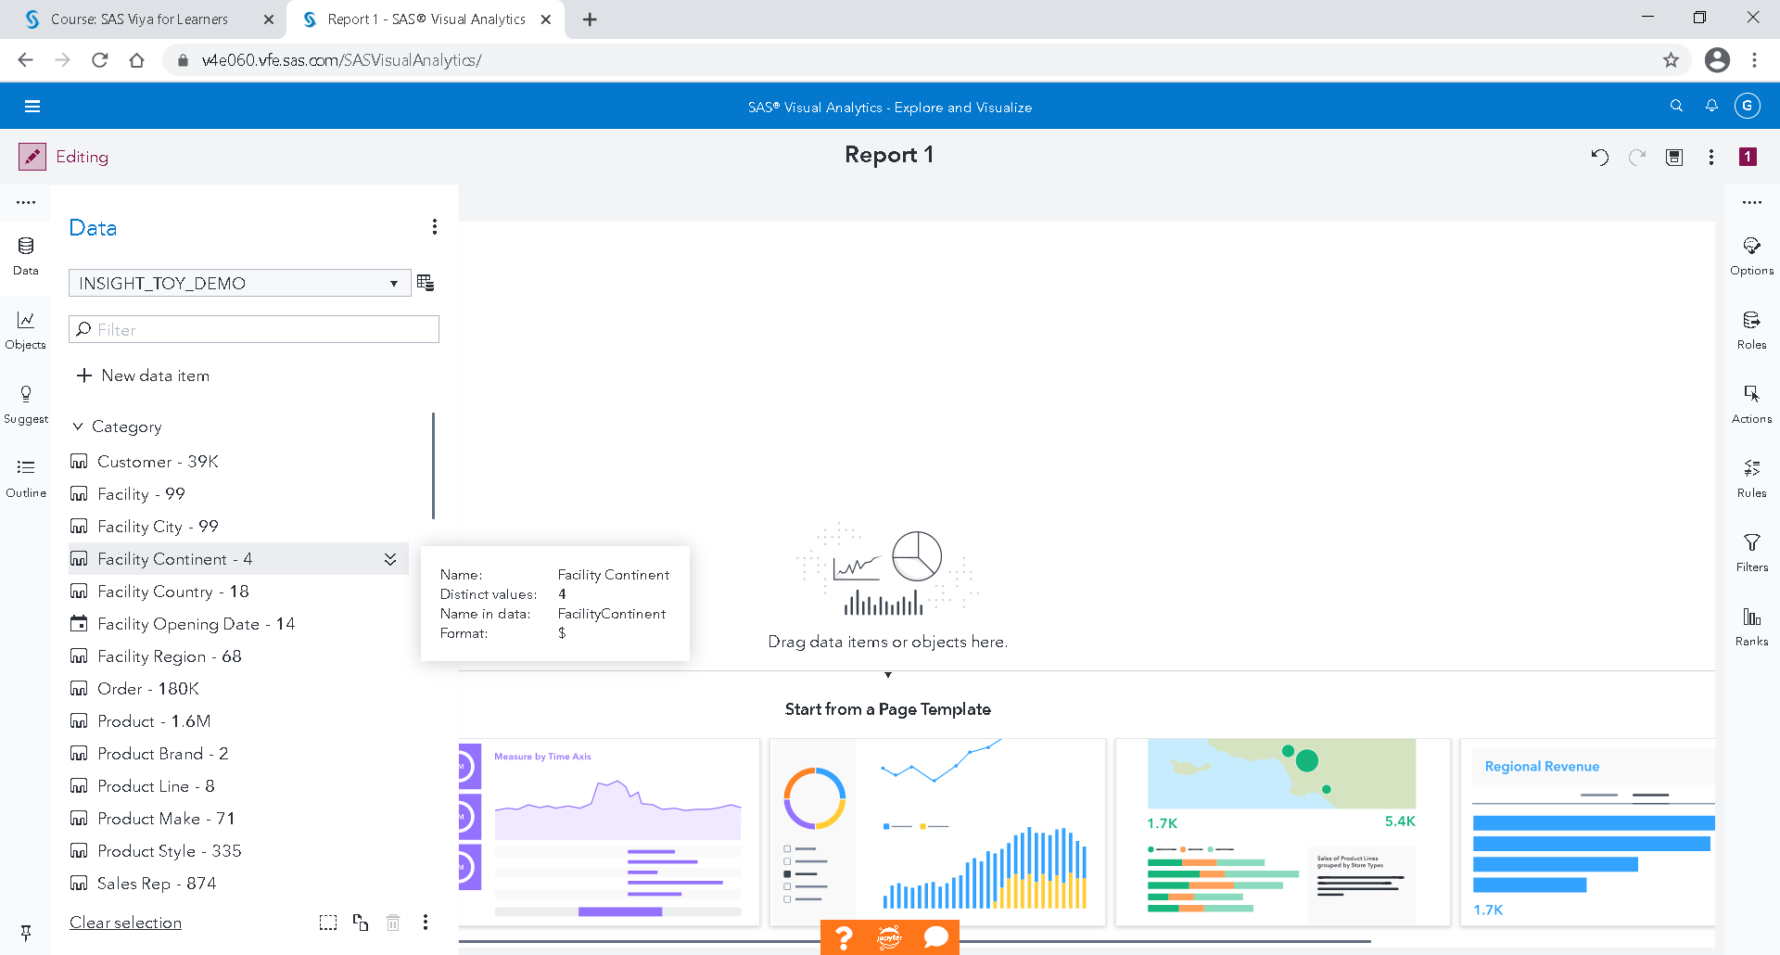

Double-click on Facility Continent

If there is no measurement selected, by default, the frequency will be used. In our case, it is the number of transactions per continent.

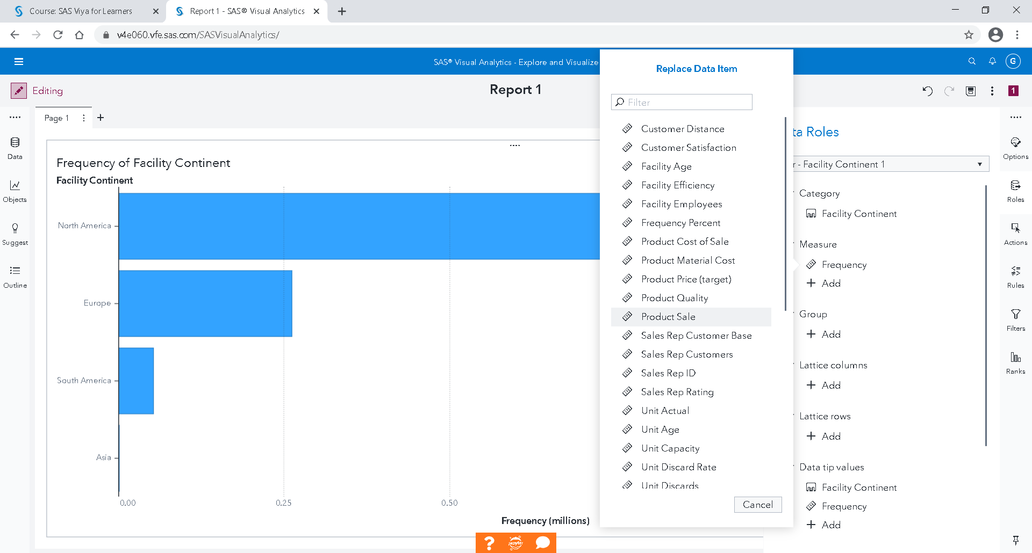

You can replace the frequency by "Product Sale"

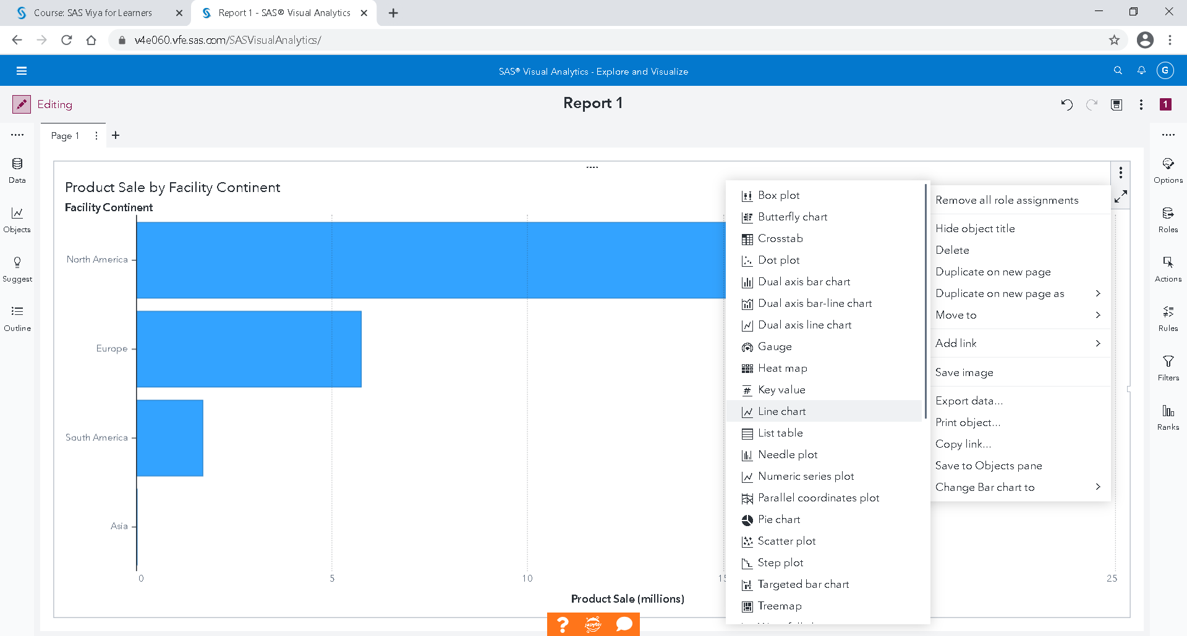

By clicking on the three small dots at the top right of the graph, you can change the representation and select the line chart

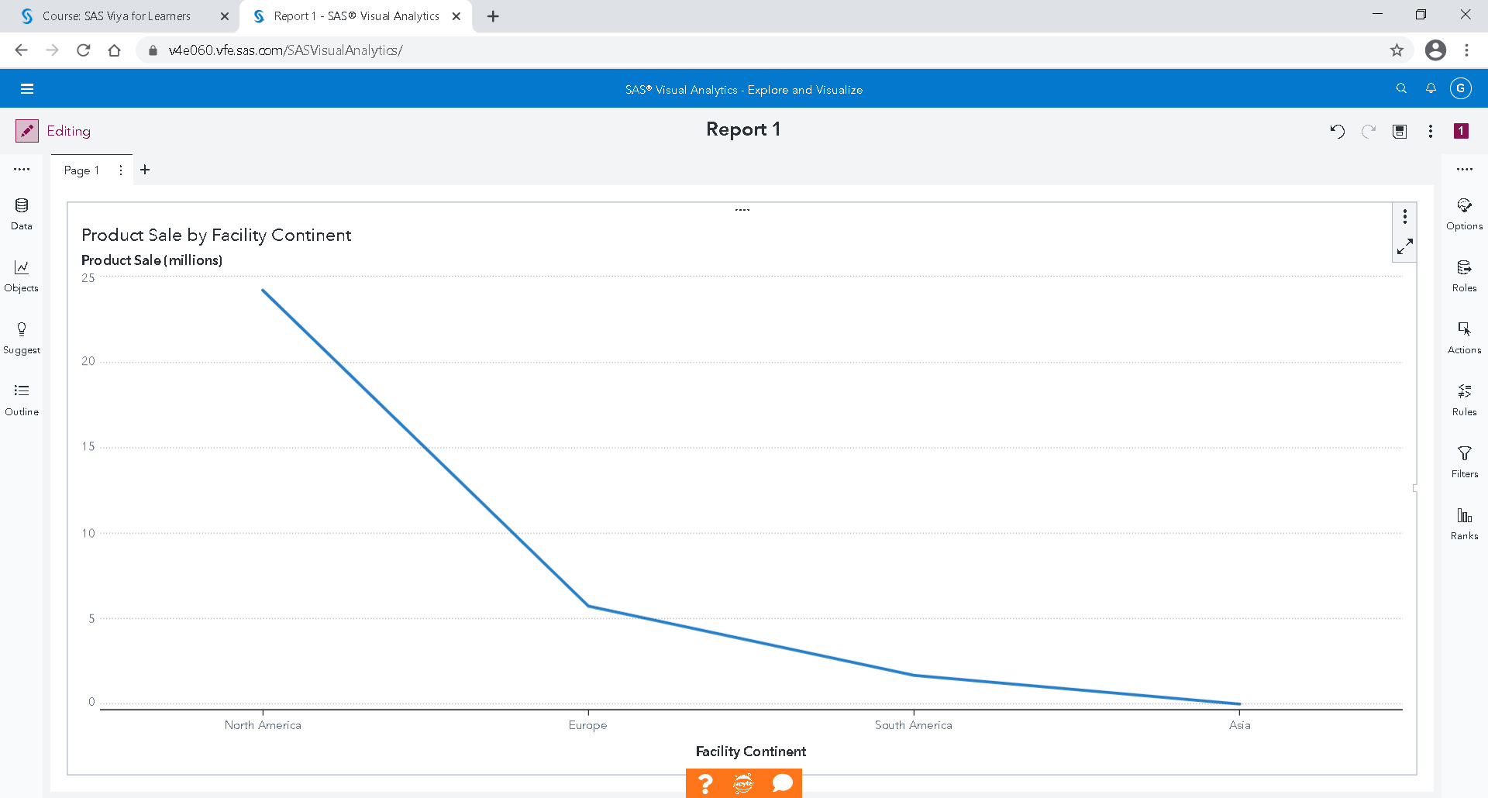

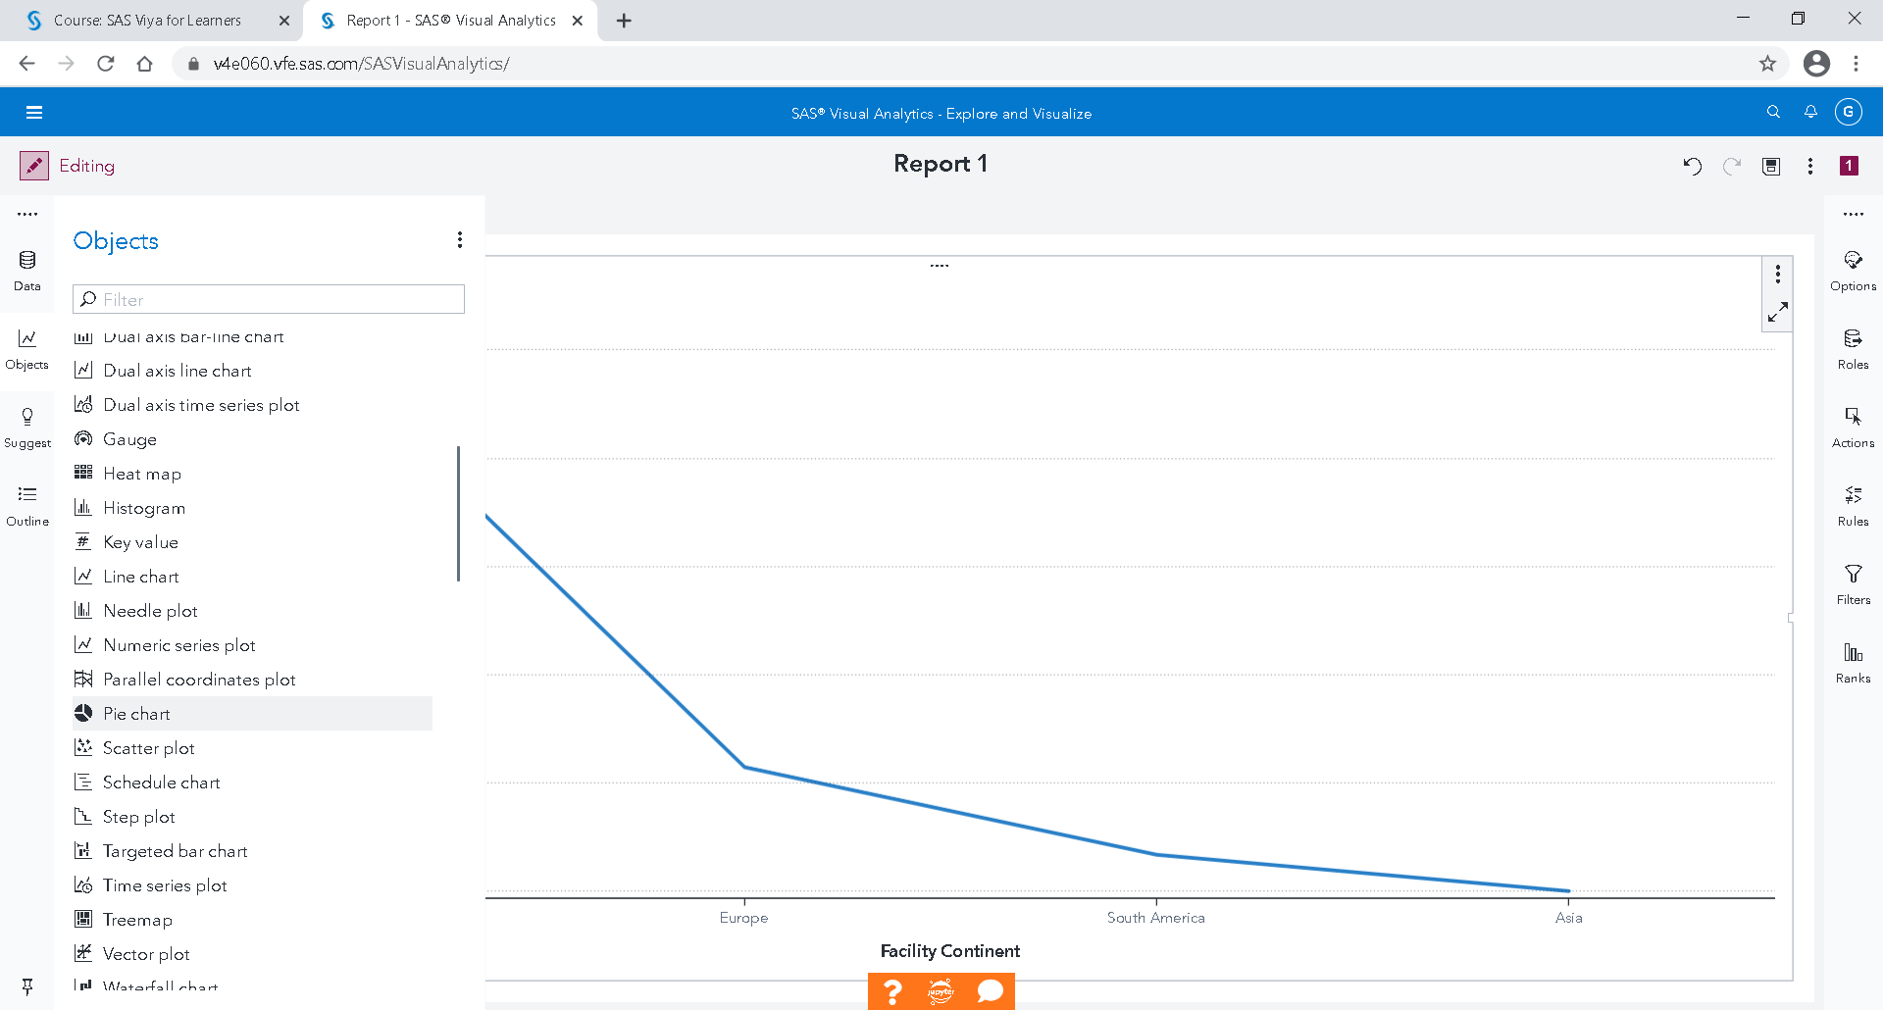

If you want a Pie Chart below the curve, just click the object button, then select this Object and drag and drop it.

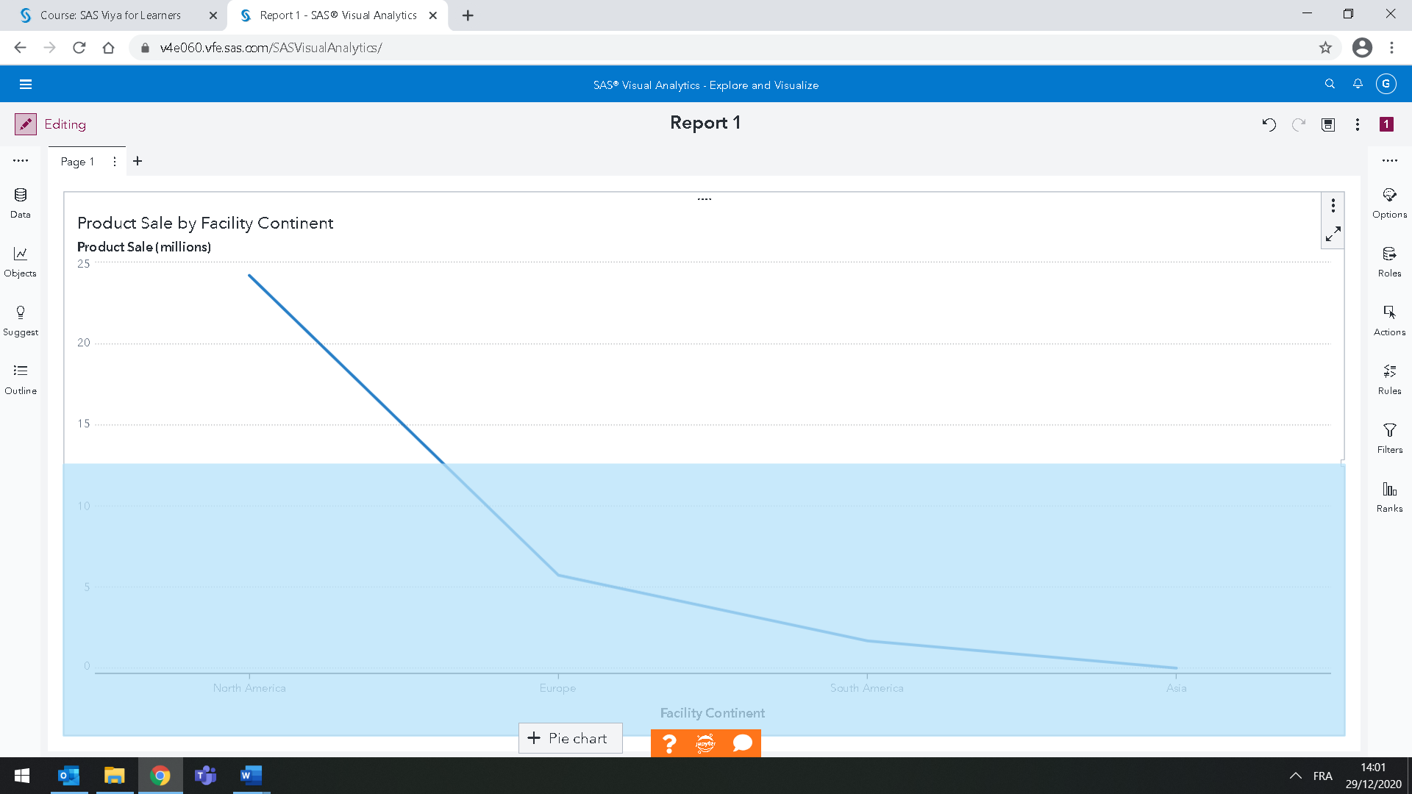

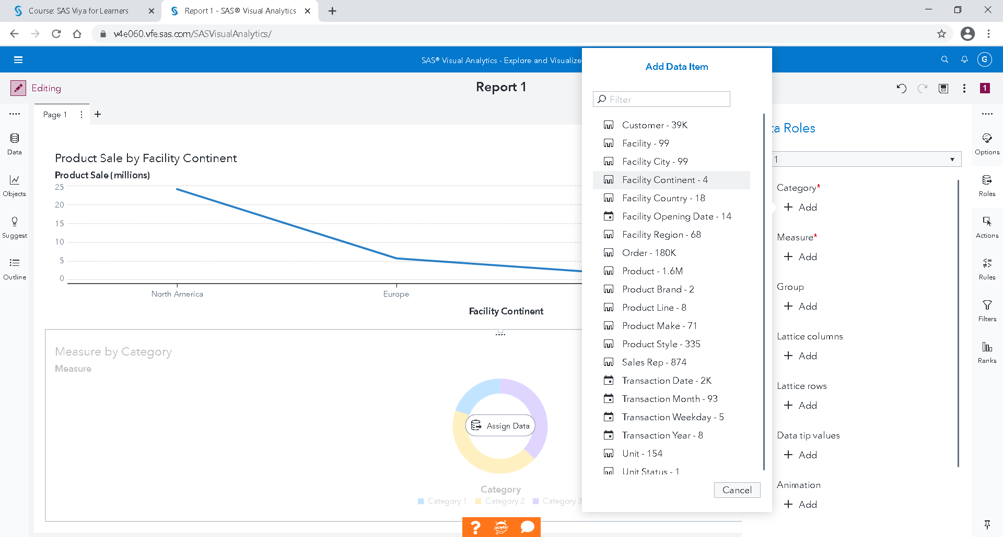

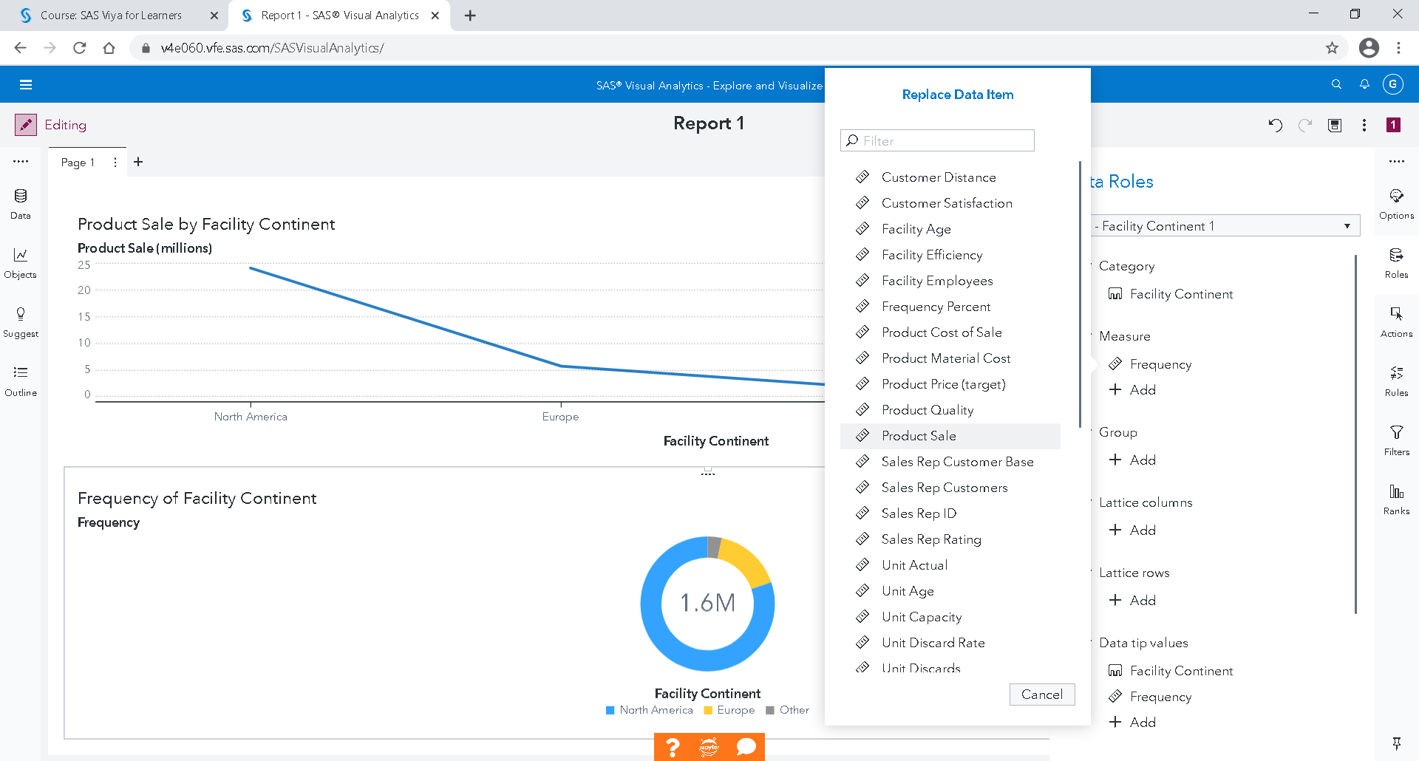

On the right, on the role of data, the "continent" is selected as a category and the frequency is replaced by "Product Sale" as a measure.

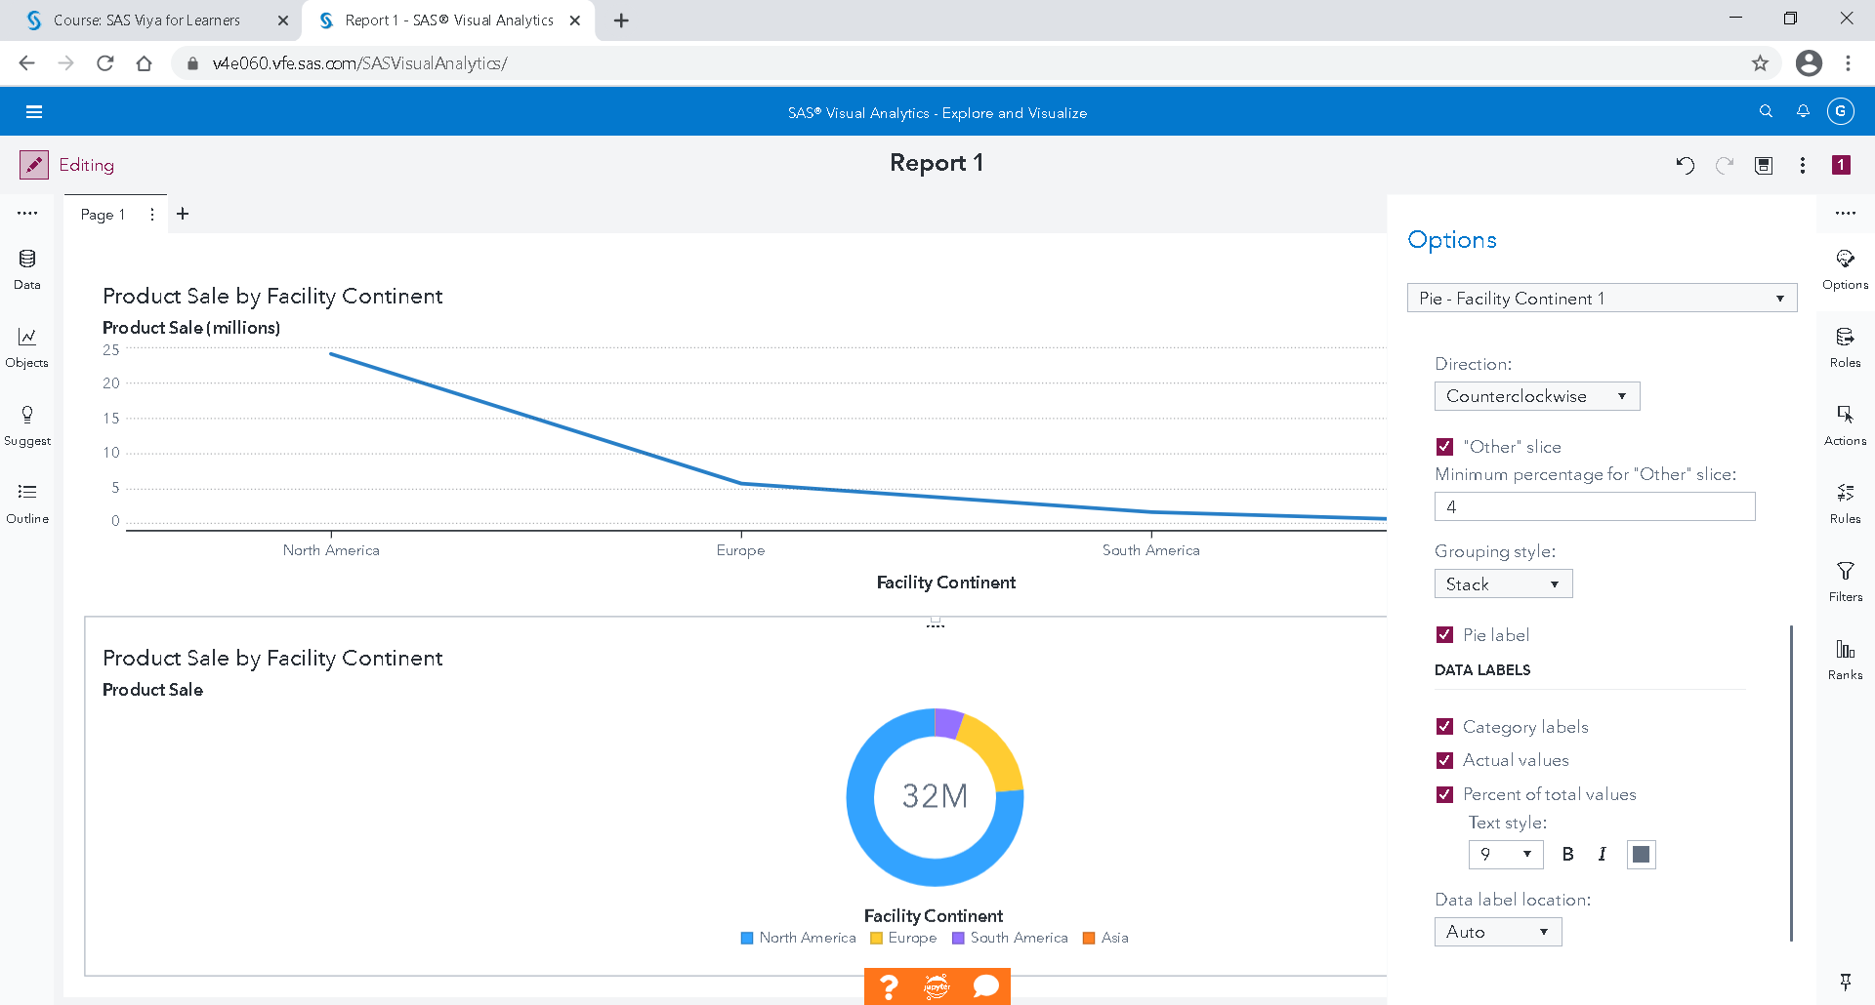

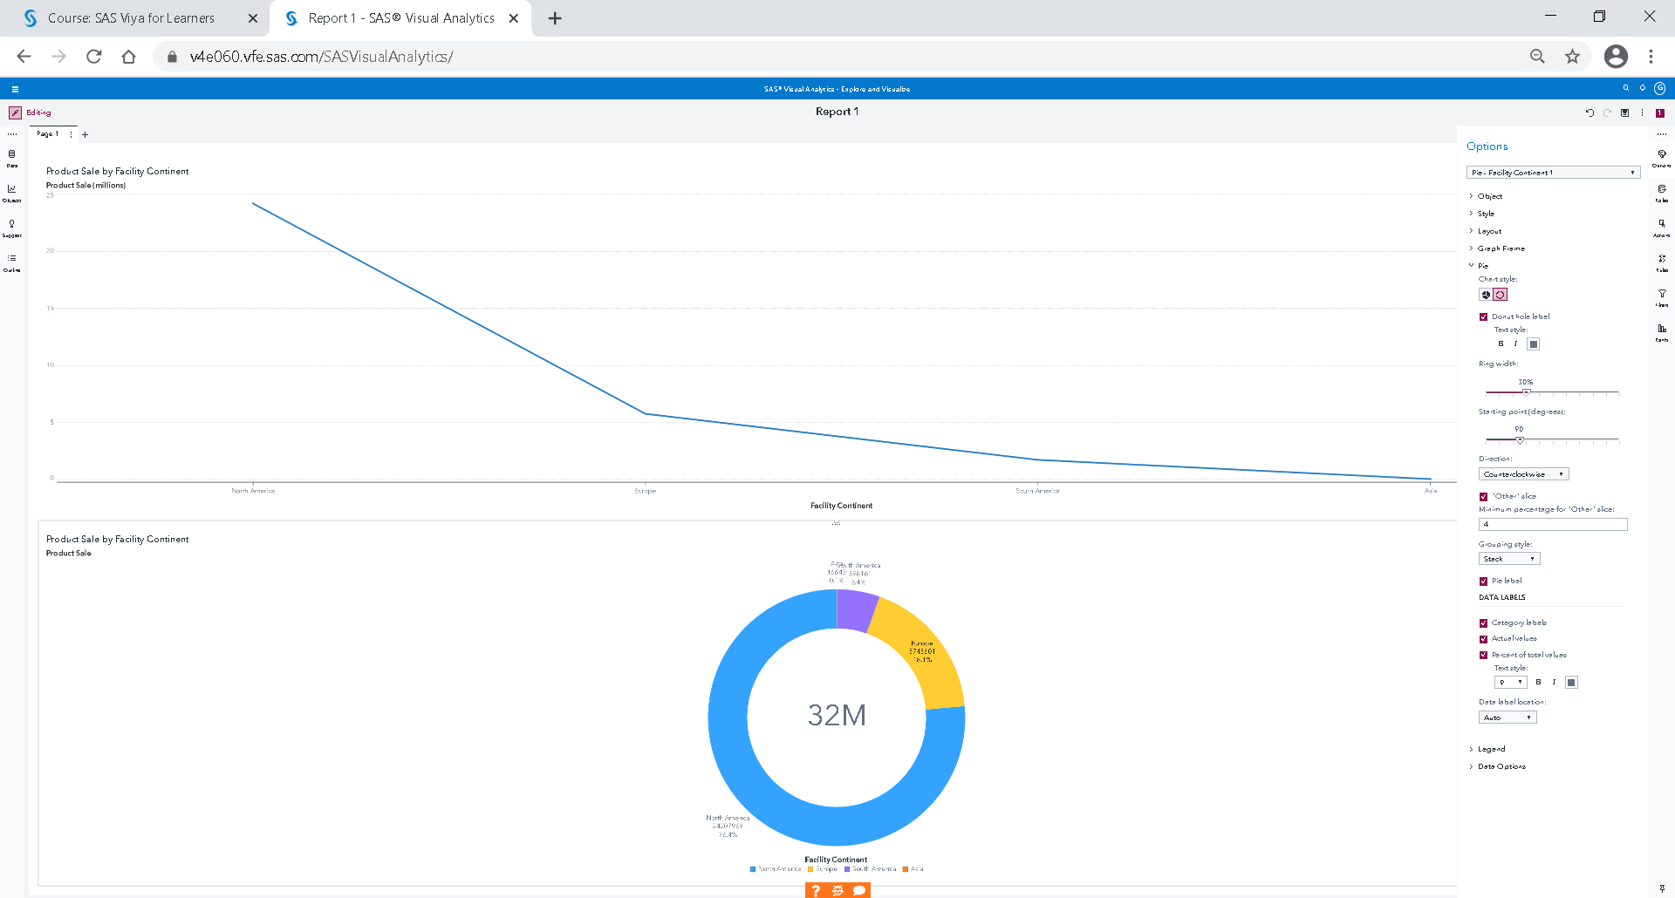

If the resolution is not sufficient, it may be necessary to uncheck the label or enlarge the size of the window.

To add a page to your report, click on + next to page 1.

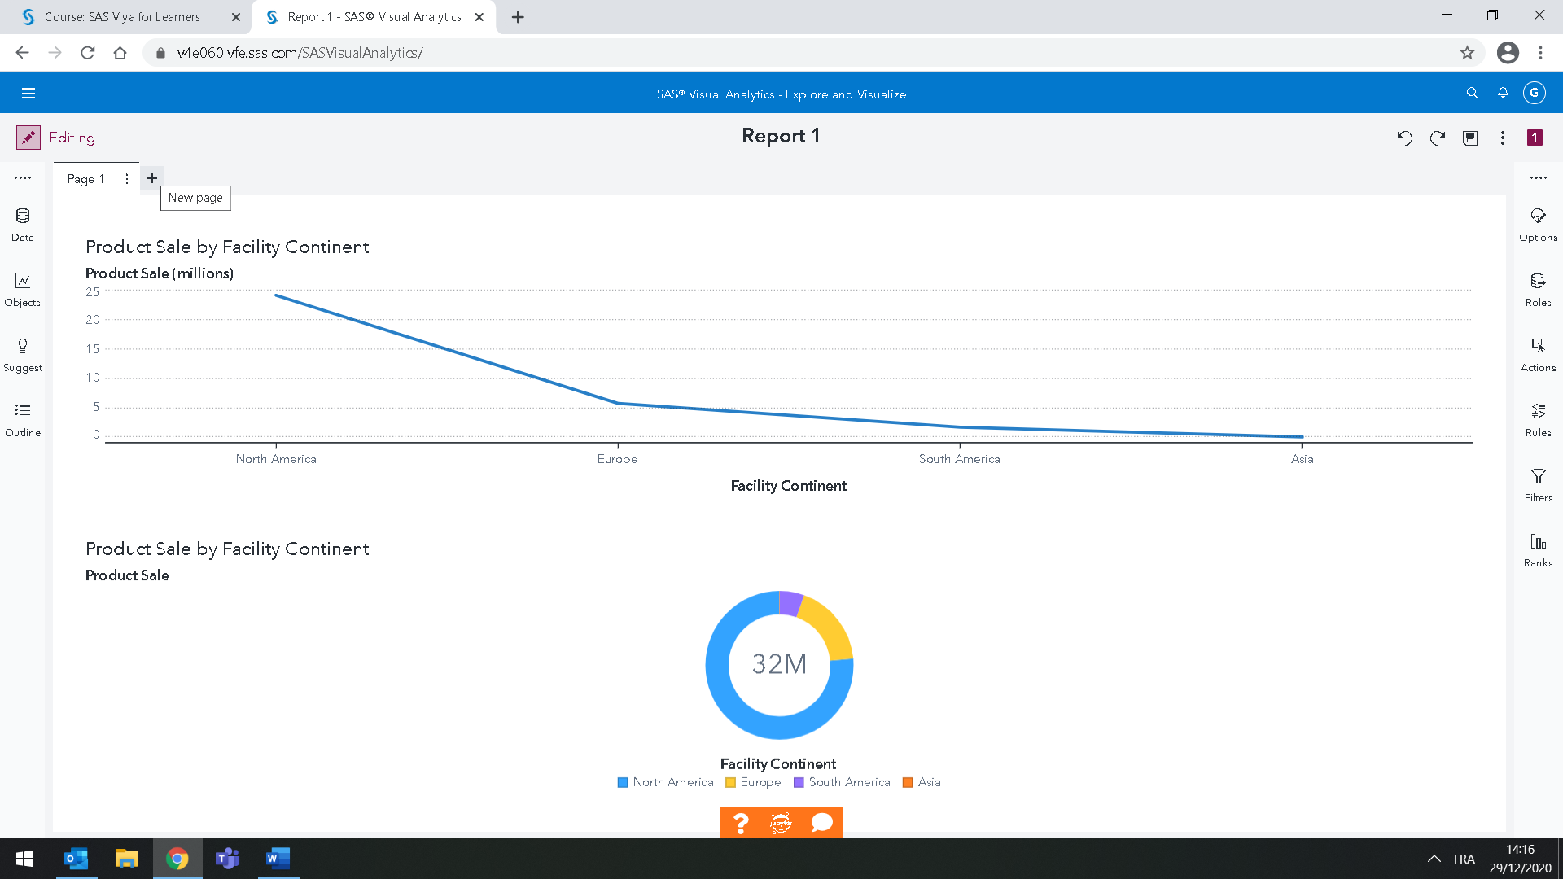

### Creating hierarchy and Crosstab

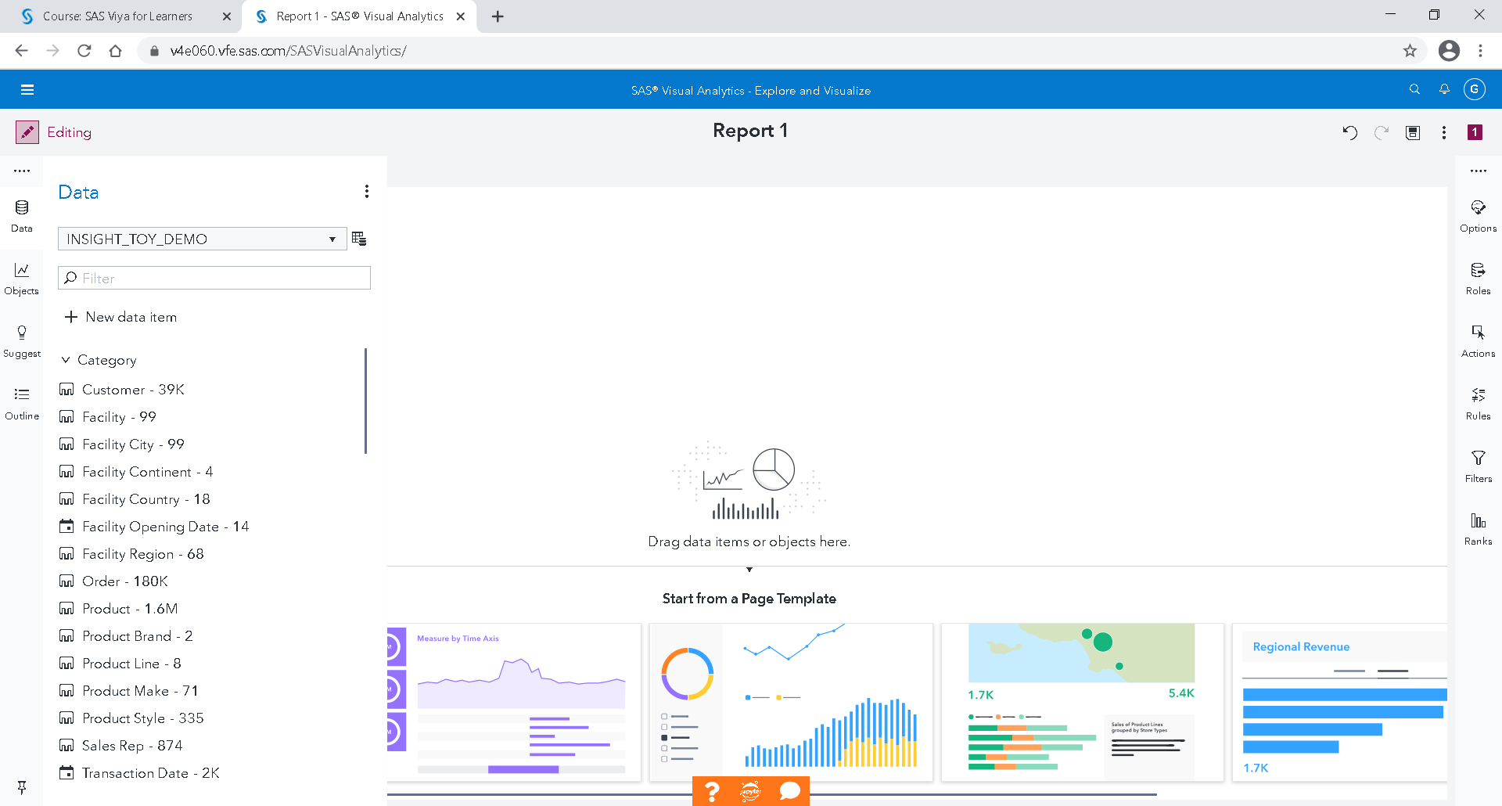

Go to data menu 🡪 select a new data item 🡪 hierarchy

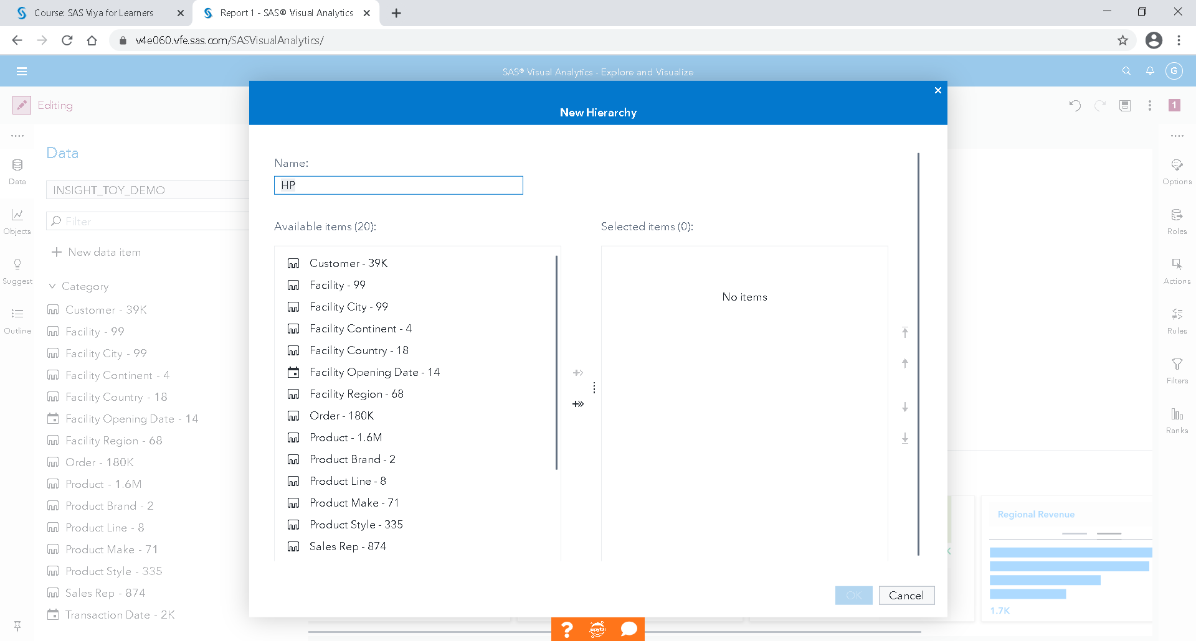

You can name it: « HP»

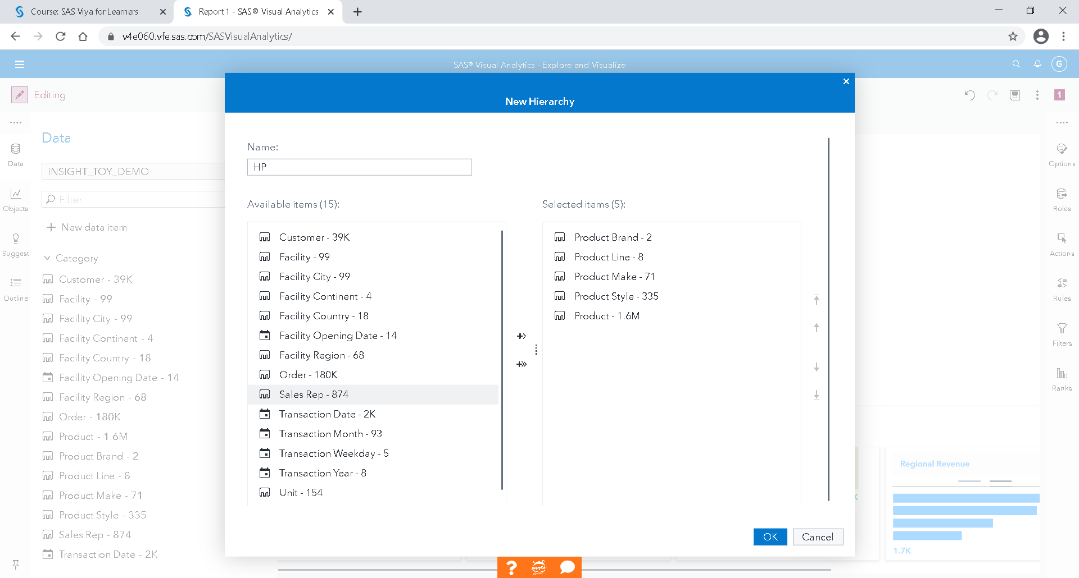

Select in order:

Product Brand

Product Line

Product Make

Product Style

Product

OK

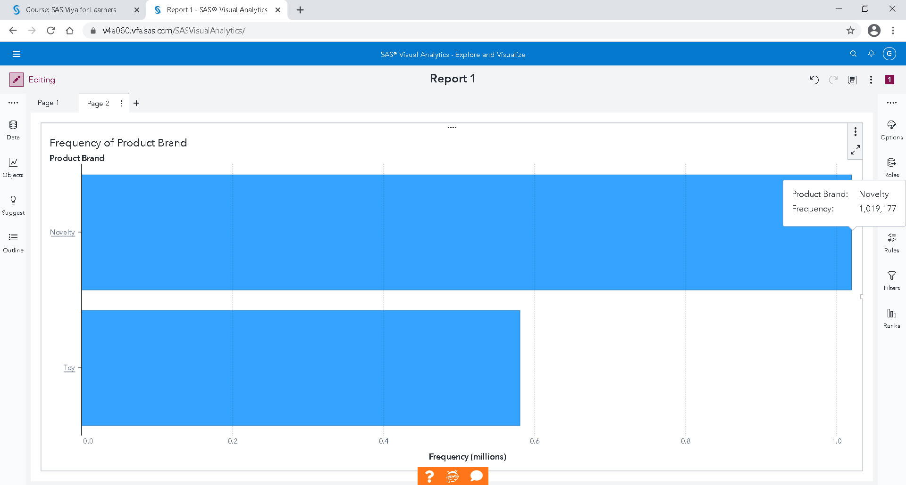

By adding the product hierarchy, the default graph is a bar chart.

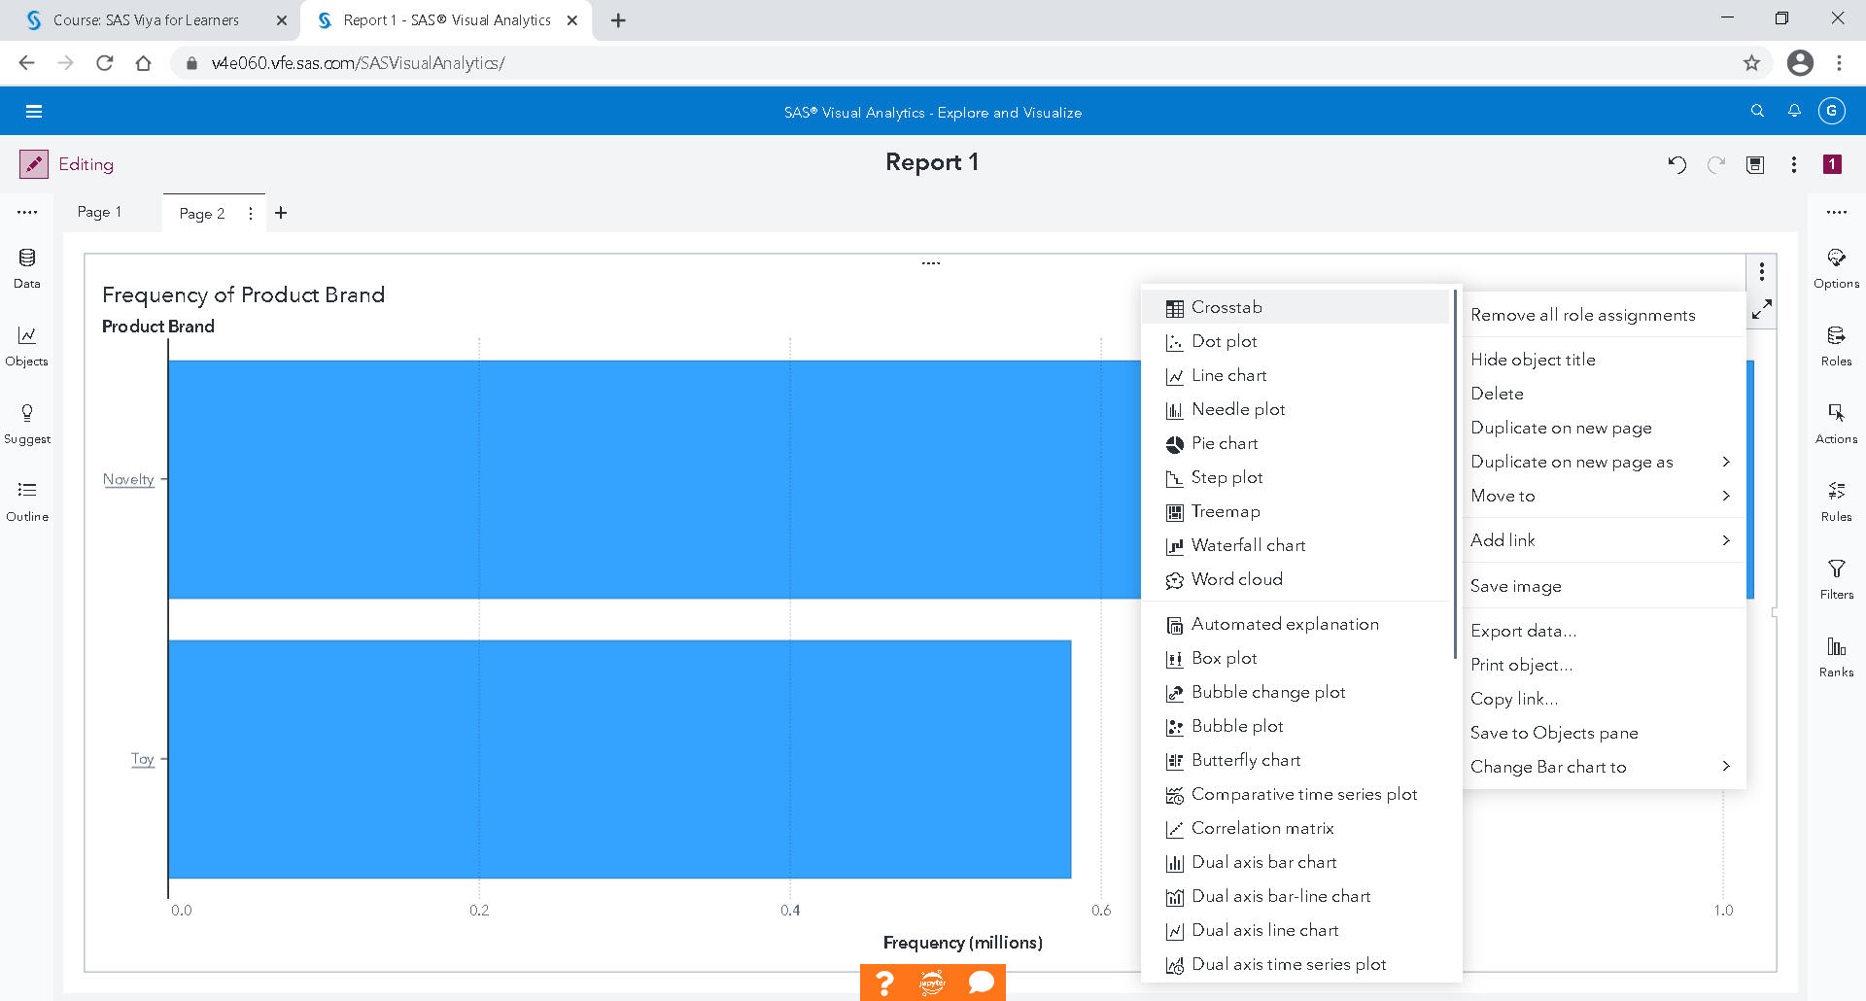

This representation can be replaced by a crosstab.

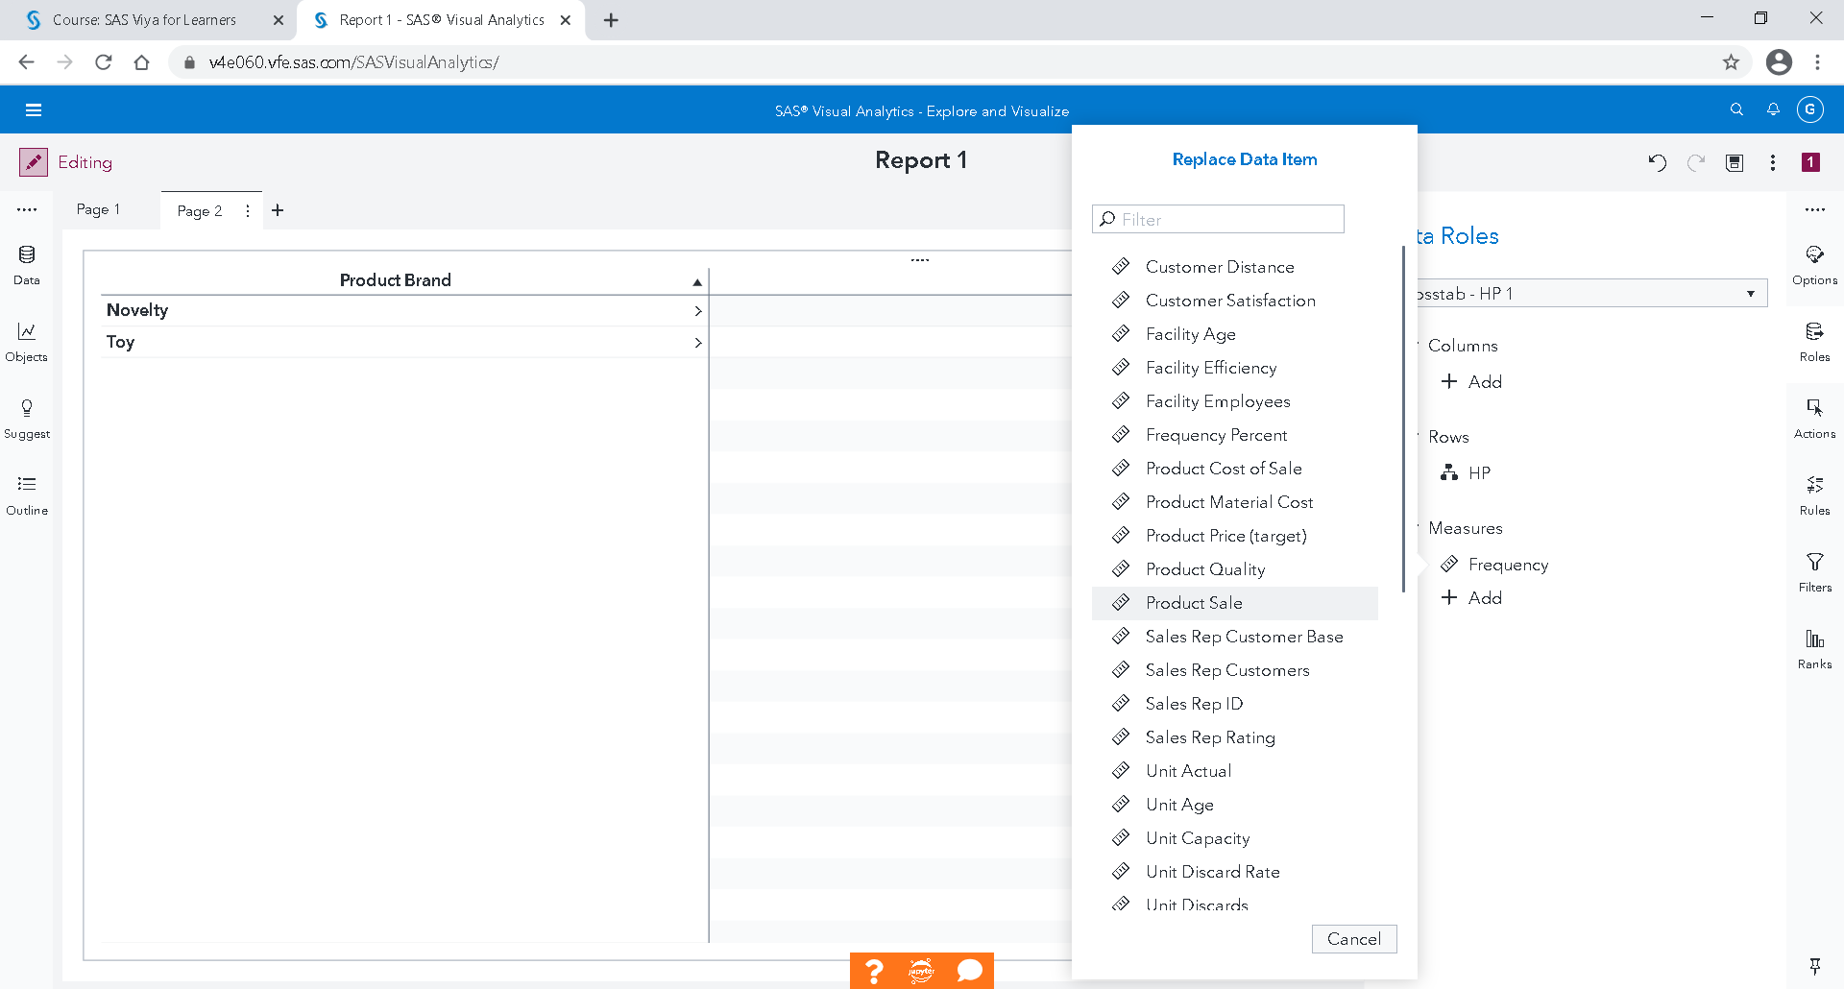

We can add "Product Sale" to replace the Frequency.

If you click on the name of the hierarchy level, you select it.

If you click on the arrow after the name, you expand it.

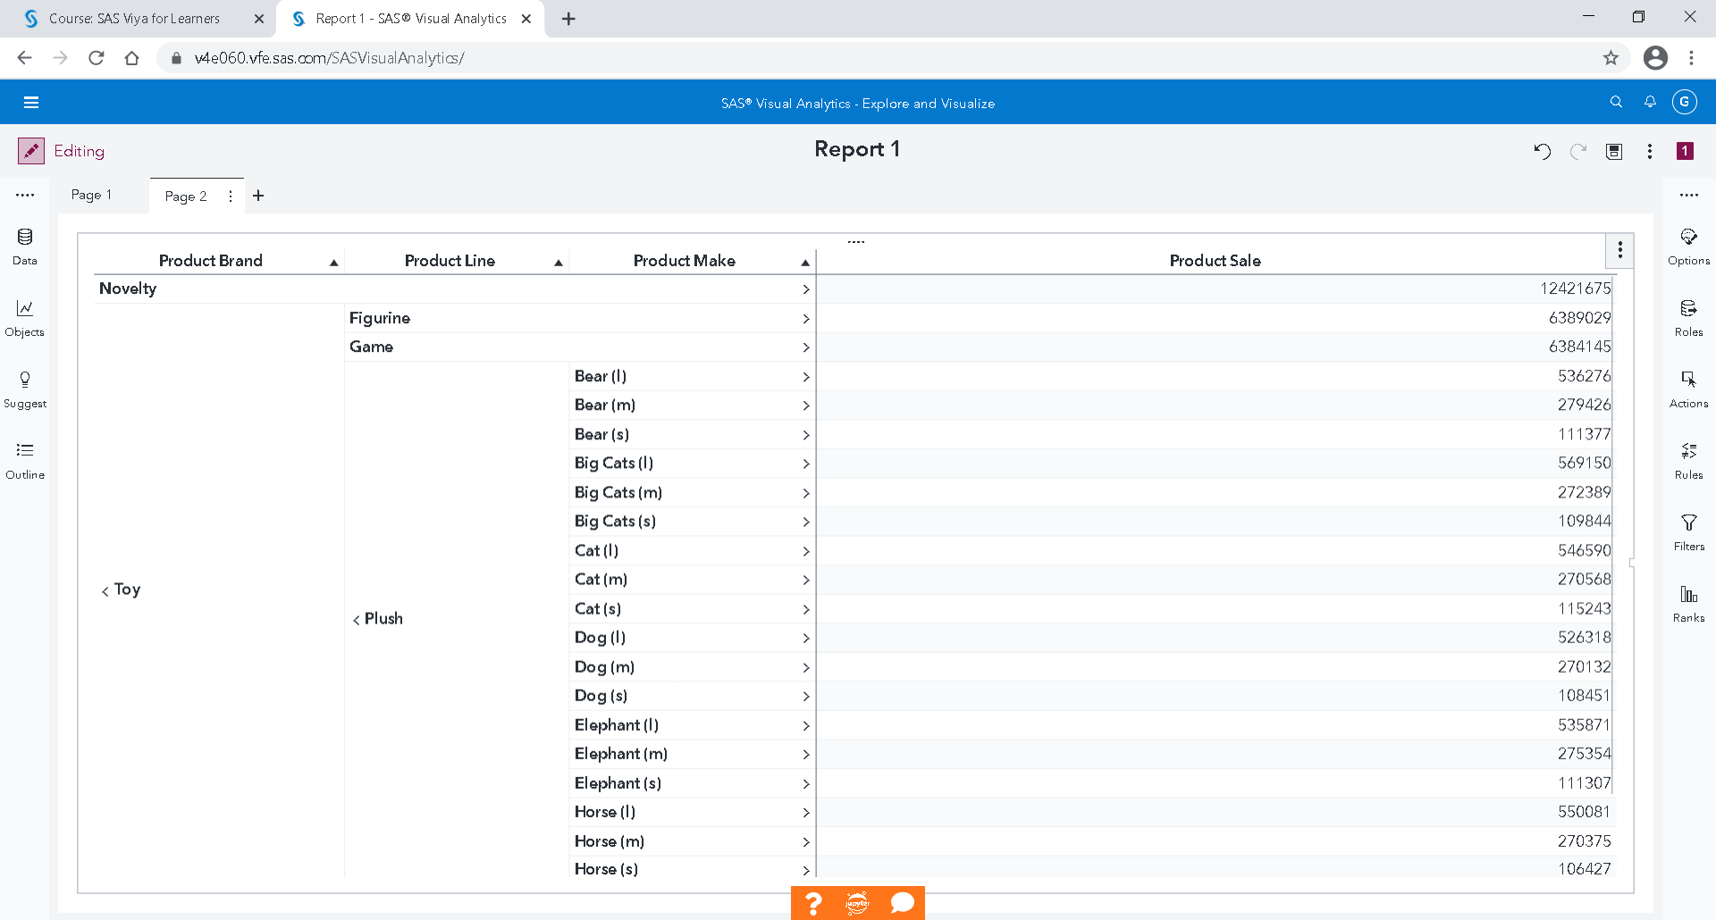

Add a third page to your report.

### Create a geographical hierarchy

To represent the data on a world map, we will here create a geographical hierarchy « Continent 🡪 Country 🡪 Region 🡪 City 🡪 Facility » using coordinates World Geodetic System (WGS84) coordinates.

In data:

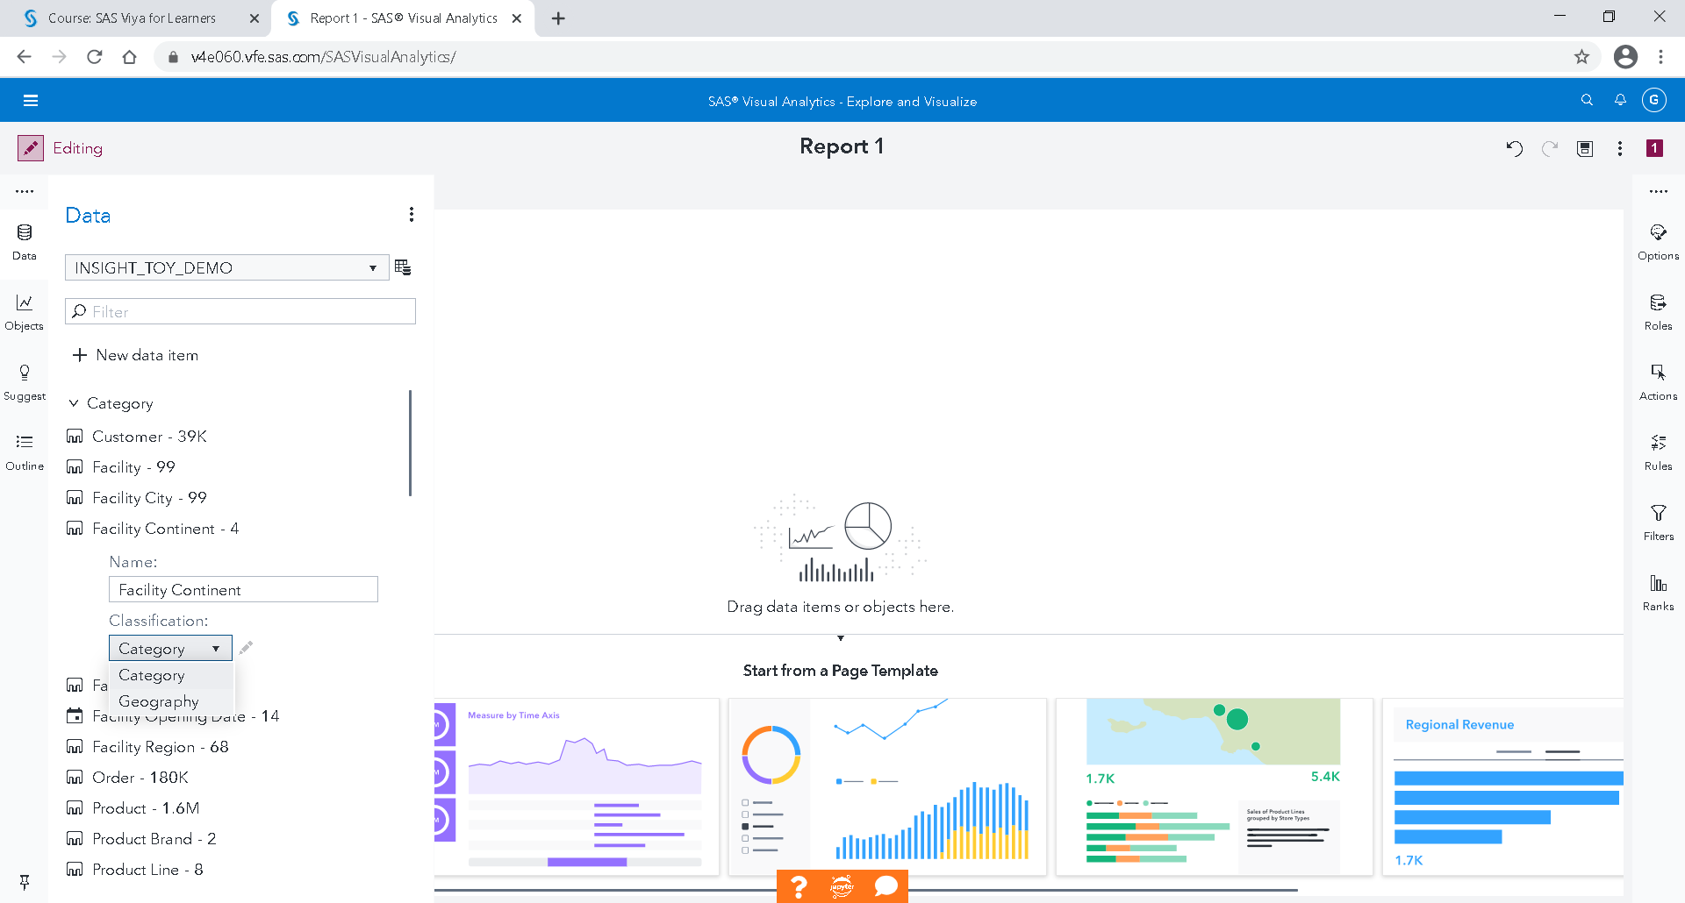

Click on the double arrow to modify the properties of "Facility Continent"

Instead of category, select Geography

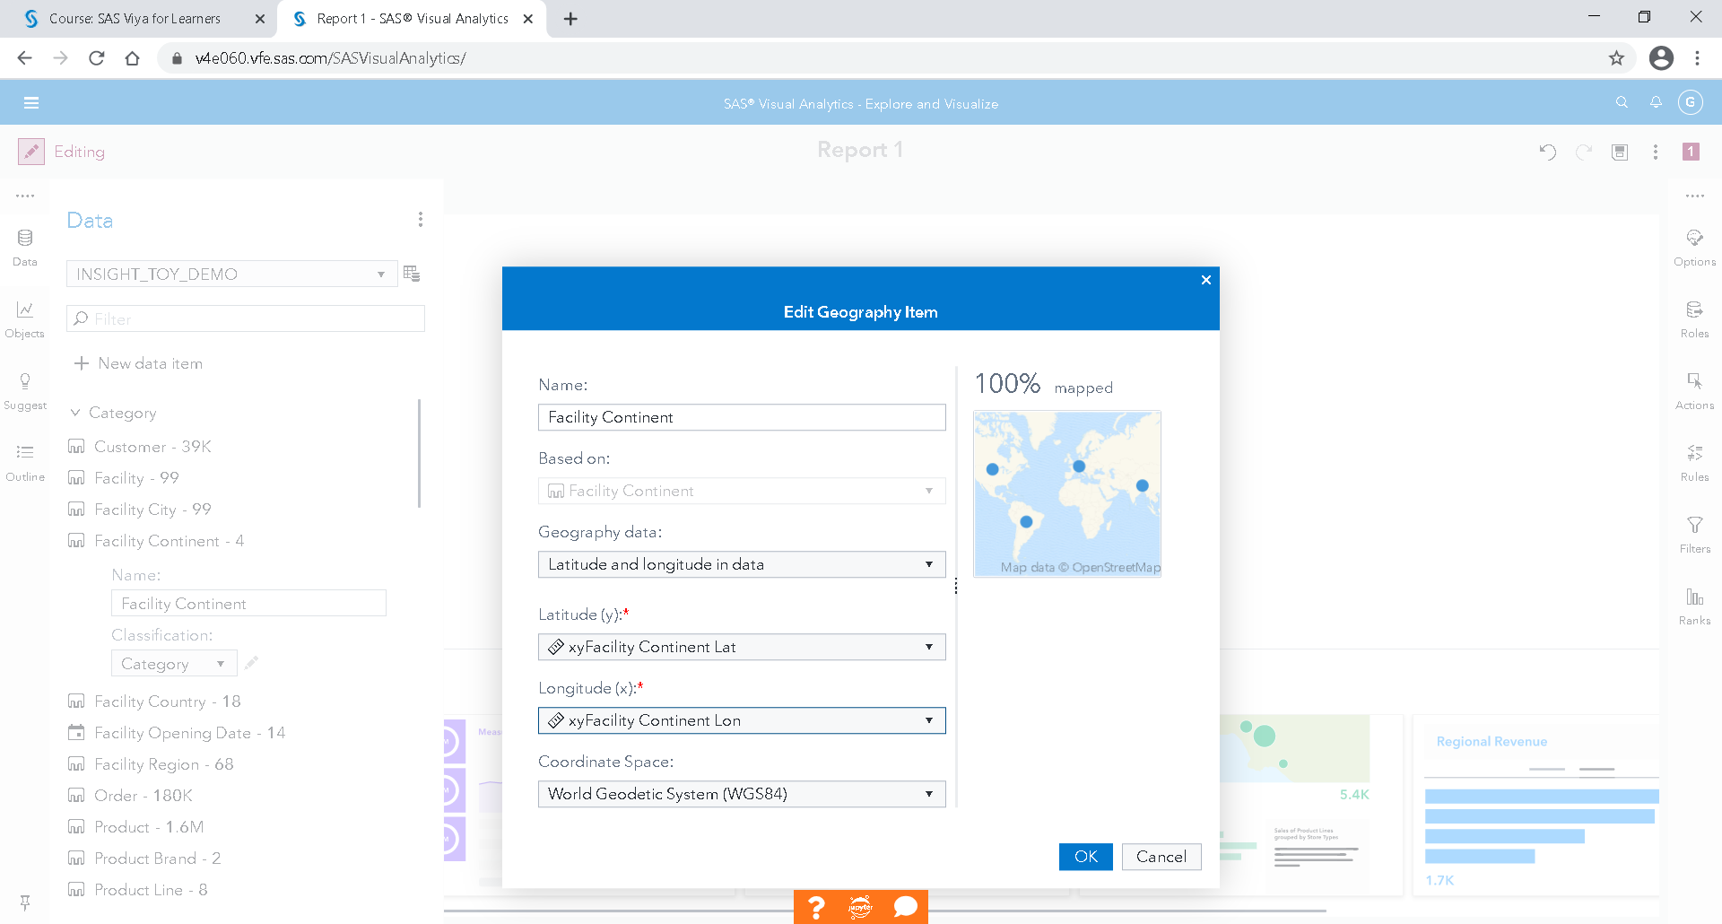

Select Latitude and longitude in data

Select "xyFacility Continent Lat" for Latitude

And select "xyFacility Continent Lon" for Longitude

OK

Repeat the same steps to Country, Region, City and Facility

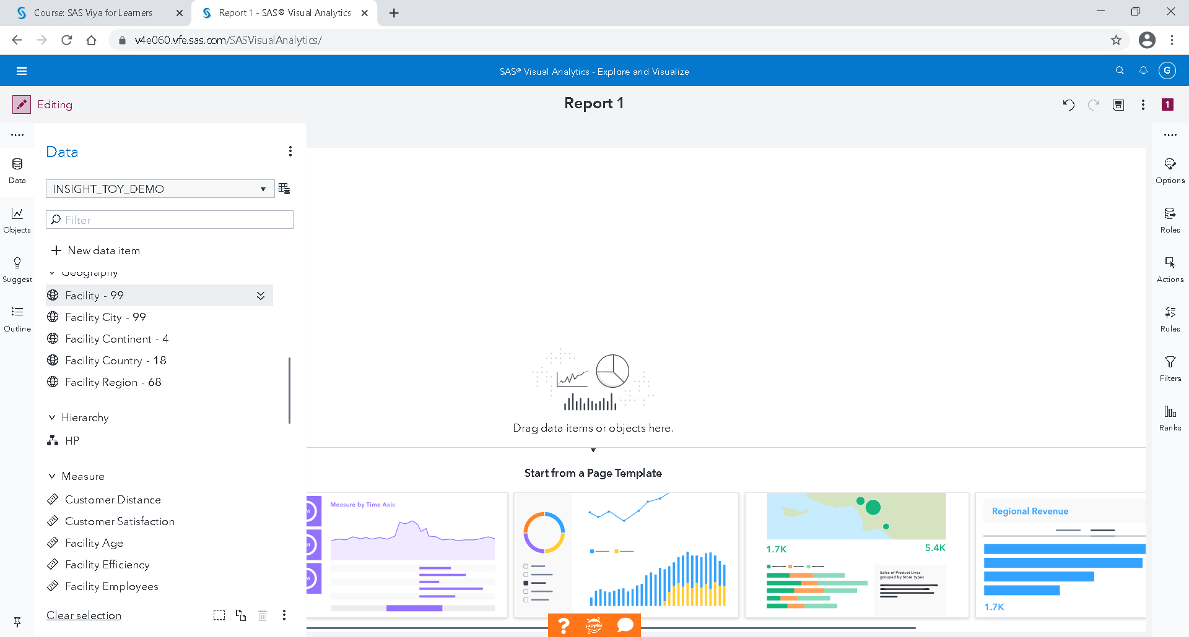

We get five geographical elements.

A hierarchy can then be created: New data item 🡪 to add a new hierarchy.

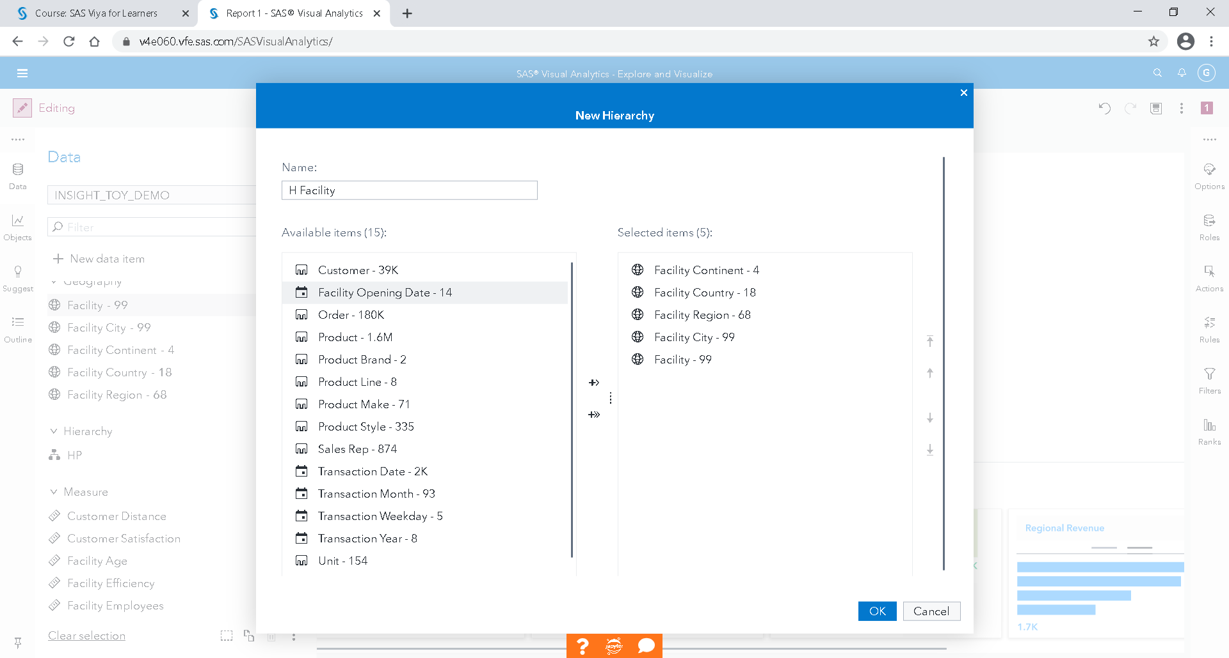

Select items in the right order: Continent, Country, Region, City and Facility.

Rename this hierarchy Geo.

OK

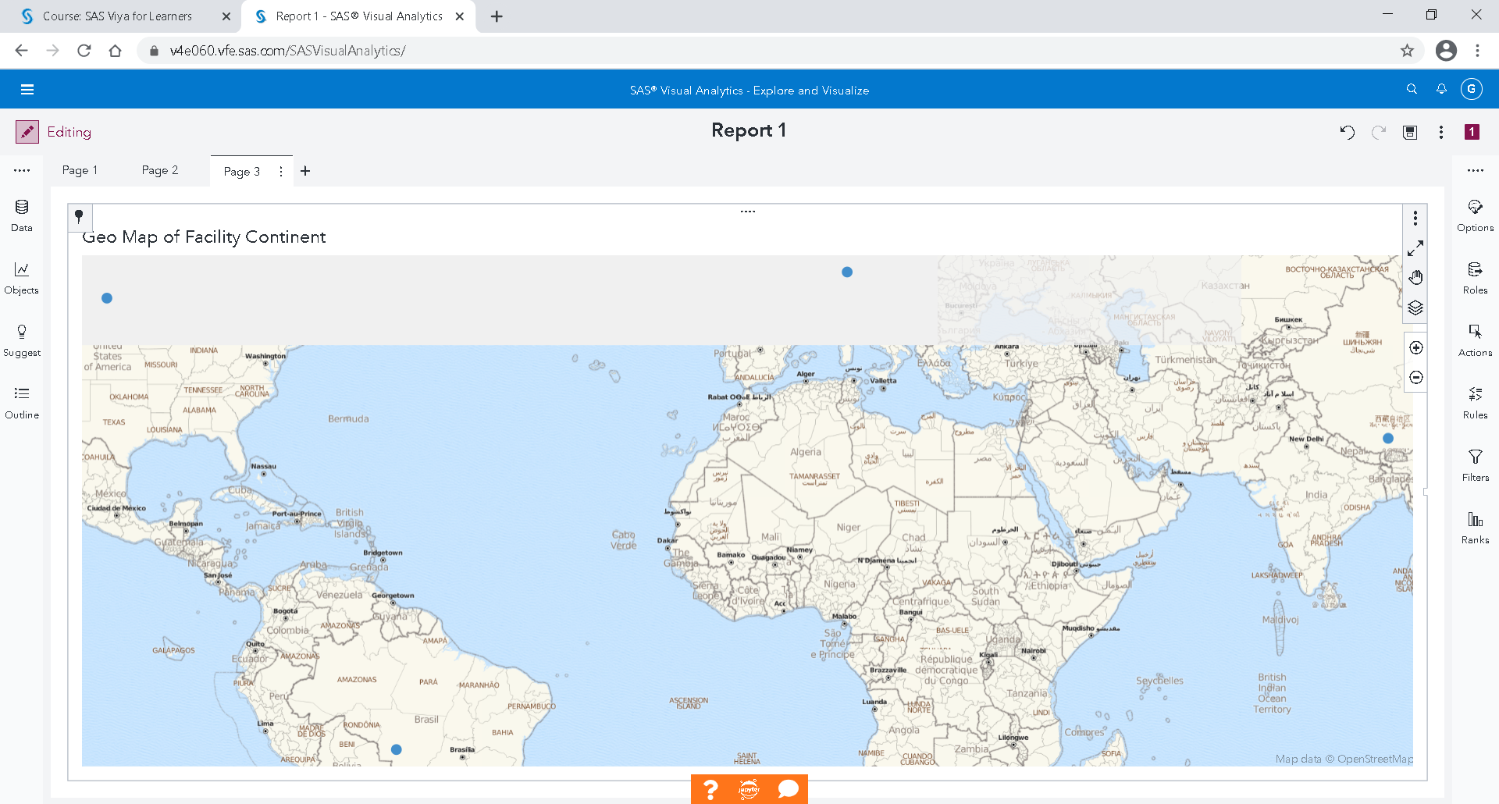

Add this hierarchy to the third page of your Report.

By double-clicking on the point of Europe, we get:

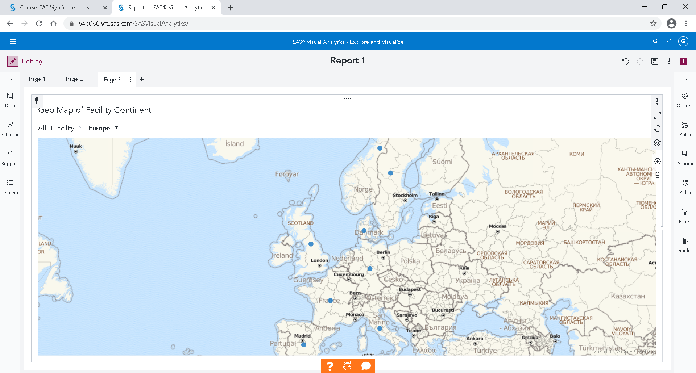

Sizes of dots are frequency. If you want the turnover, you must change it by " Product sale"

At the top left of the graph, you can go up in hierarchy.

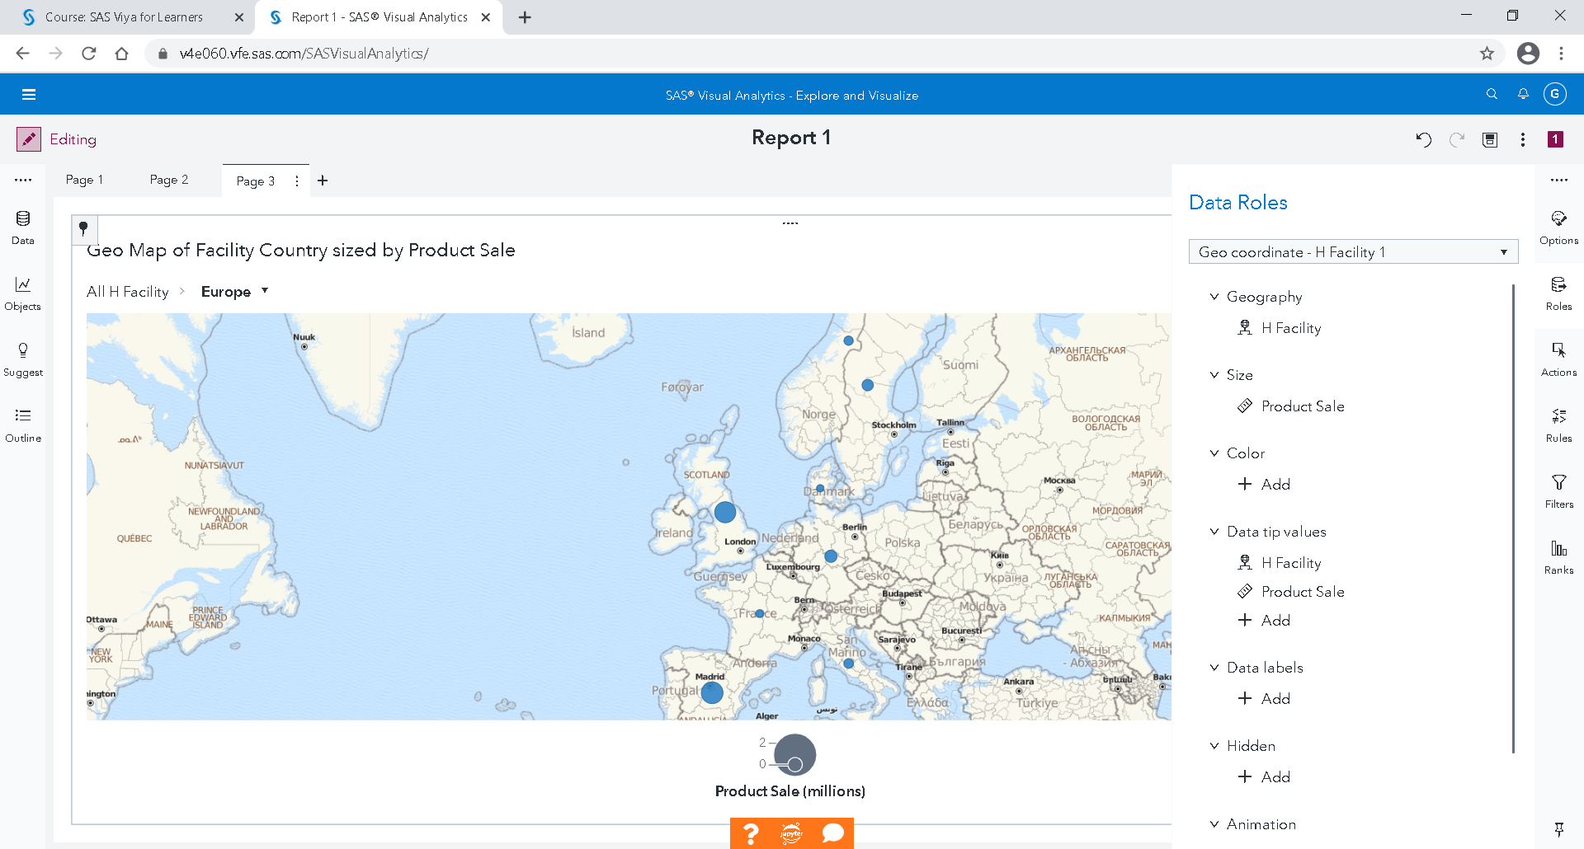

If you also add customer satisfaction, you get the following graph with the color depending on customer satisfaction.

Customer satisfaction is a percentage. The sum of a percentage does not make sense but the average yes.

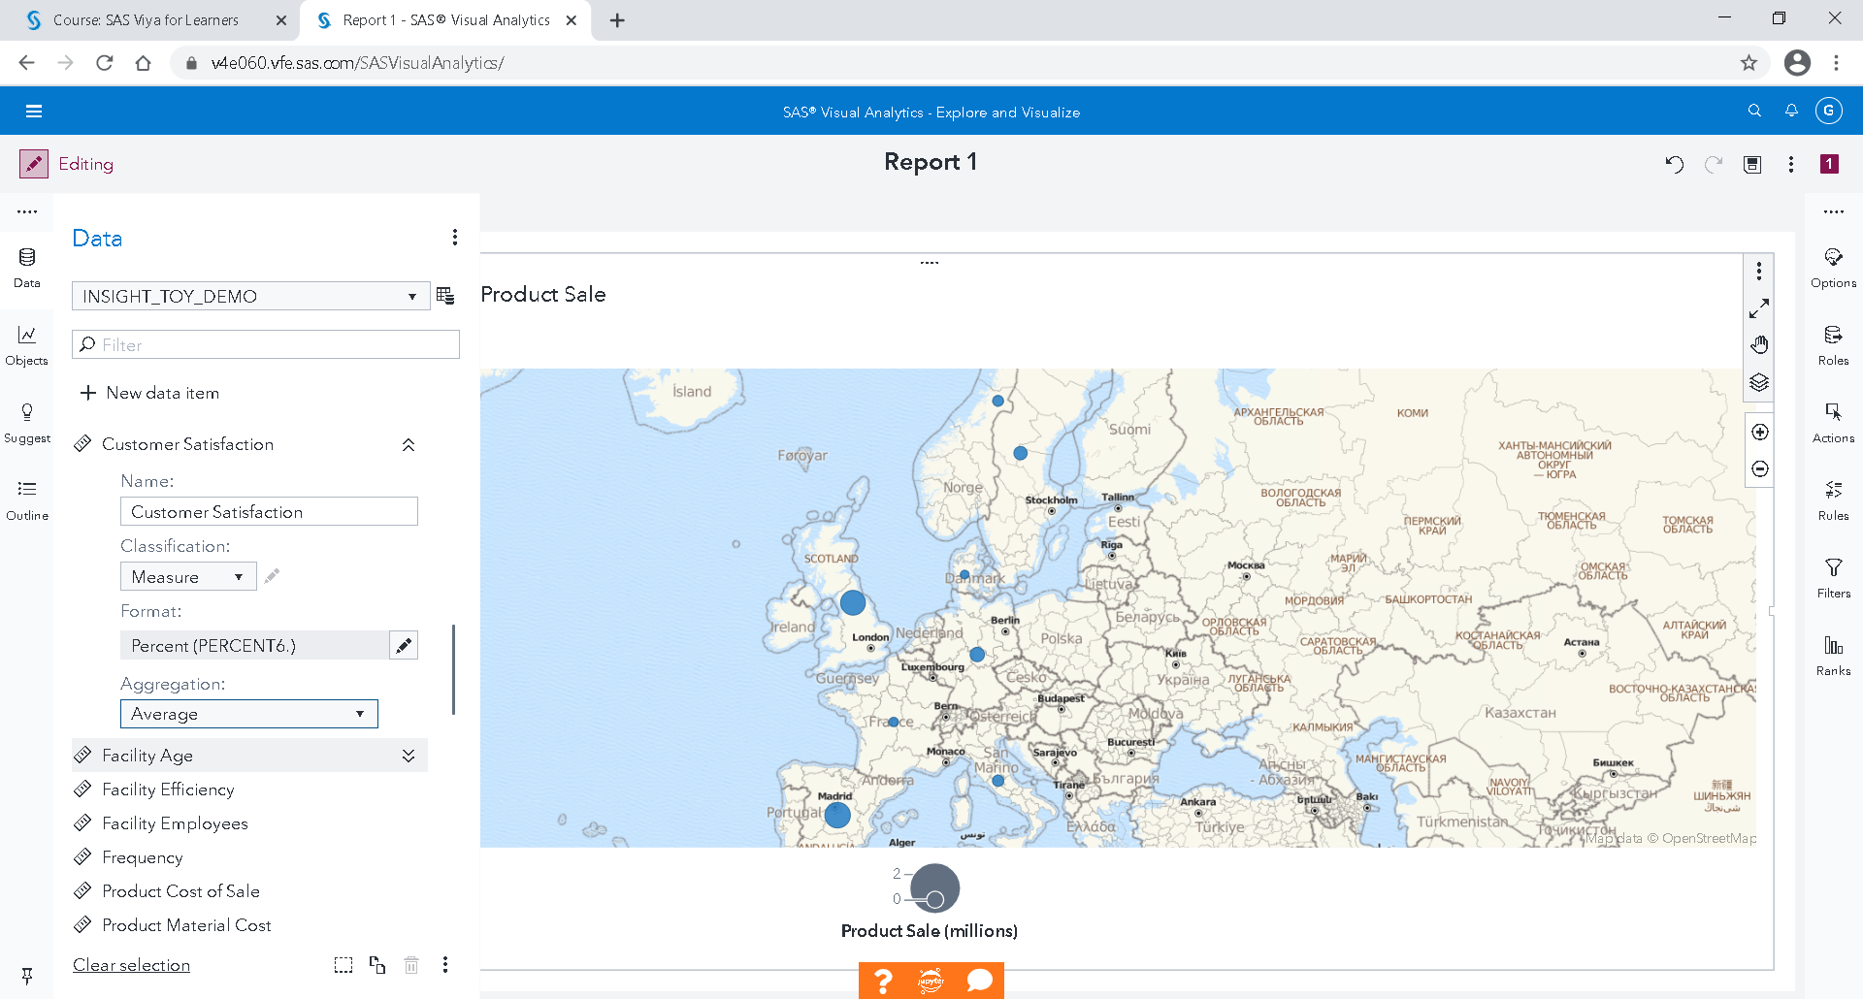

For customer satisfaction, select aggregation by average.

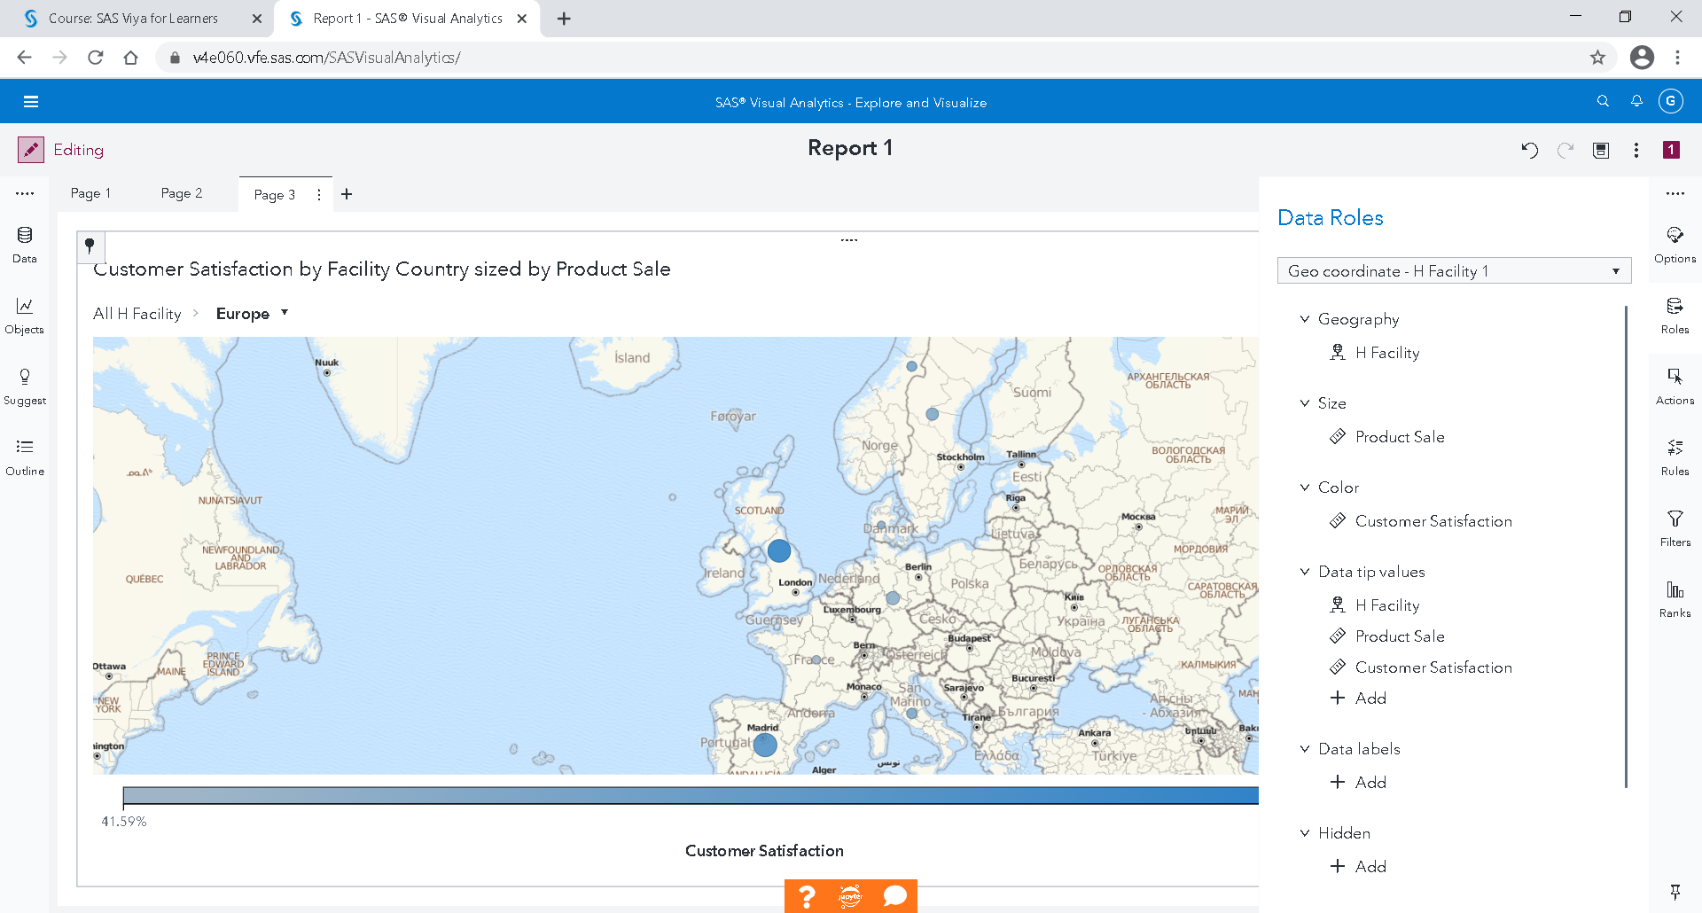

Add customer satisfaction as color points on your card.

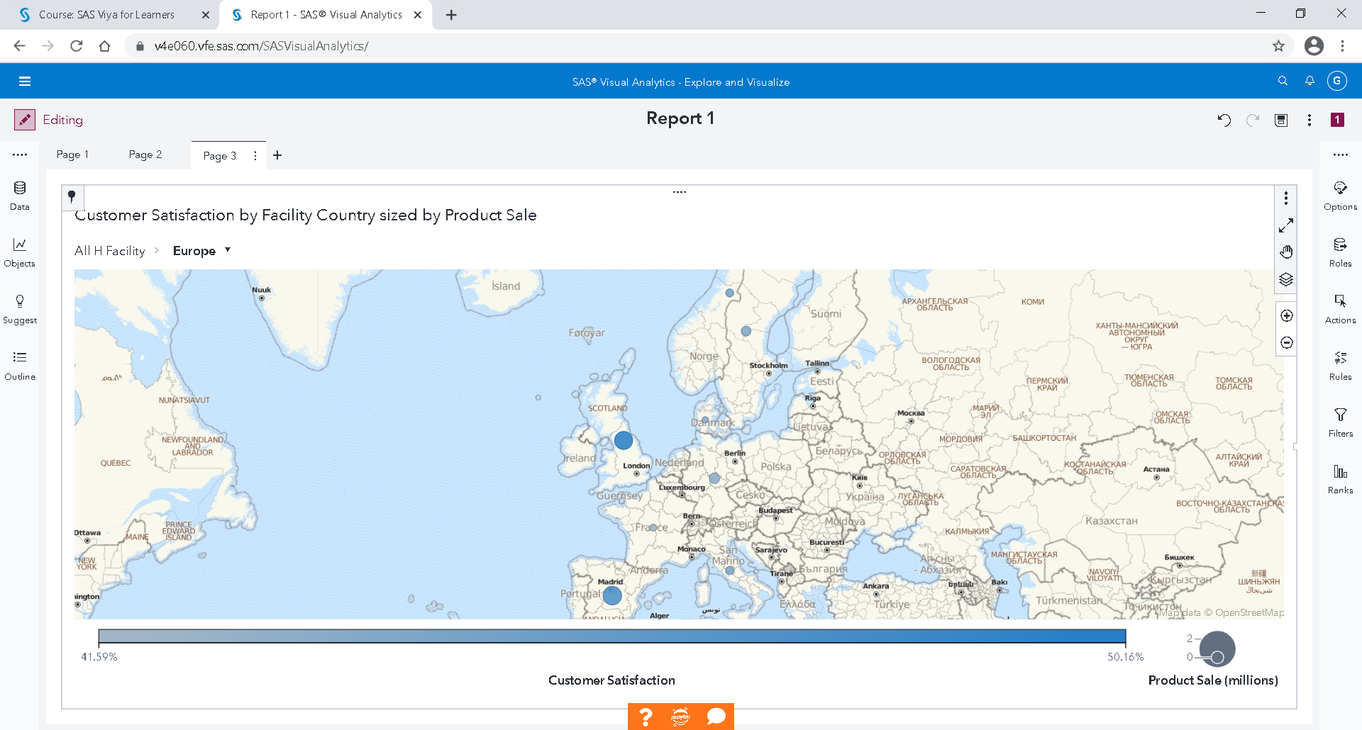

Add a fourth page to your report.

### Create dashboards

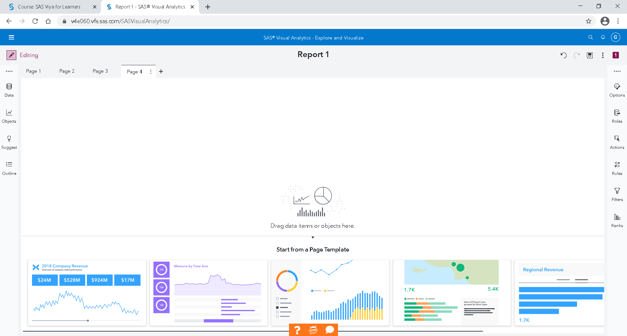

In your 4th page, from objects, select and drop then

The Bar Chart in the middle,

The Tree Map on the right,

And the Gauge at the bottom right.

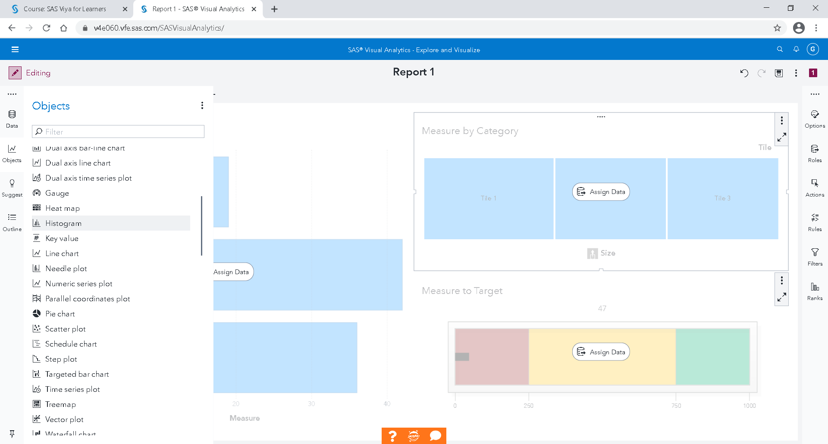

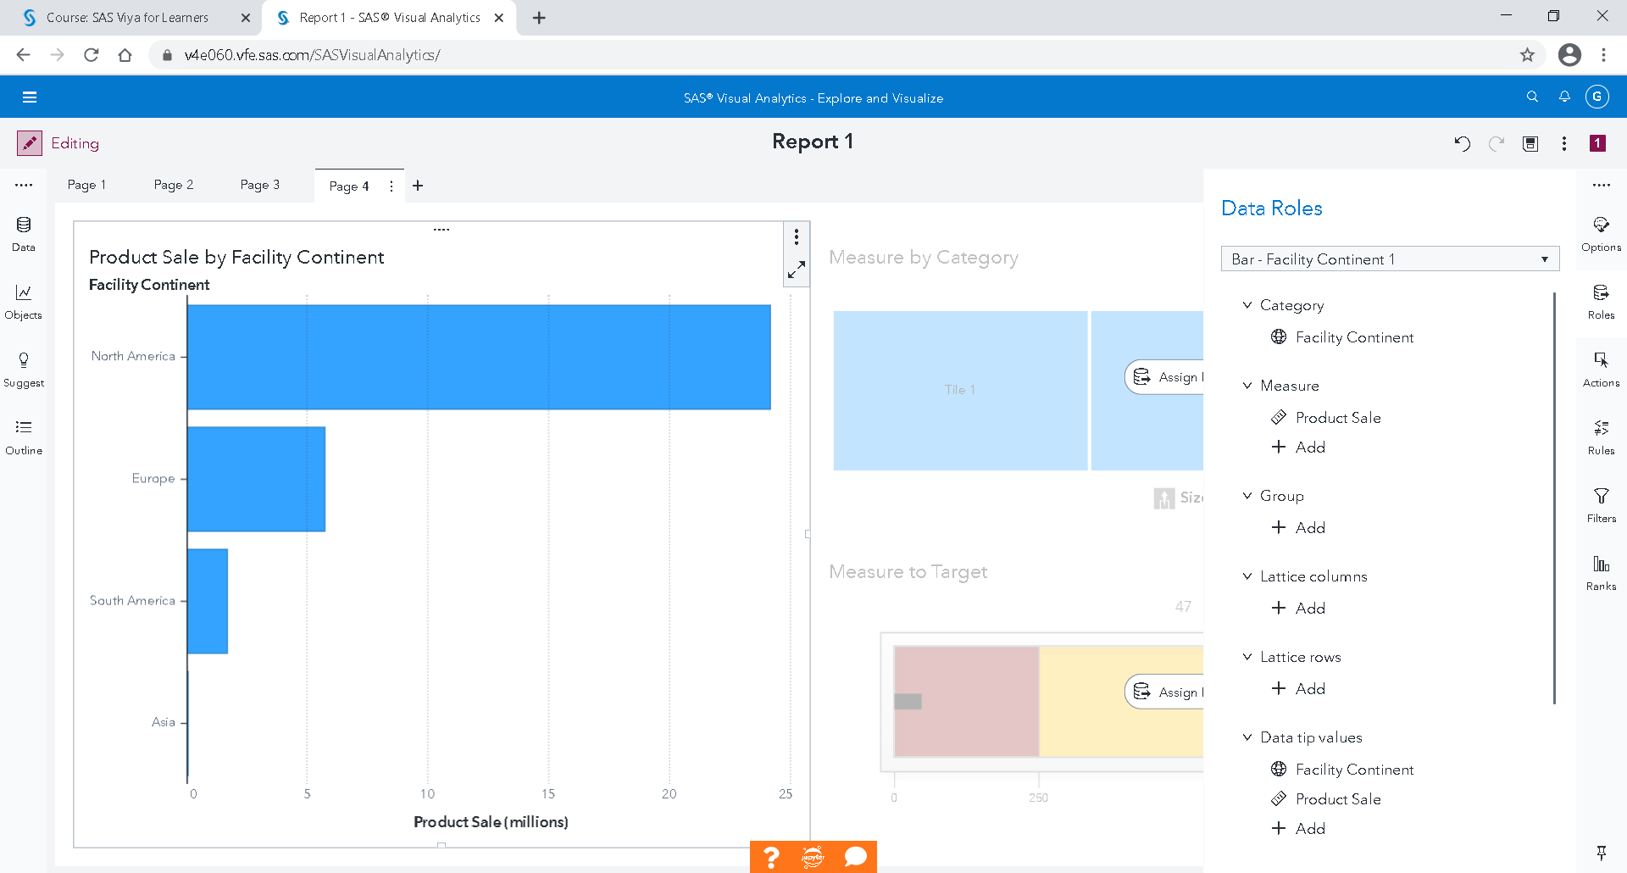

When the Bar Chart is selected, select Facility Continent as a Category and replace the Frequency by Product sale

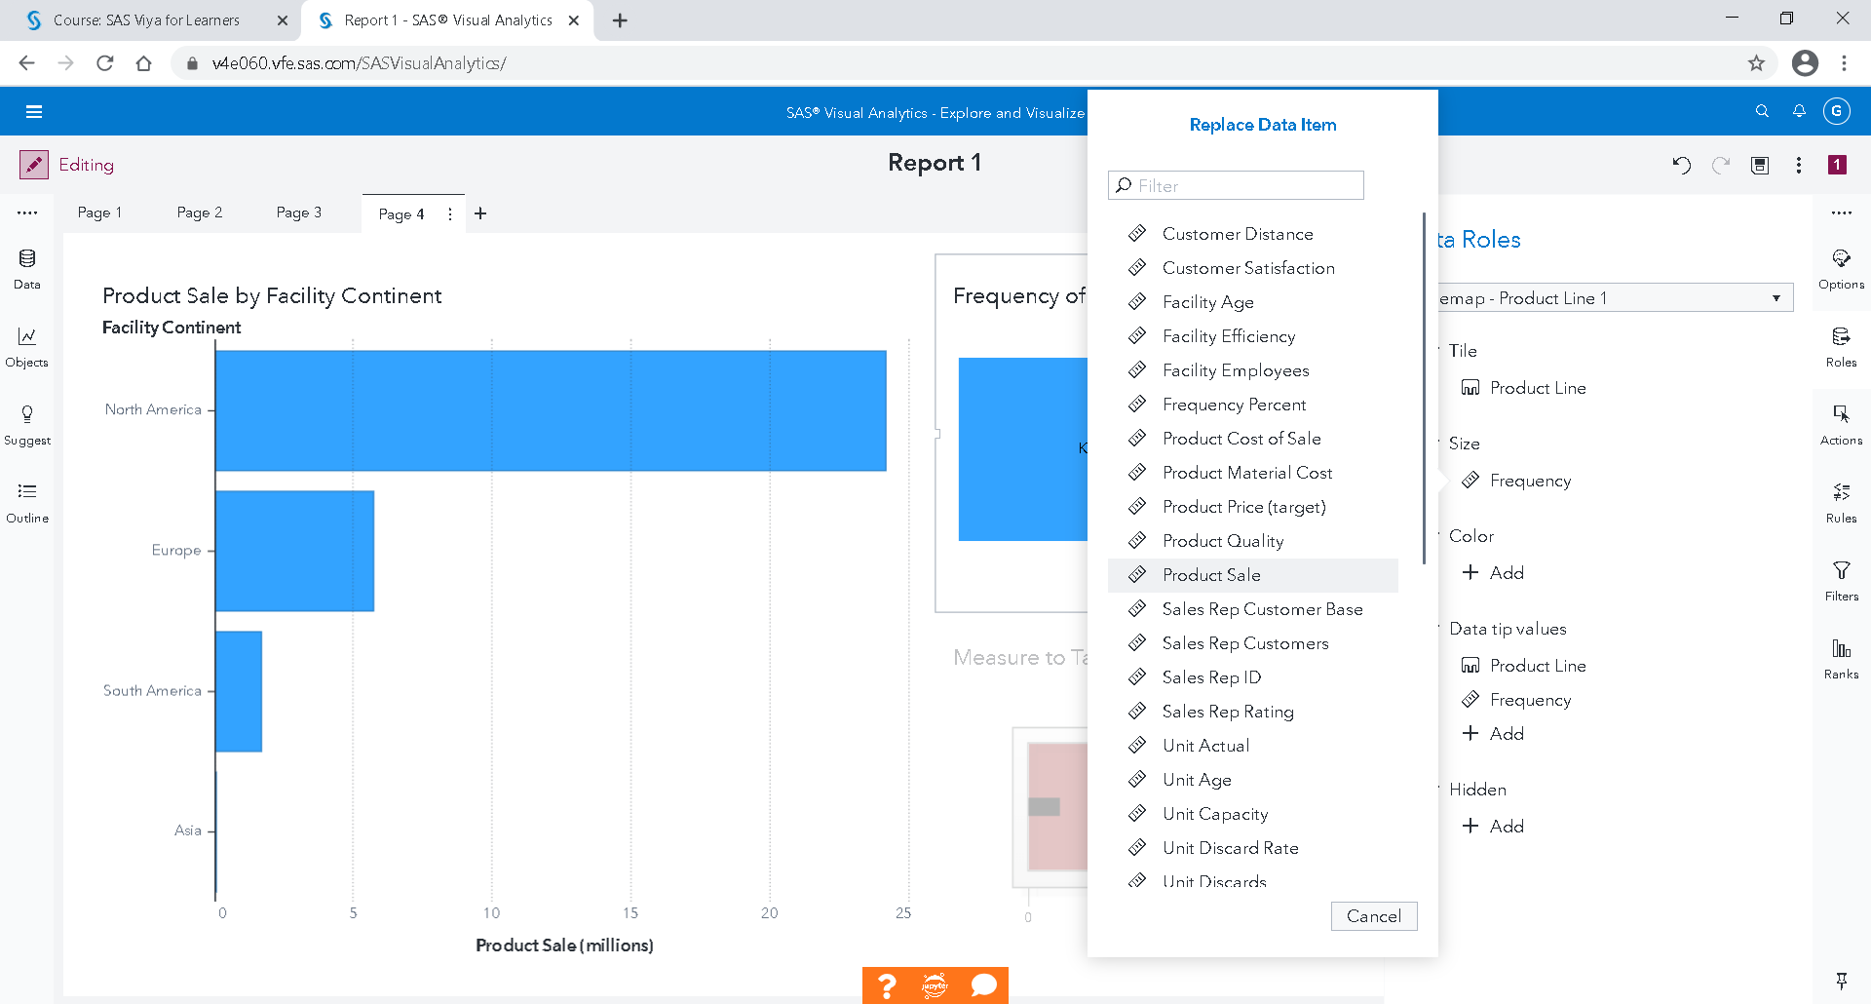

When the Tree Map is selected, select Product Line as a Category and replace the Frequency by Product sale

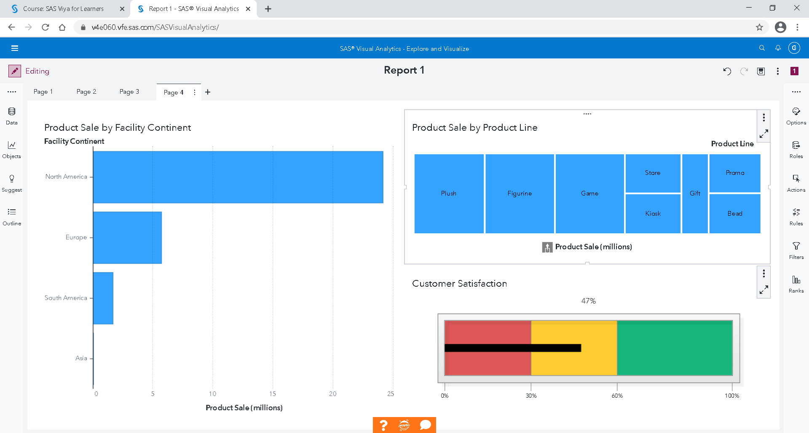

When the Gauge is selected, select Customer Satisfaction as a Measure

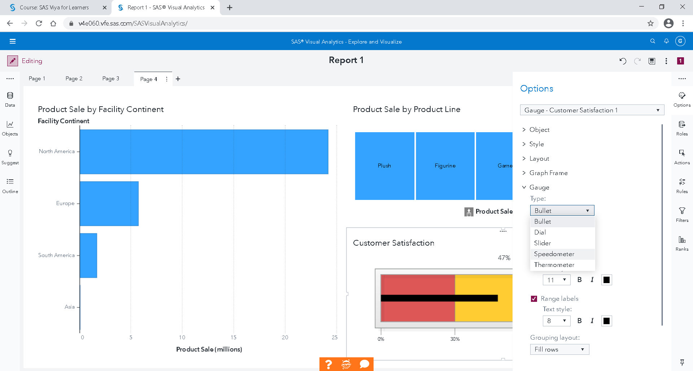

When the Gauge is selected, in the right, in Options, change the Bullet Gauge type by Speedometer

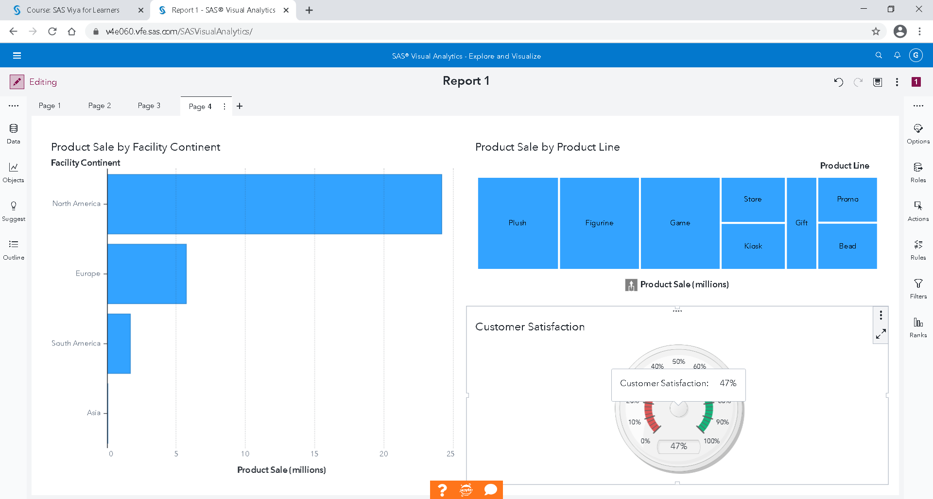

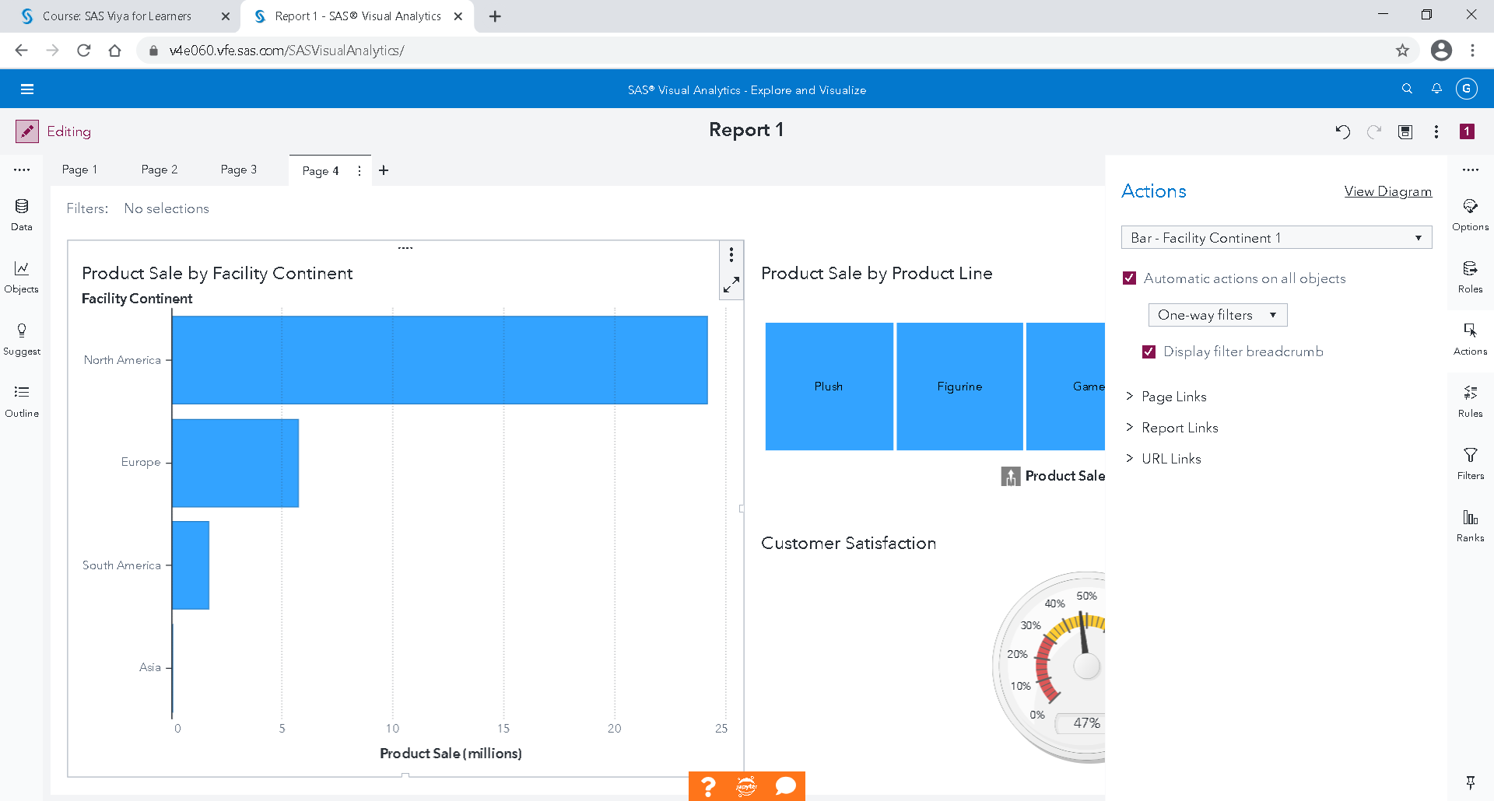

When the Bar Chart is selected, in the right, in Actions, select Automatic actions on all objects



If you click on a stick in Bar Chart, it filters elements in other two objects.

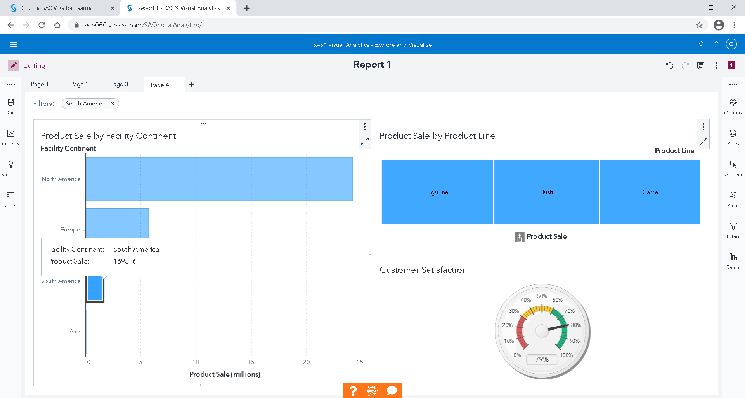

For example, in South America, customer satisfaction is excellent.

### Save your work

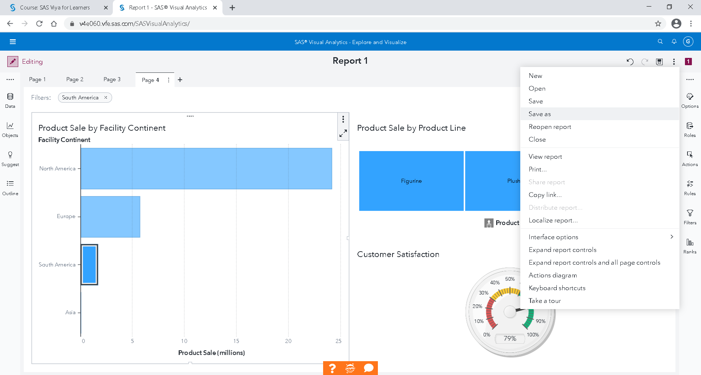

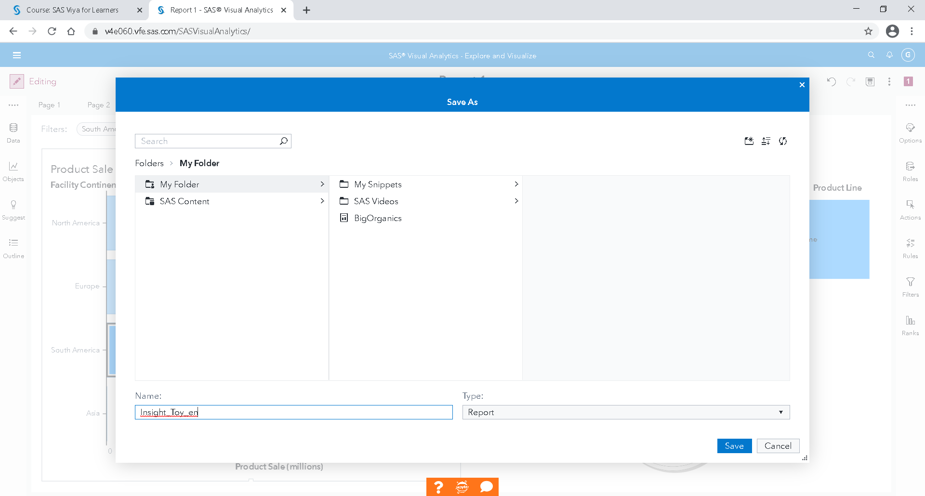

You can save it in your folder

Save

### Export in pdf your work in pdf

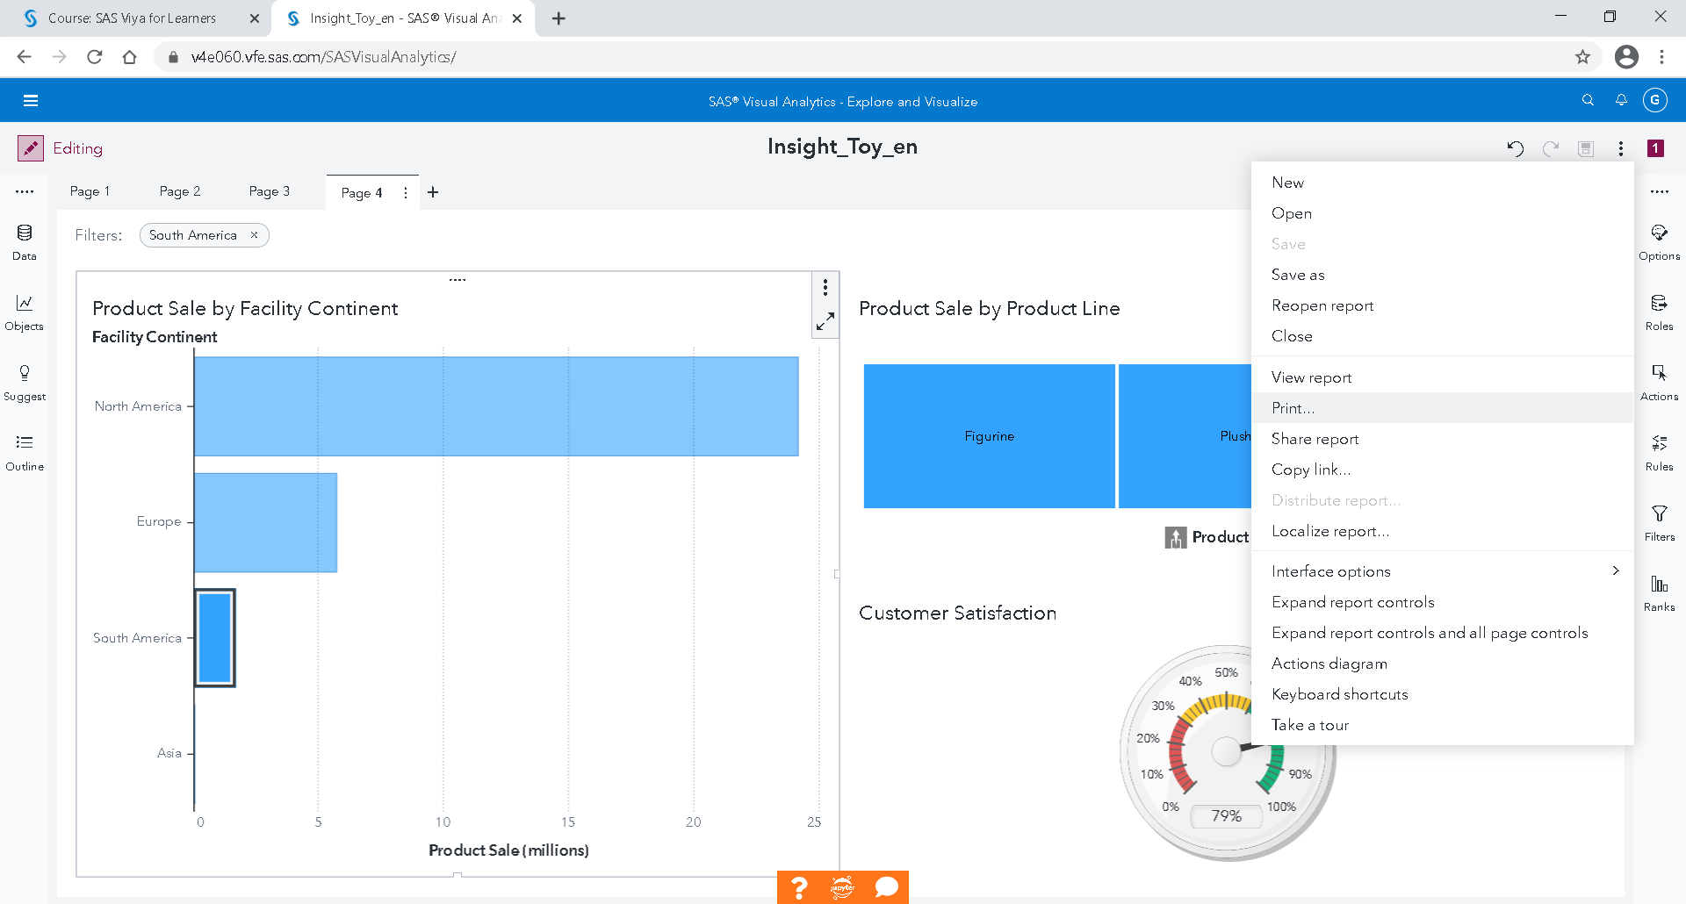

Print

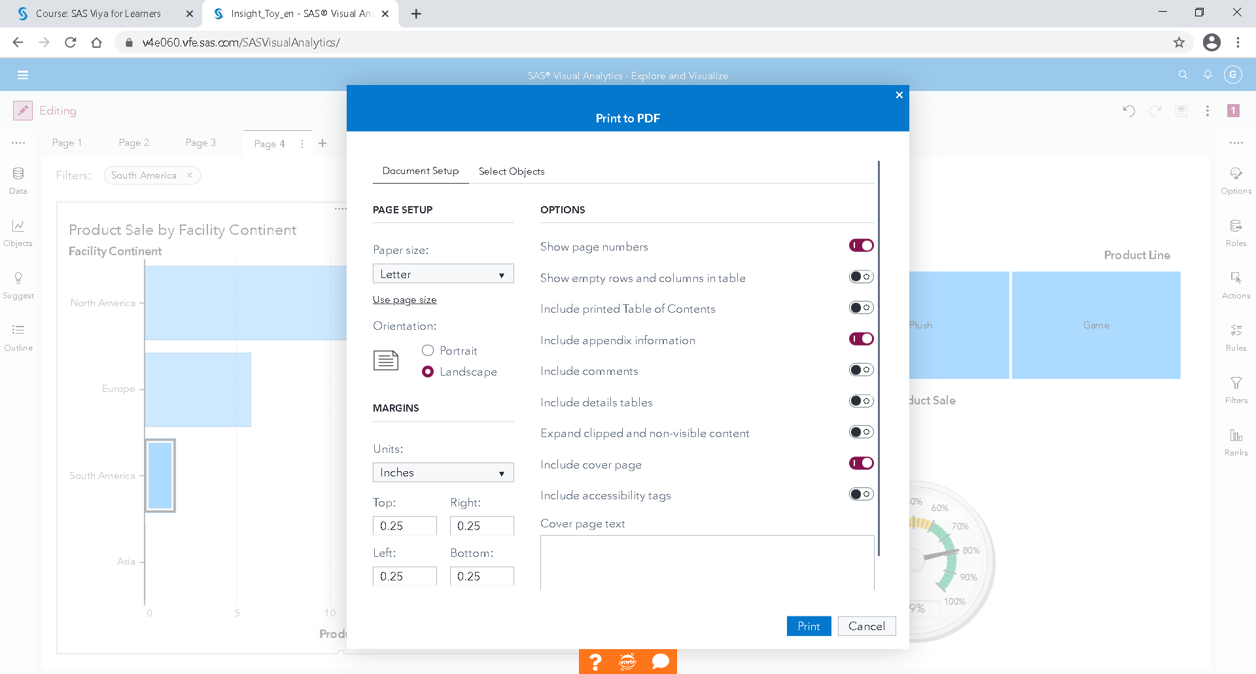

Print

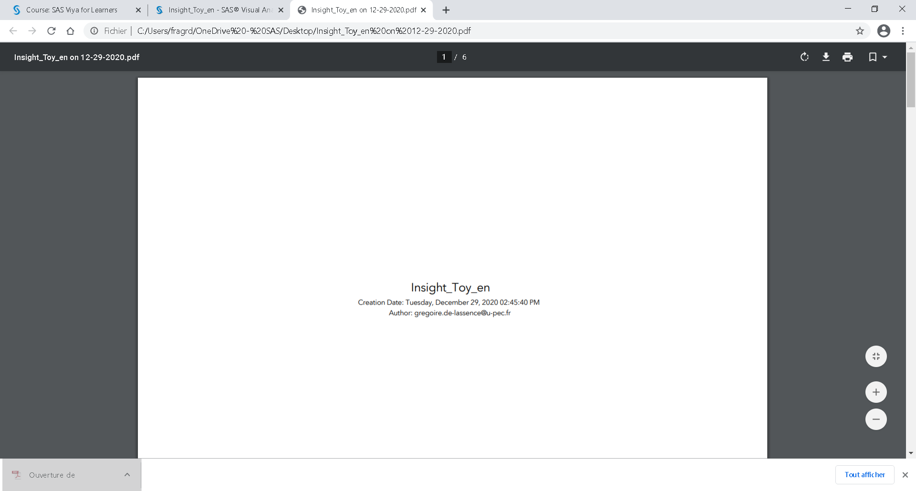

Save your pdf in your computer.

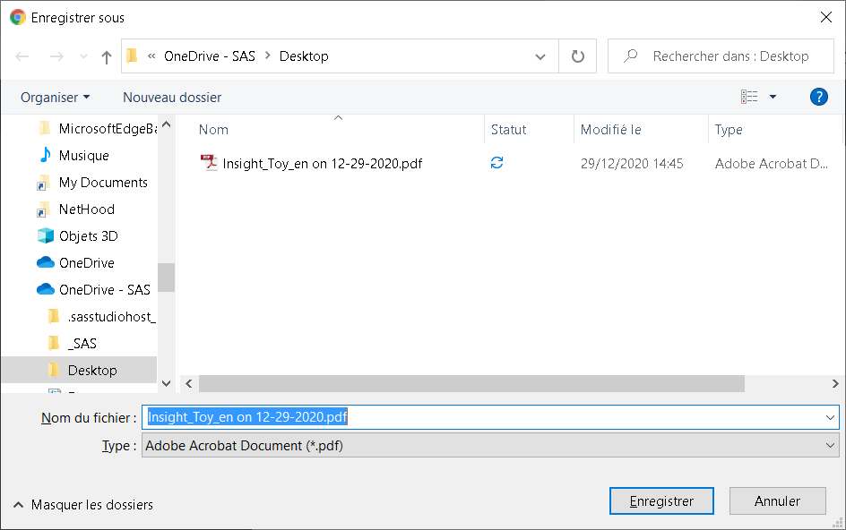

OK

Go back to SAS Visual Analytics

Create a new report

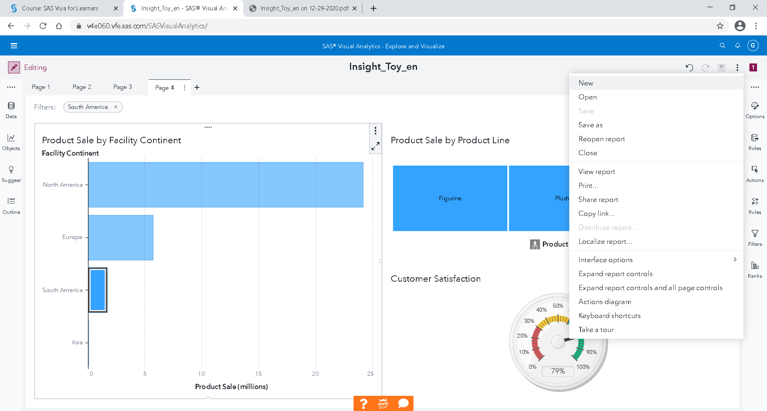

### Exercises

Create a new report on Insight toy Demo (same data base)

1)           Create an automatic chart that shows the Product Cost of Sale by Facility Continent.

2)           Create in a new page, a box plot that shows the Product Cost of Sale by Product Line.

3)           Create in a new page, an automatic chart that shows the Unit Capacity by Transaction Month.

4)           Create a tree map visualization that shows Product Sale by Facility Country.

5)           What is the product sale for each country in South America? Use at least three types of charts and suggest which one in your opinion works better in answering this question. After you created the first chart, duplicate your chart by clicking on Duplicate.

6)           In which two months of 2004 the cost of sale was lowest in Atlanta? Use just one chart to answer the question.

7)           Create a report with at least four sections (=pages).

The BI report should include key facts about company’s performance on a global and regional level. These facts should include both financial and marketing related data.

Try to decide the appropriate visualization tool depending on the data you use. How will the charts be perceived by a simple user? What questions he/she may ask?

Make use of additional tools such as global and local filters and text inputs.

Use at least six different charts from both Graphs and Tables objects, two from Gauges, two from Controls and two from Others.

Print your report: it will create a pdf. Save the pdf and send it by mail to our professor.

## Machine Learning with Visual Analytics Hands-On

### Big Organics

#### Description:

A supermarket has a customer loyalty program and is offering a new line of organic products. As an initial buyer incentive plan, the supermarket provided coupons for the organic products to all of the loyalty program participants and collected data that include whether these customers have purchased any of the organic products. The supermarket’s management wants to determine which customers are likely to purchase these organic products.

### Data

The Organics data set contains 13 variables and 111 115 observations.

|  |  |  |  |
| --- | --- | --- | --- |
| **Name** | **Type** | **Class** | **Description** |
| Affluence Grade | Numeric | Measure | Affluence Grade is a grade measured on a scale from 1 to 34 |
| Age | Numeric | Measure | Age is the age in years |
| Customer Loyalty ID | Character | Category | Customer Loyalty Identification number |
| Gender | Character | Category | Customer gender (M = male, F = female, U = unknown) |
| Geographic Region | Character | Category | Geographic Region (5 regions in UK: South East, South West, Midlands, North, Scottish) |
| Loyalty Card Tenure | Numeric | Measure | Loyalty Card Tenure is the time as a loyalty card member (in months: 0-39) |
| Loyalty Status | Character | Category | Status of the loyalty card (Tin, Silver, Gold, Platinum) |
| Organics Purchase Count | Numeric | Measure | TARGET (discrete) - Number of Organic Products Purchased |
| Organics Purchase Indicator | Numeric | Measure | TARGET (binary) - Organic Products Purchased? (1 = yes, 0 = no) |
| Television Region | Character | Category | Regional TV broadcasting |
| Total Spend | Numeric | Measure | Total amount spent (previously) |

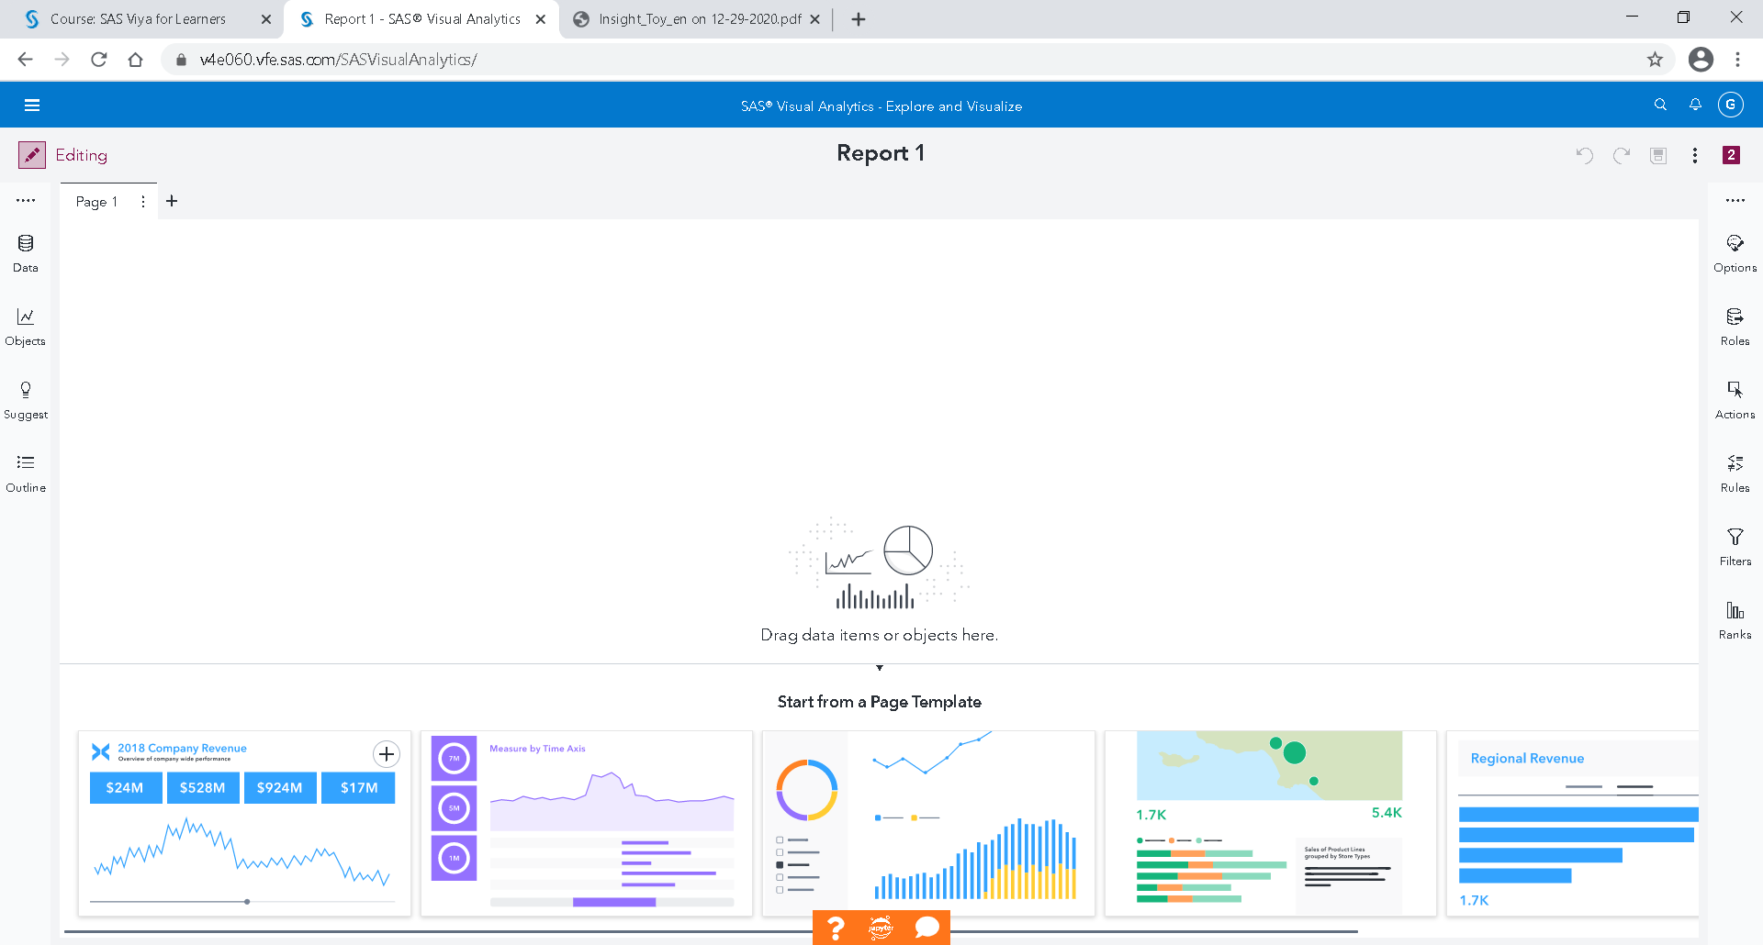

Once in the SAS Viya for Learners - Drive, on the three small lines at the top left, select "Explore and Visualize Data"

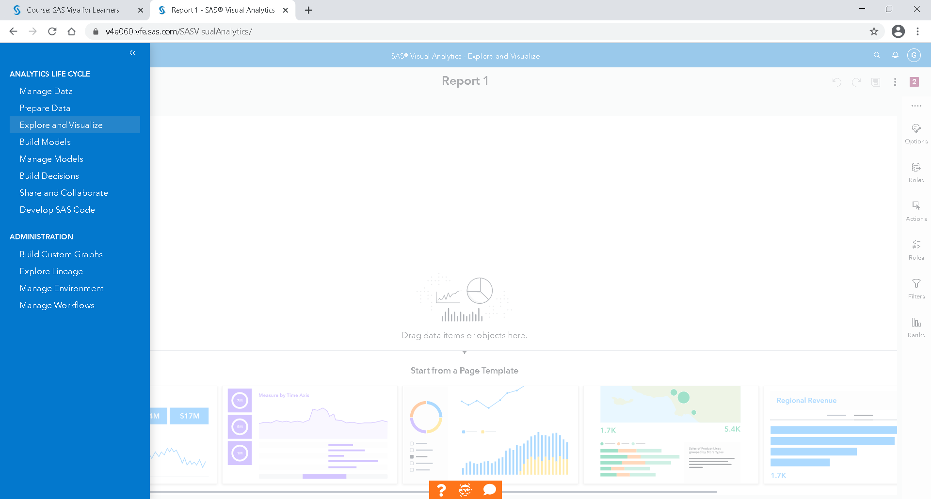

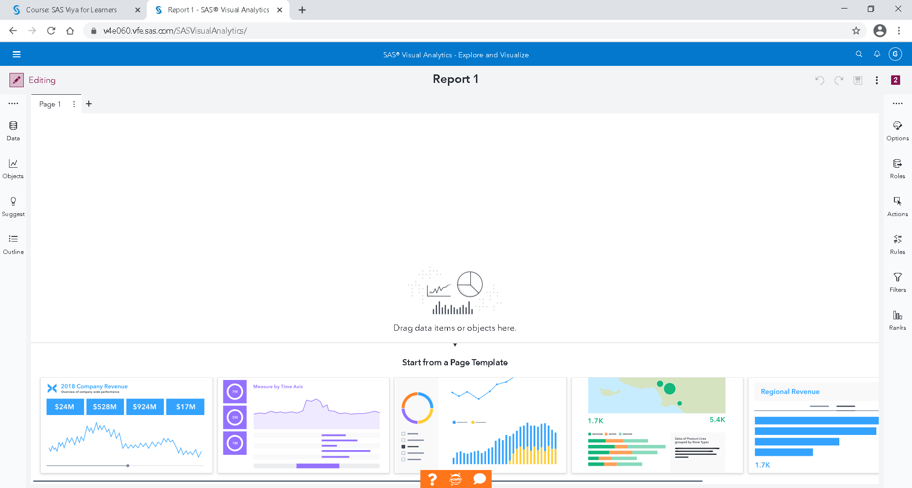

Choose a data source

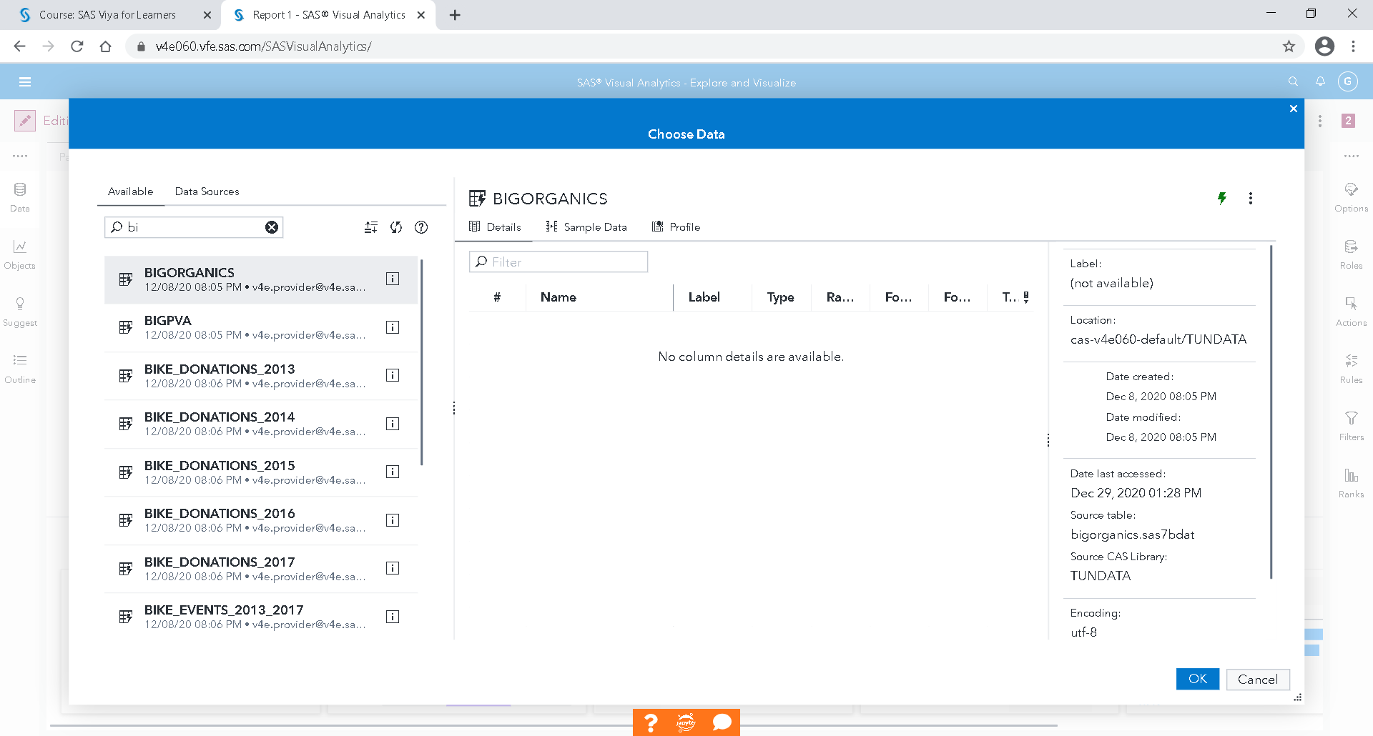

Open Organics data

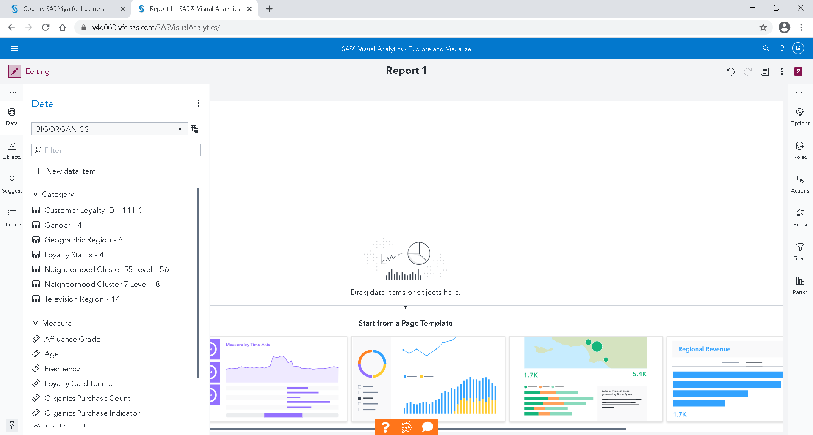

The left pane enables you to work with data, add objects, and use the report outline to organize your content.

The right pane enables you to work with details about the report, its pages, and its objects.

To start with, let’s check the distribution of Organics Purchase Indicator, but before drop the data item into your Visualization window, you must change the level Measure to Category just with 3 clicks on it.

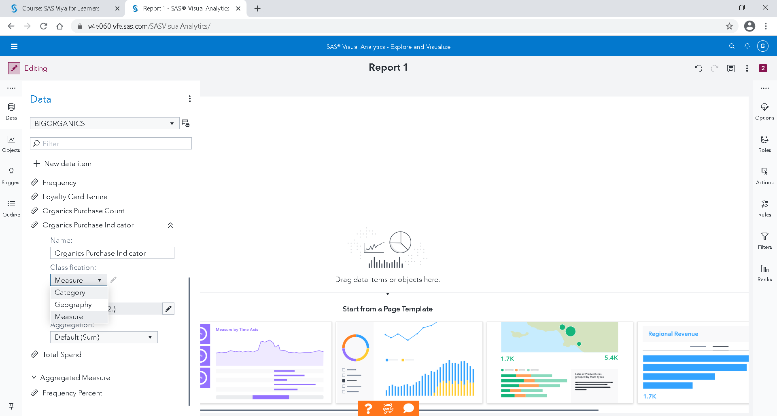

**3**

**2**

**1**

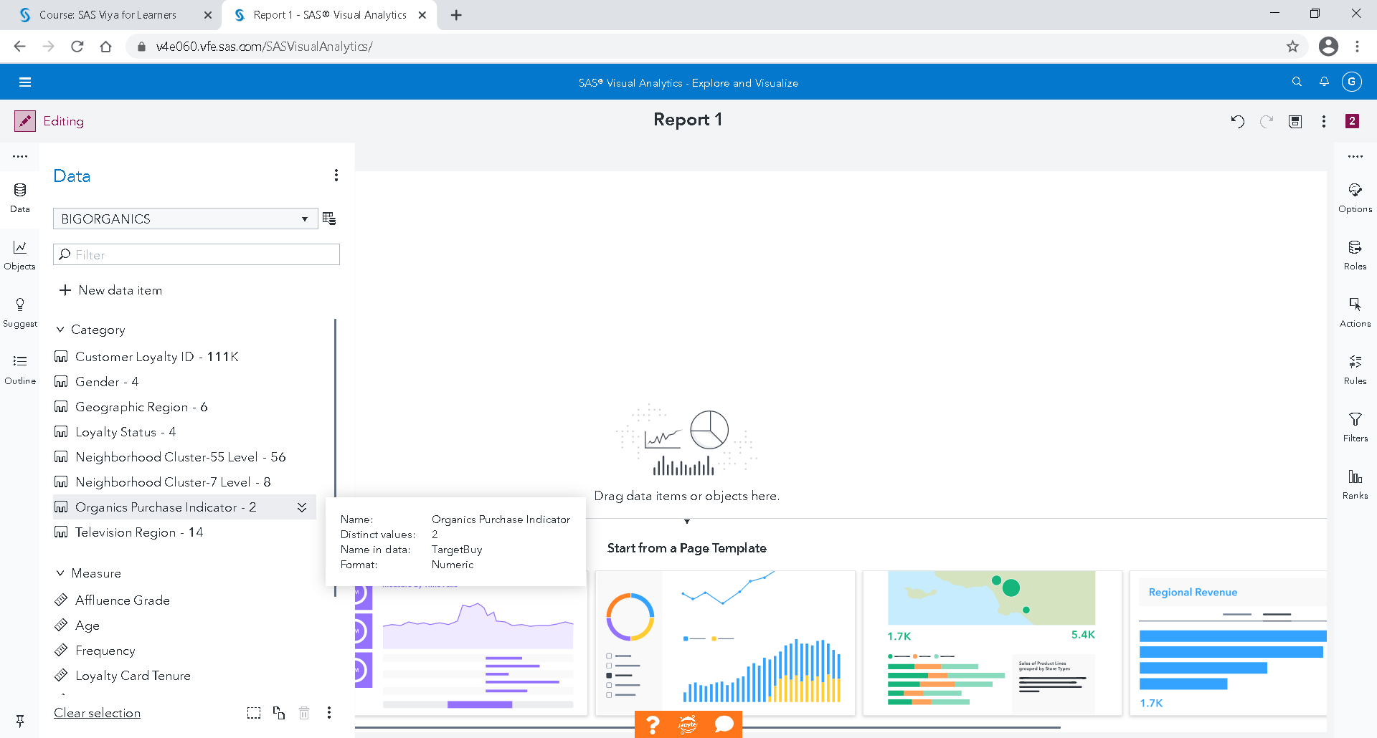

Drop the data item into your Visualization window

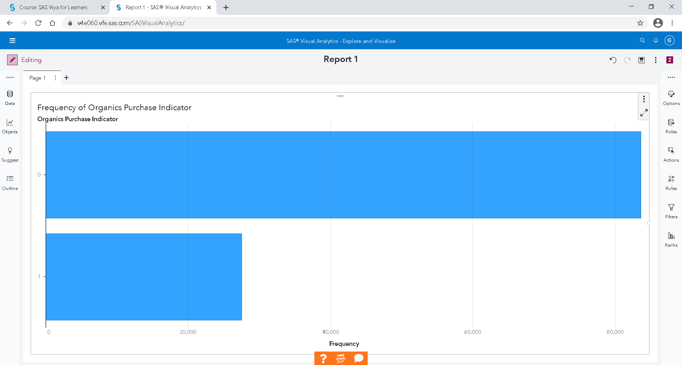

Check the distribution of Customers Gender, just drop the data item Gender into your Visualization window.

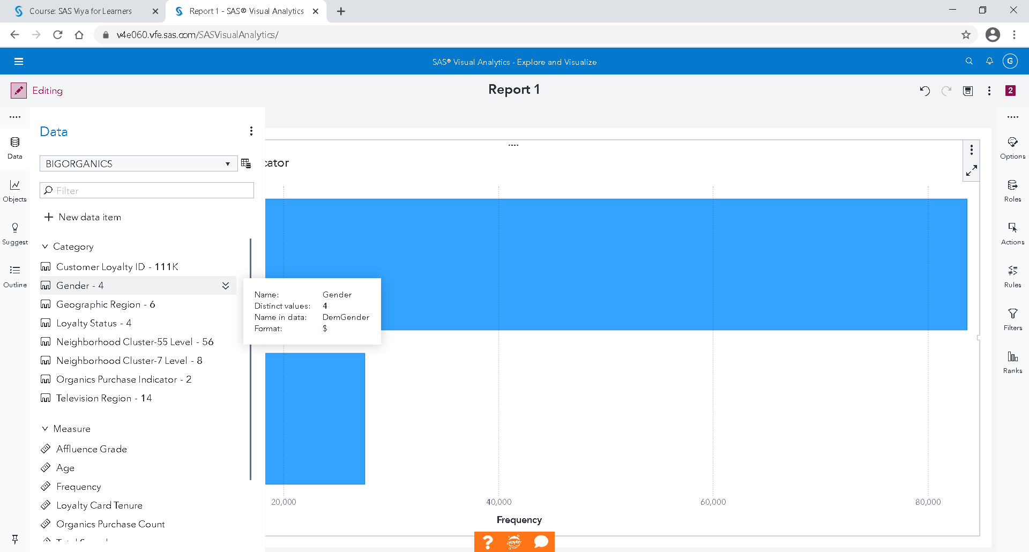

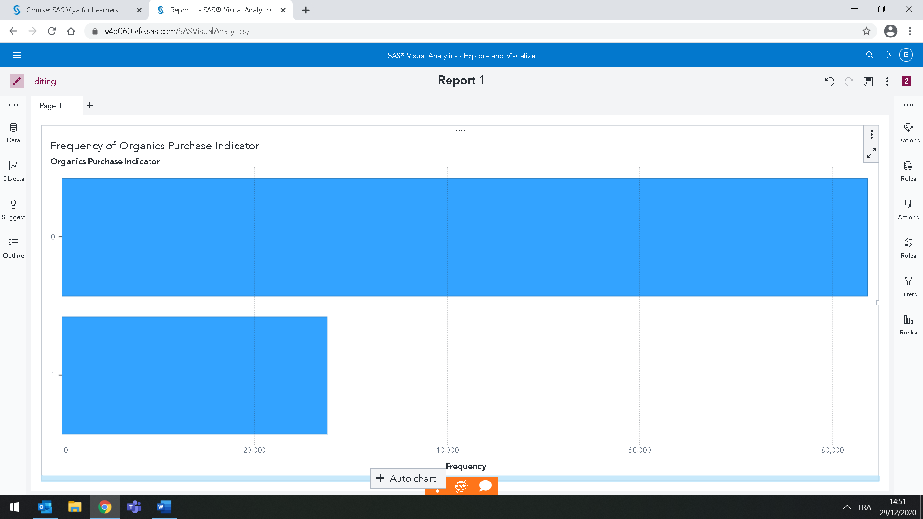

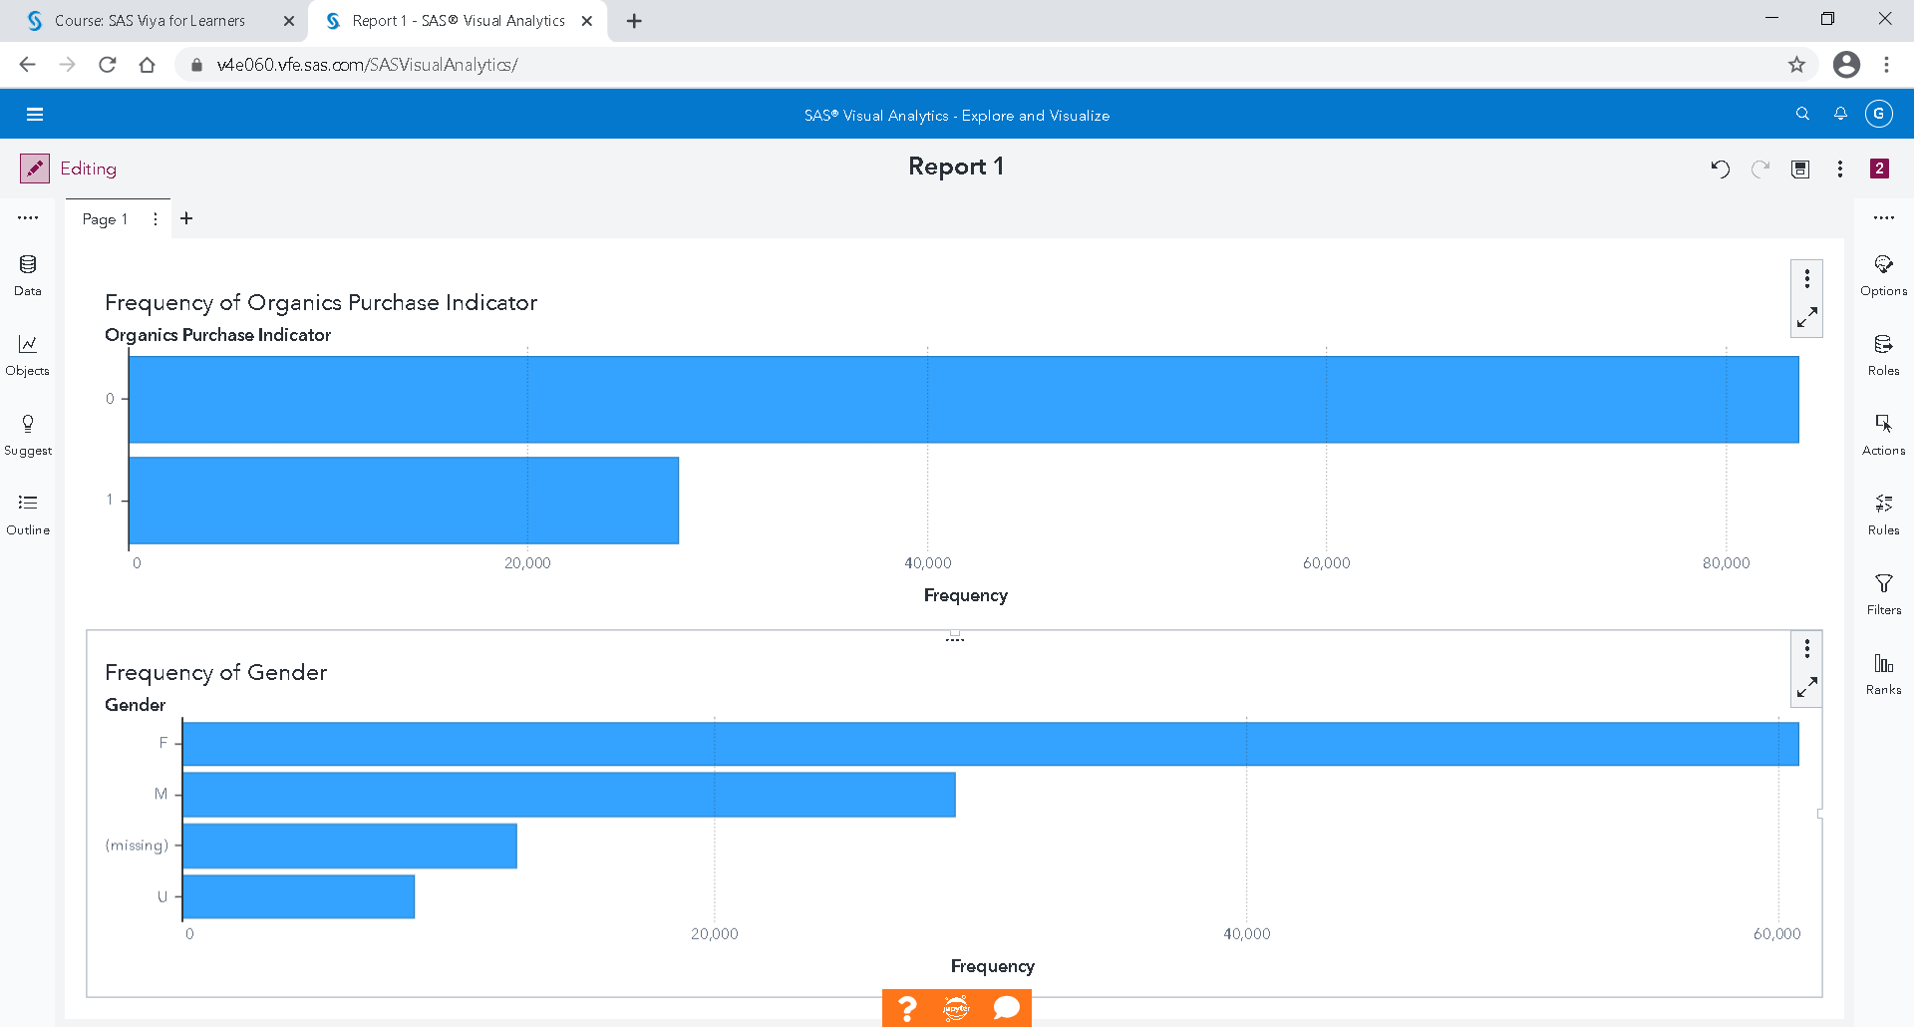

Save frequently your report

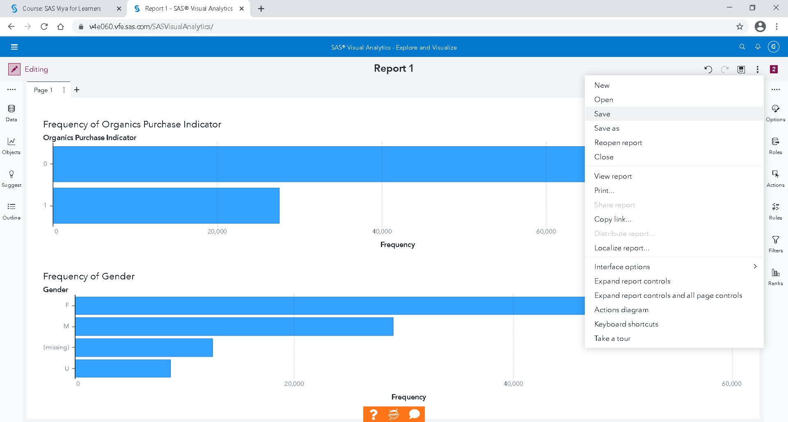

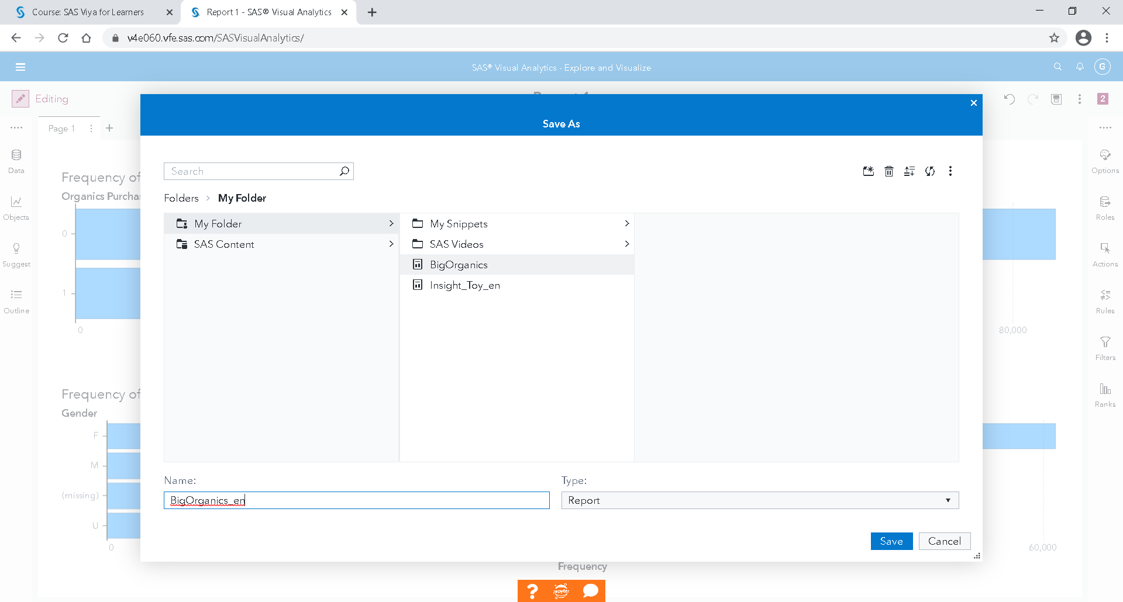

Save in your folder

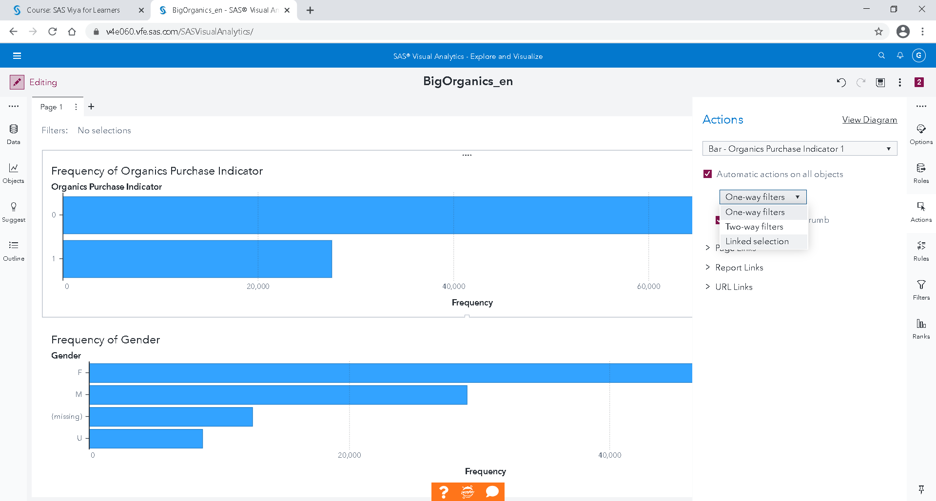

Select one graph, go to Actions on the right, select Automatic actions on all objects and Linked selection.

If you click on female in the gender graph, you can see that in proportion, female by more organic’s products.

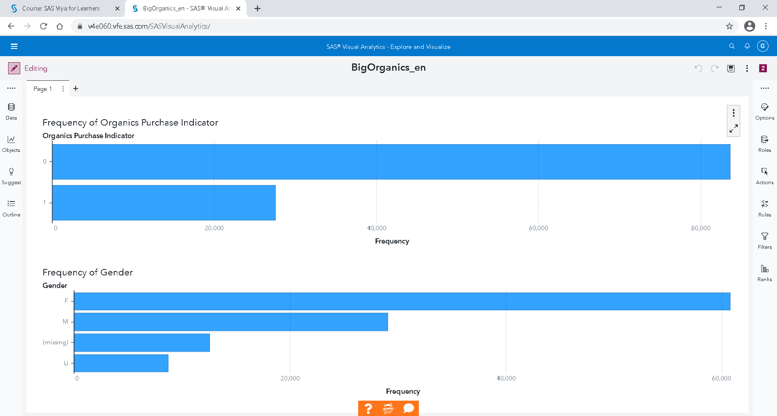

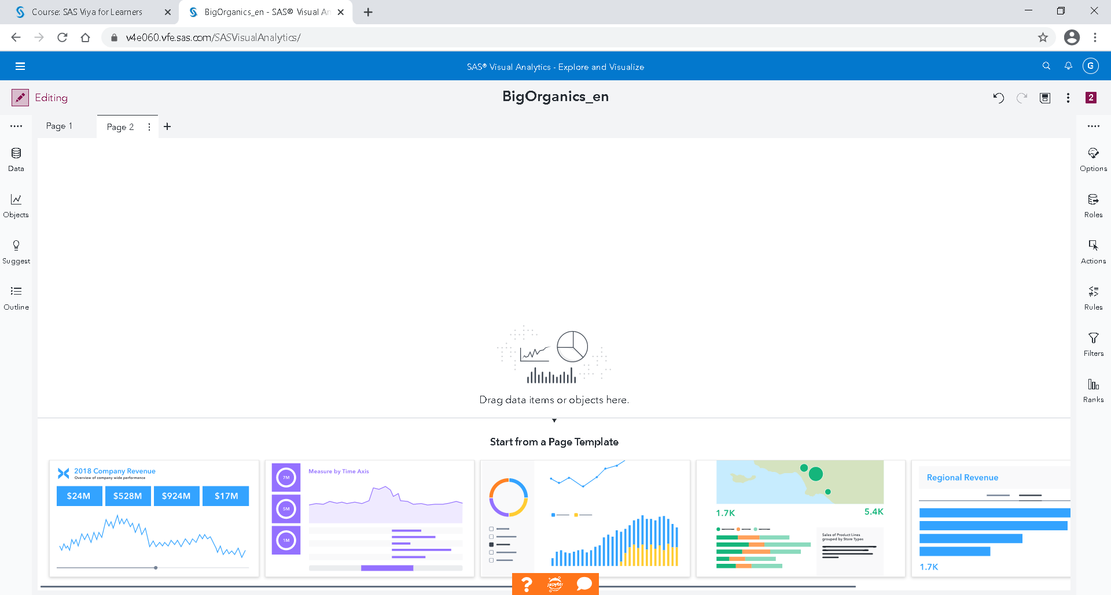

You can create a new page

## Decision Trees

A decision tree creates a segmentation of the data based on a series of rules. Each rule assigns an observation to a node based on the value of one predictor. Rules are applied sequentially, which results in a hierarchy called a tree. The initial node contains the entire data set and is called the root node. A node and all of its successors form a branch. The final nodes are called leaves. For each leaf, a decision is made about the response variable.

A decision tree is a supervised Predictive Model, in the sense that it requires one Target variable and at least one predictor. The Target can be a category variable (Classification Tree) or a measure variable (Regression Tree). A predictor can be a category or measure variable, but not an interaction term. A decision tree will be automatically built, but you can also manually train and prune nodes by entering interactive mode.

Now let’s build a decision tree to predict who is likely to purchase organic products.

You can create a new page.

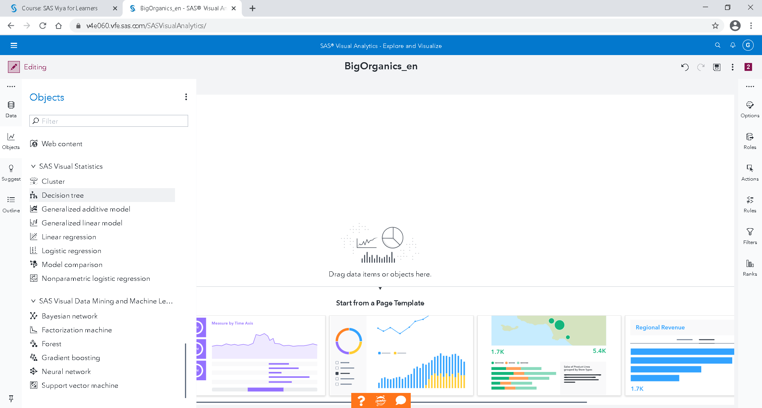

Drop Decision Tree from Objects 🡪 SAS Visual Statistics

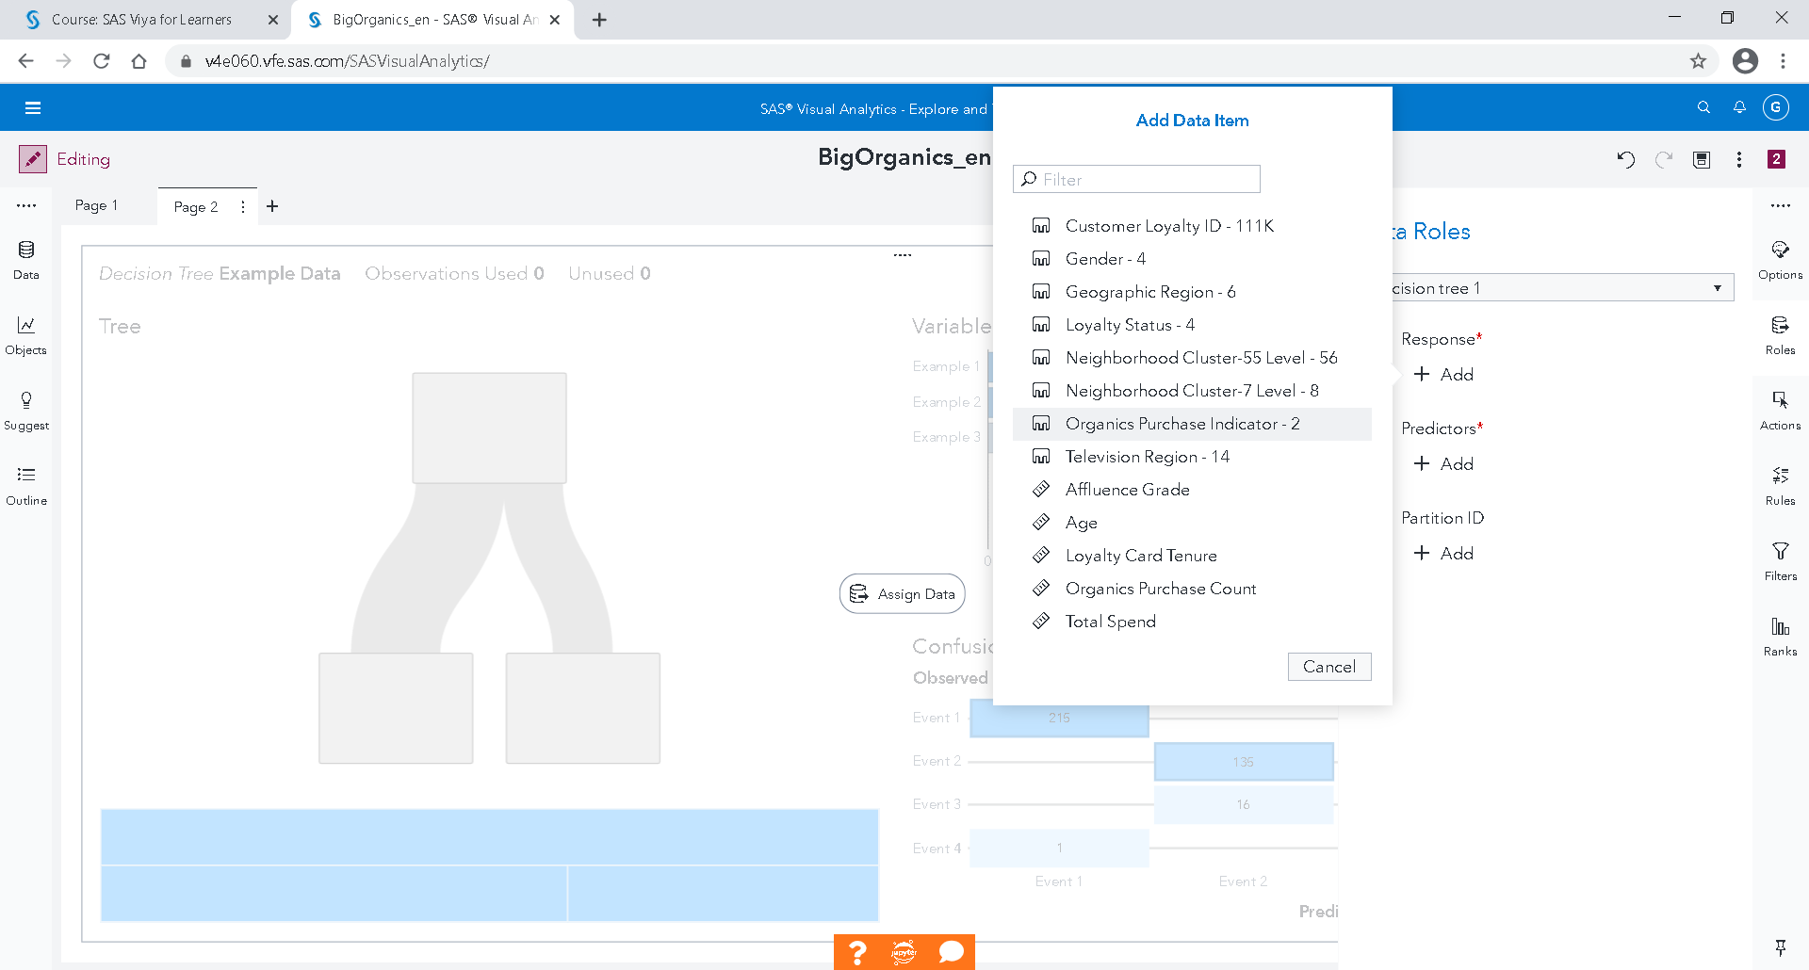

We want to build a classification tree, so we want a categorical variable, our Organics Purchase Indicator.

On, the right, in Roles, Add Organics Purchase Indicator as Response.

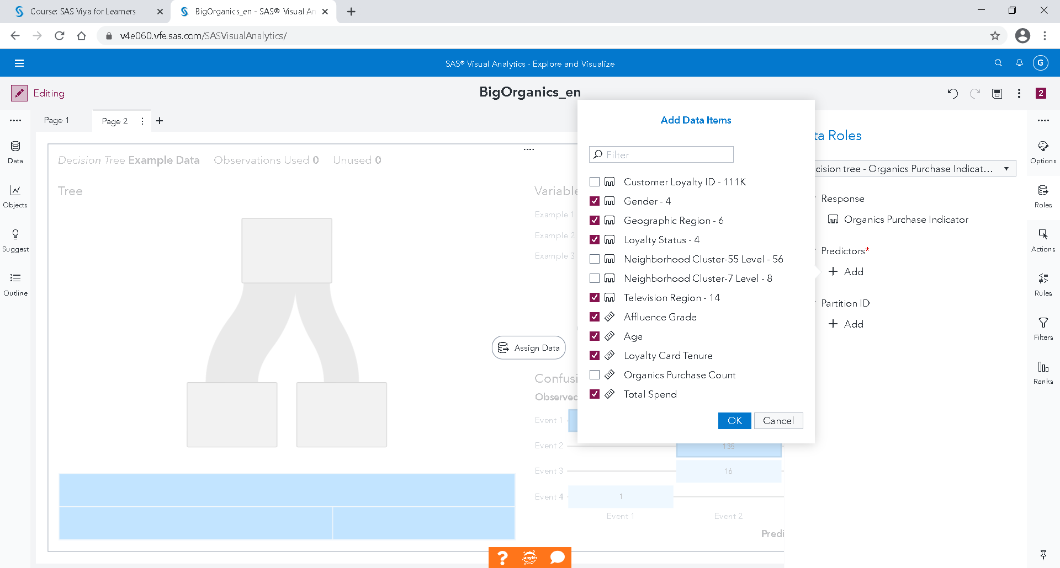

Add the following variables as **predictors**: Gender, Geographic Region, Loyalty Status, Television Region, Affluence Grade, Age, Loyalty Card Tenure and Total Spend.

OK

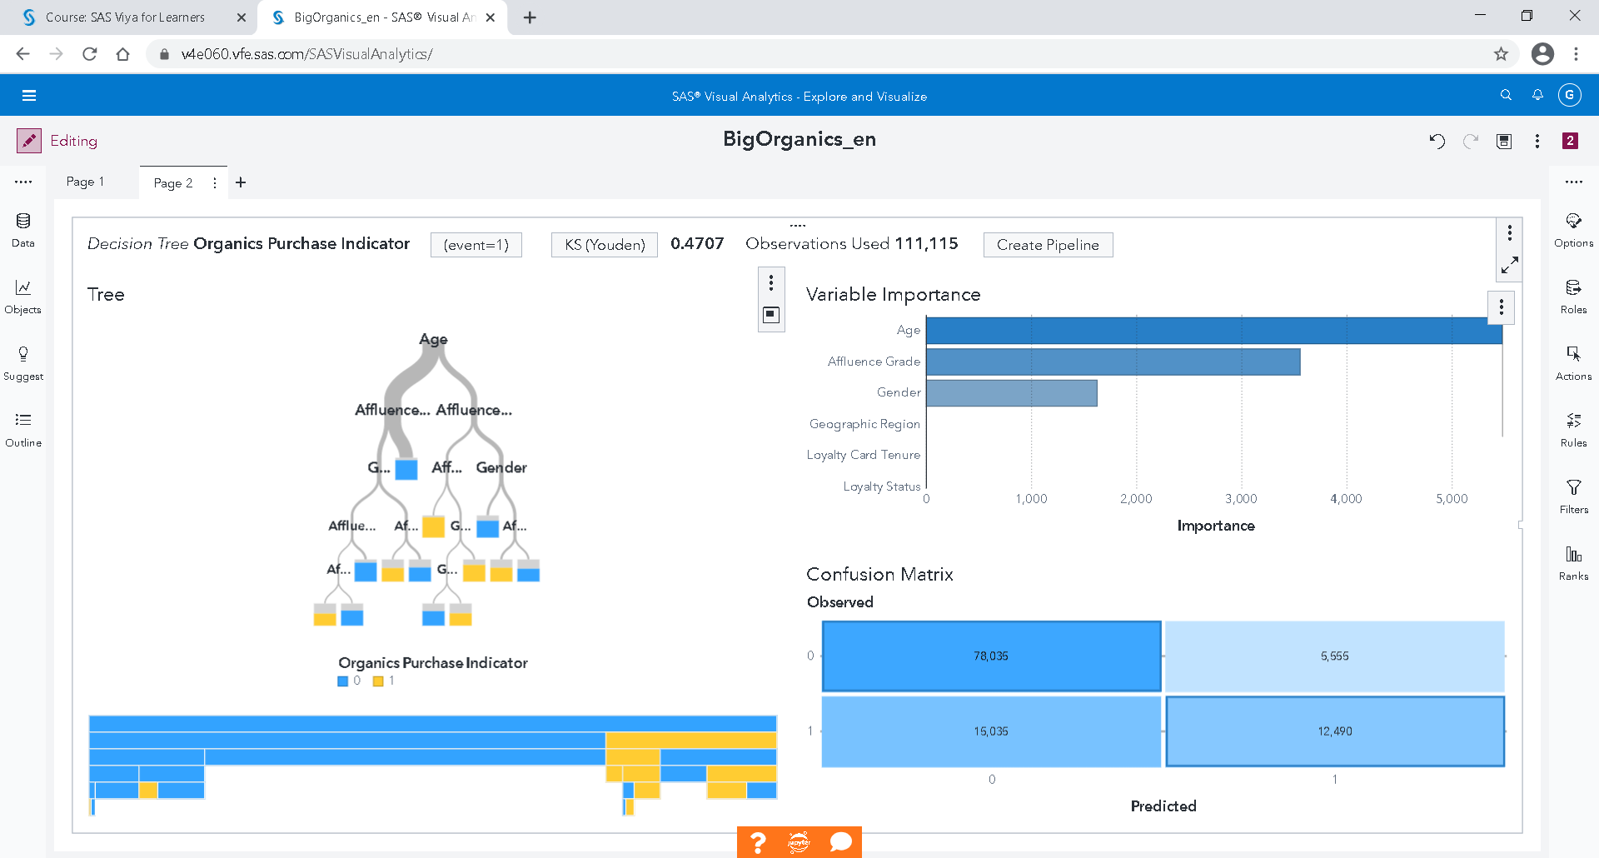

## Logistic Regression

A logistic regression attempts to predict the value of a binary response variable. A logistic regression model approximates the probability that an individual observation to belong to the level of interest. It requires a category Target (or Response) variable and at least one effect variable or interaction term.

So let’s create a Logistic Regression model to predict who is likely to purchase organic products.

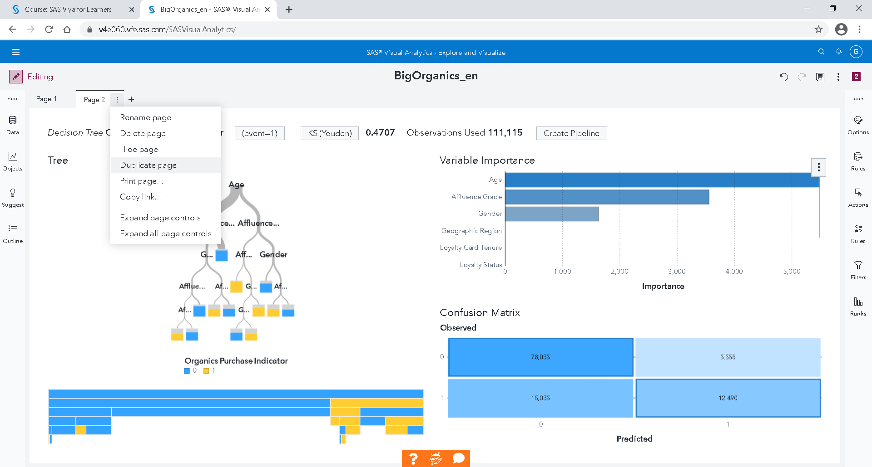

Duplicate page

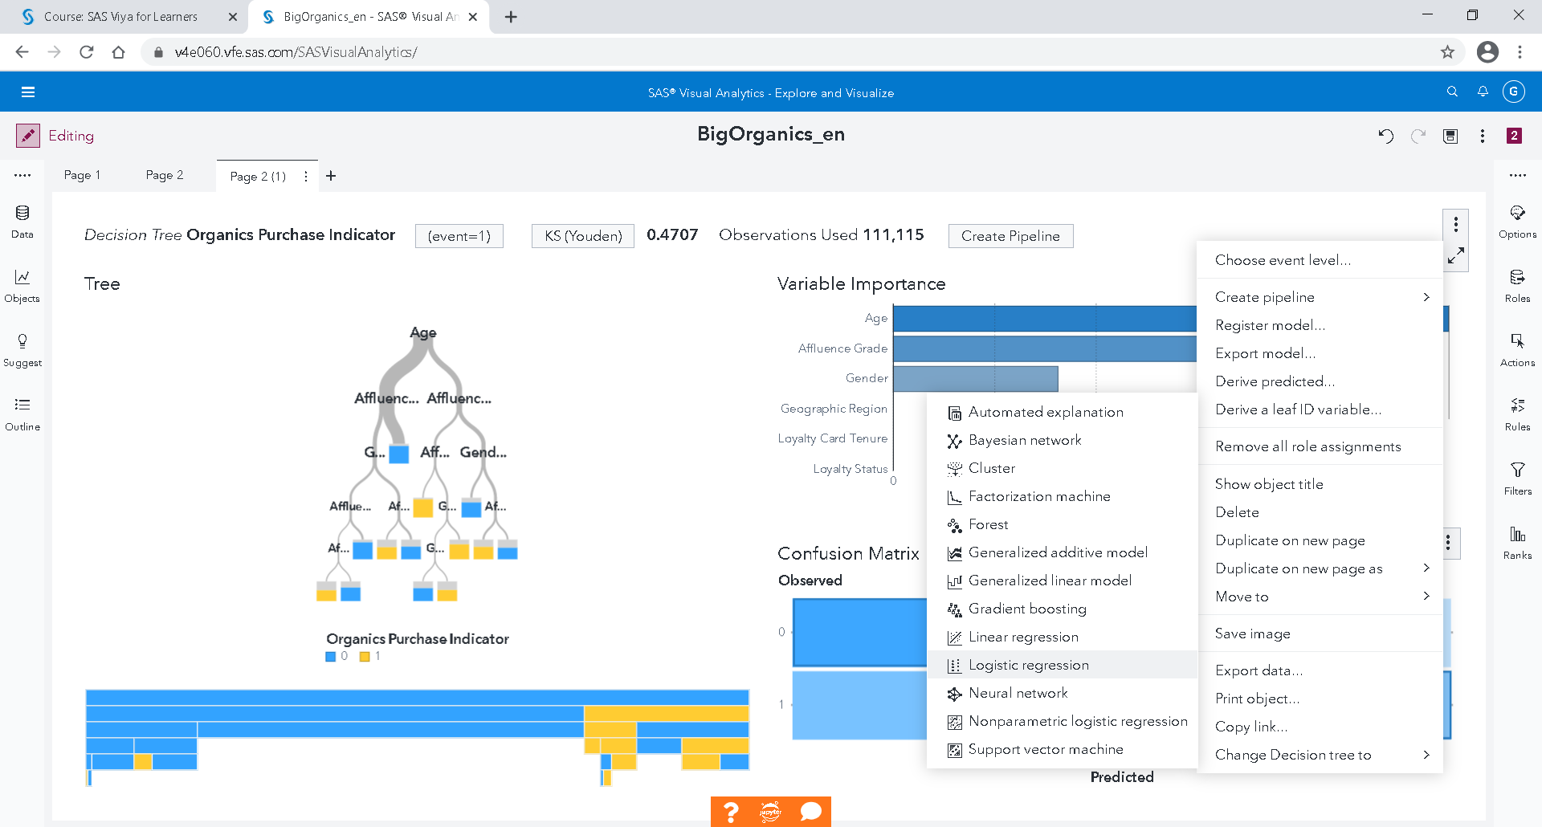

Change Decision Tree to Logistic Regression

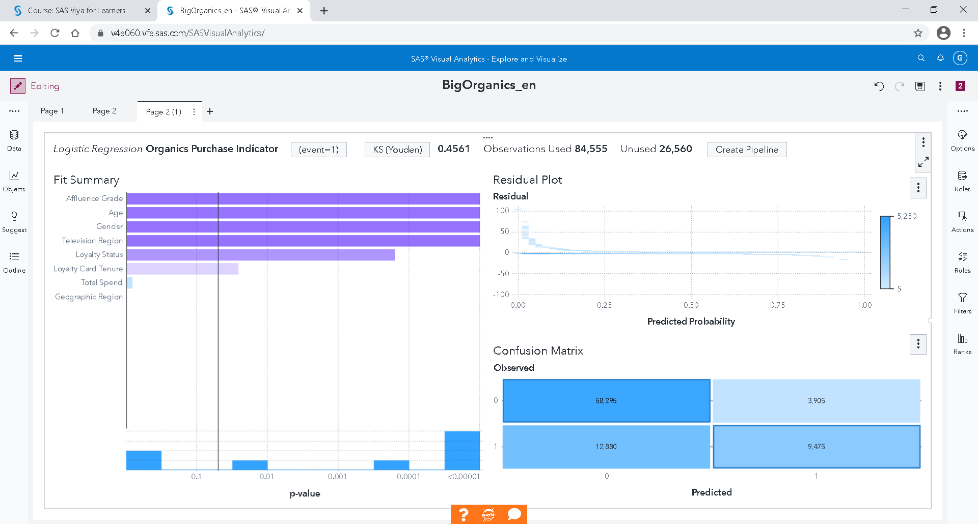

## Gradient Boosting

Gradient boosting is a machine learning technique for regression and classification problems, which produces a prediction model in the form of an ensemble of decision trees.

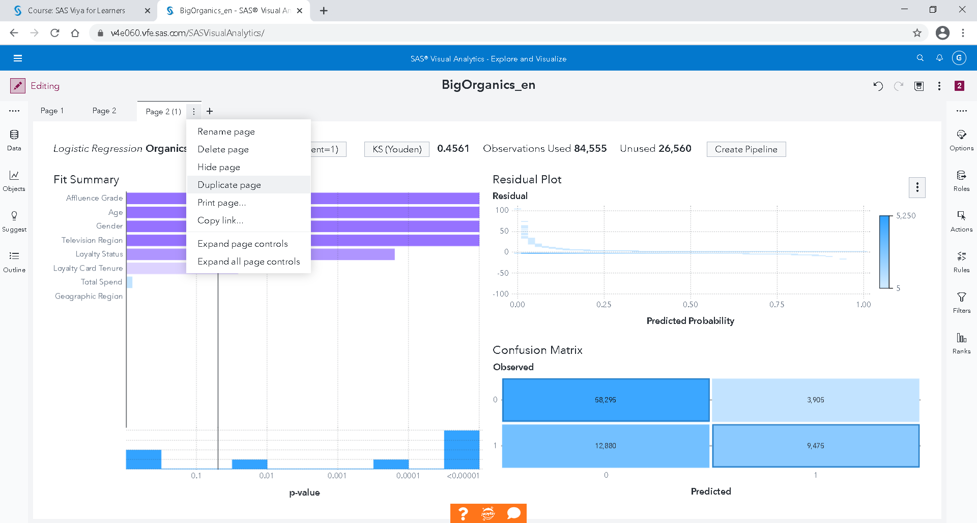

Duplicate page

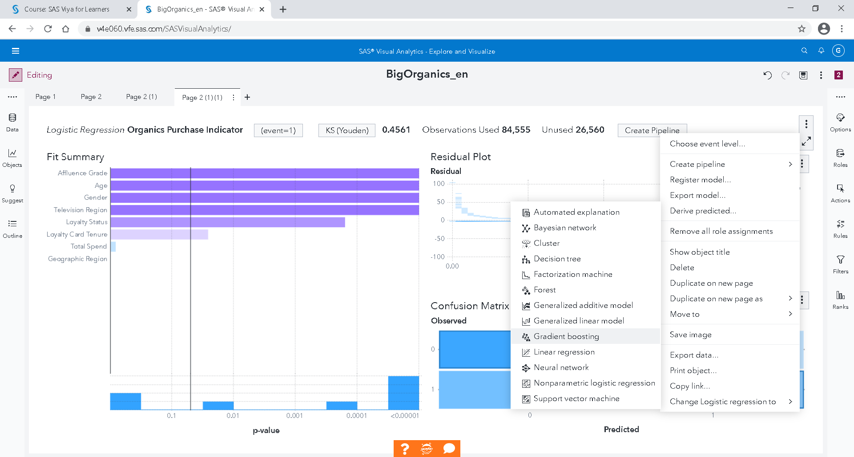

Change Logistic Regression to Gradient Boosting

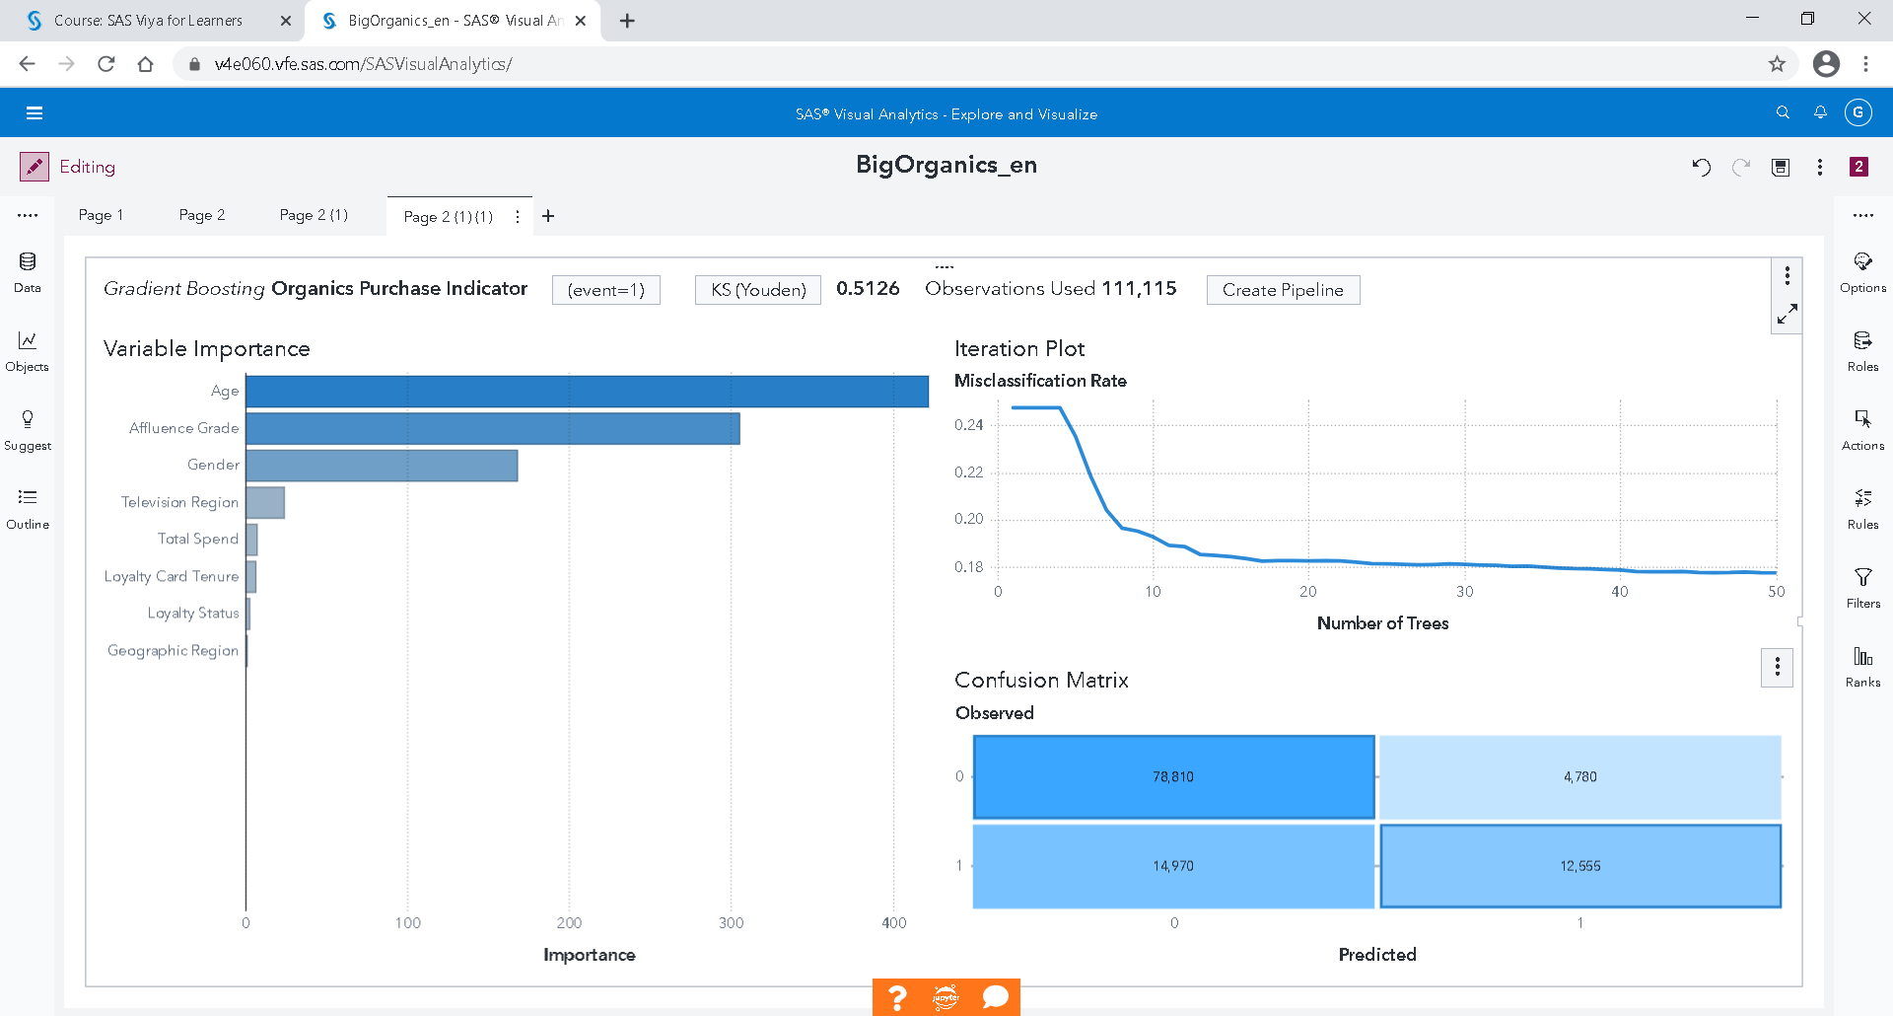

## Neural Network

Duplicate page

Change Gradient Boosting to Neural Network

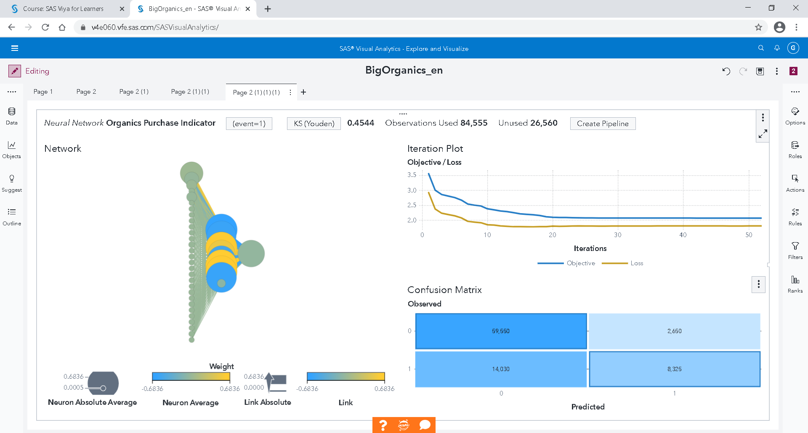

## Model Comparison

You can create a new page.

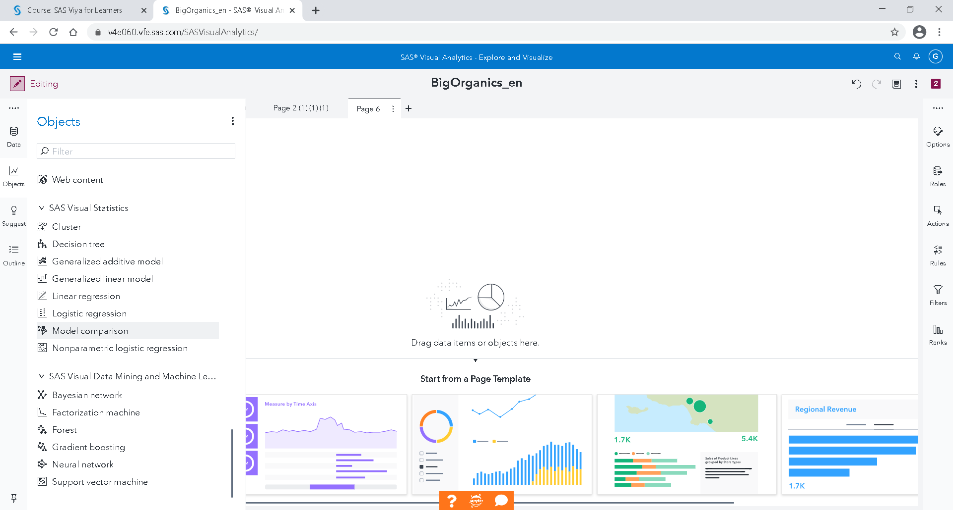

Drop Model Comparison from Objects on the left.

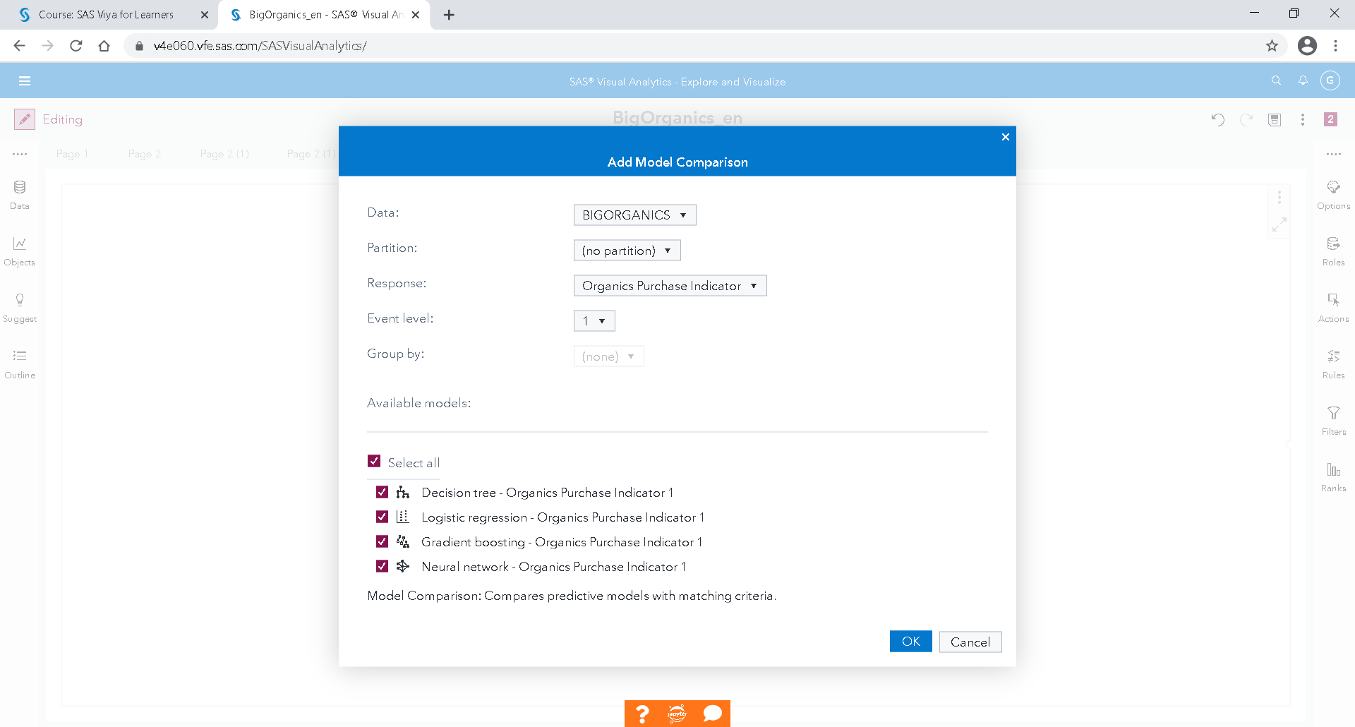

Select all

OK

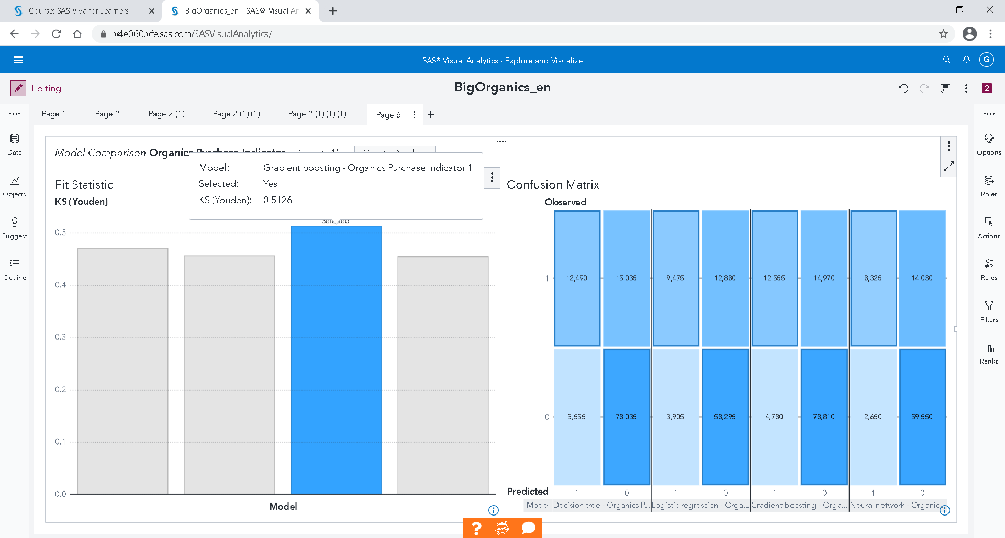

The best model is the Gradient Boosting according the KS (Youden) statistic and the lift curve.

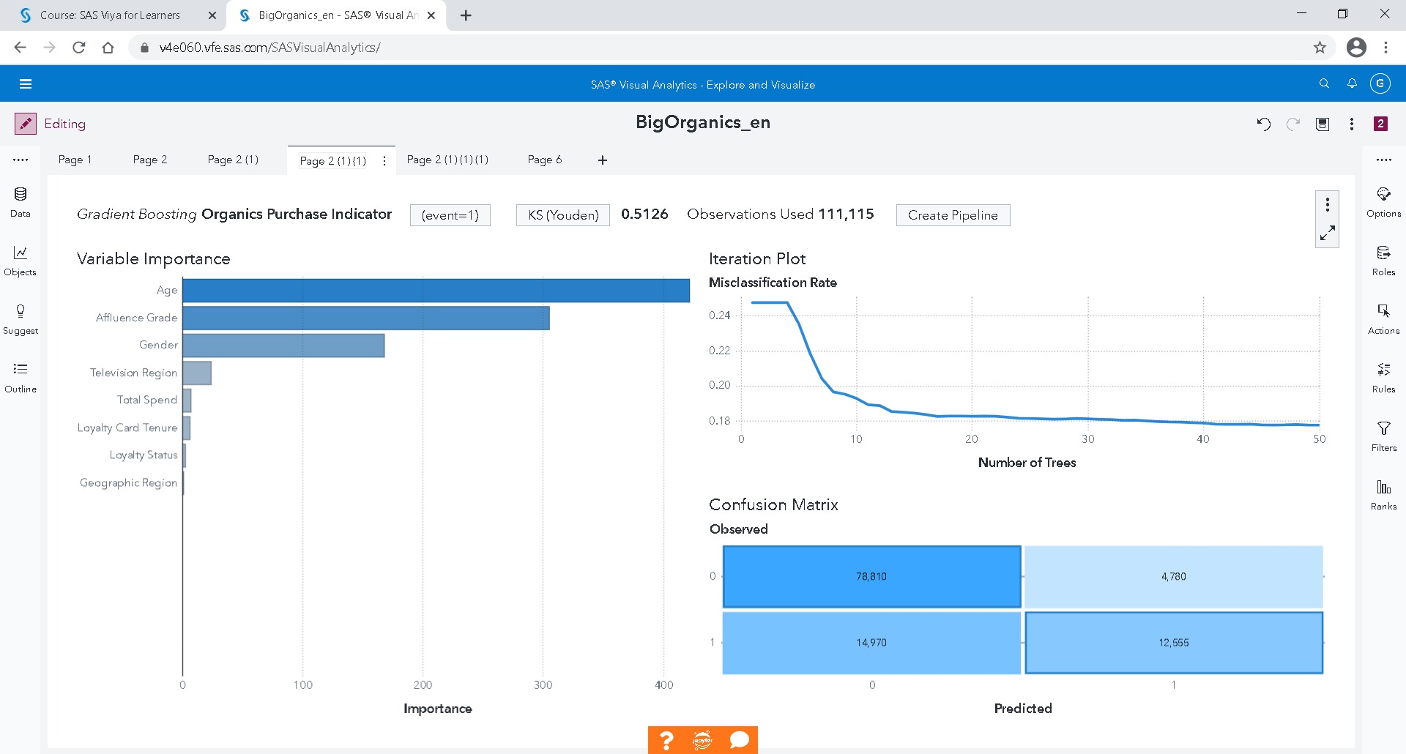

Go back to page 2(1)(1): Gradient boosting

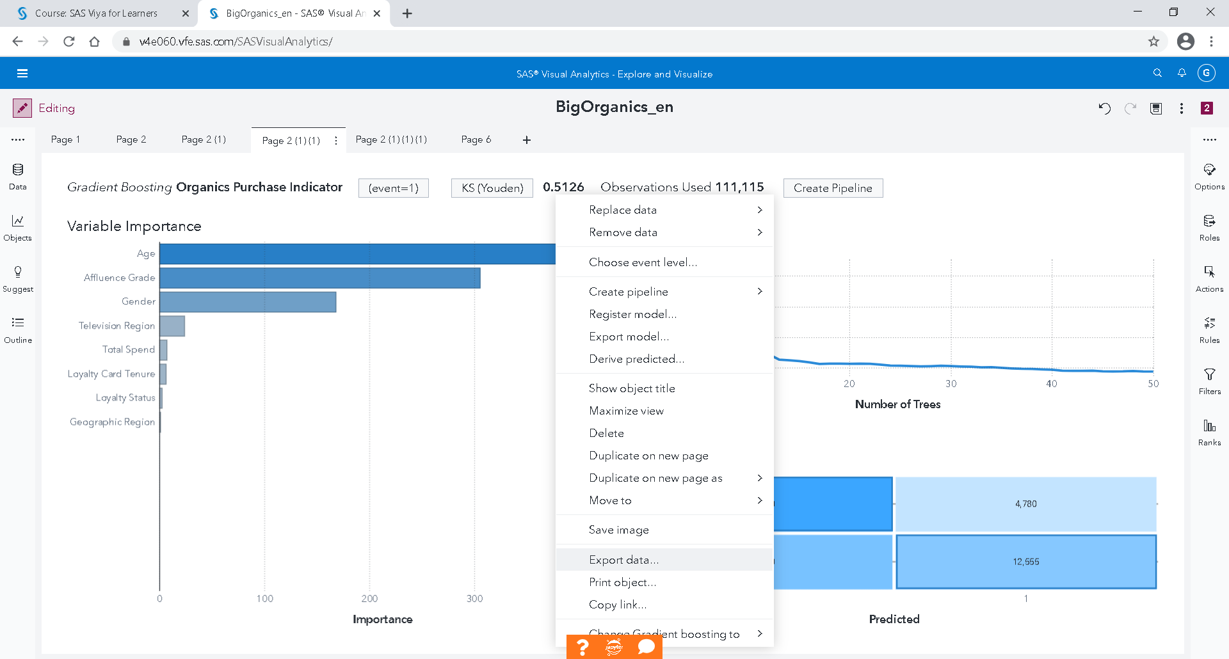

Right click in the middle 🡪 Export data

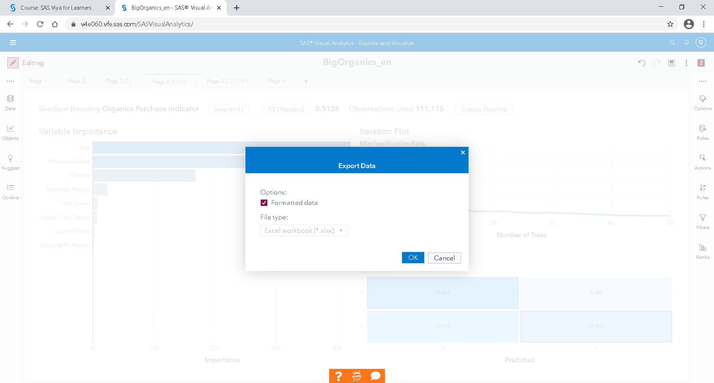

OK

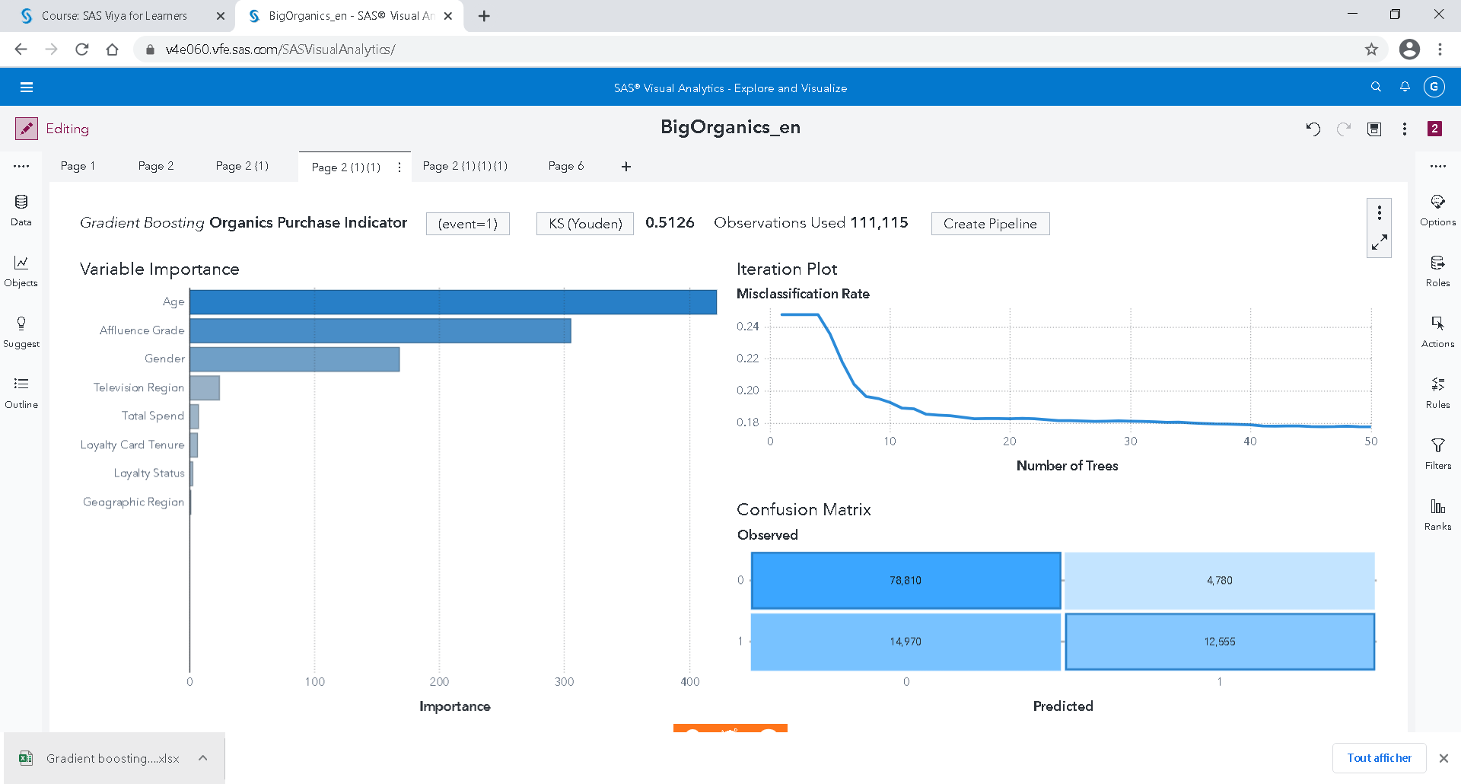

Open the downloaded Excel file

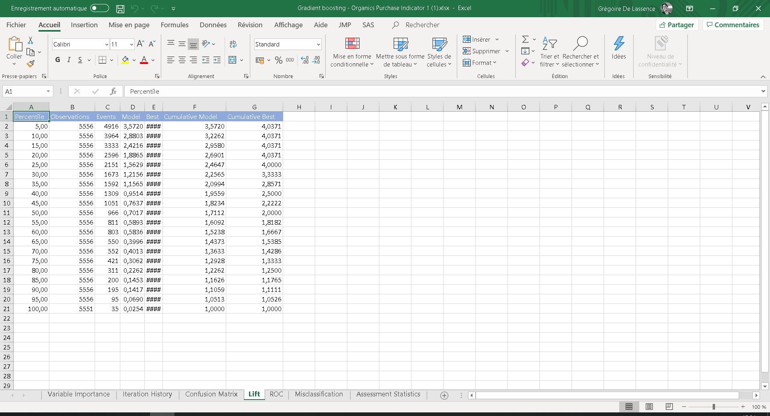

Go to **Lift** Sheet

Create a ROI column

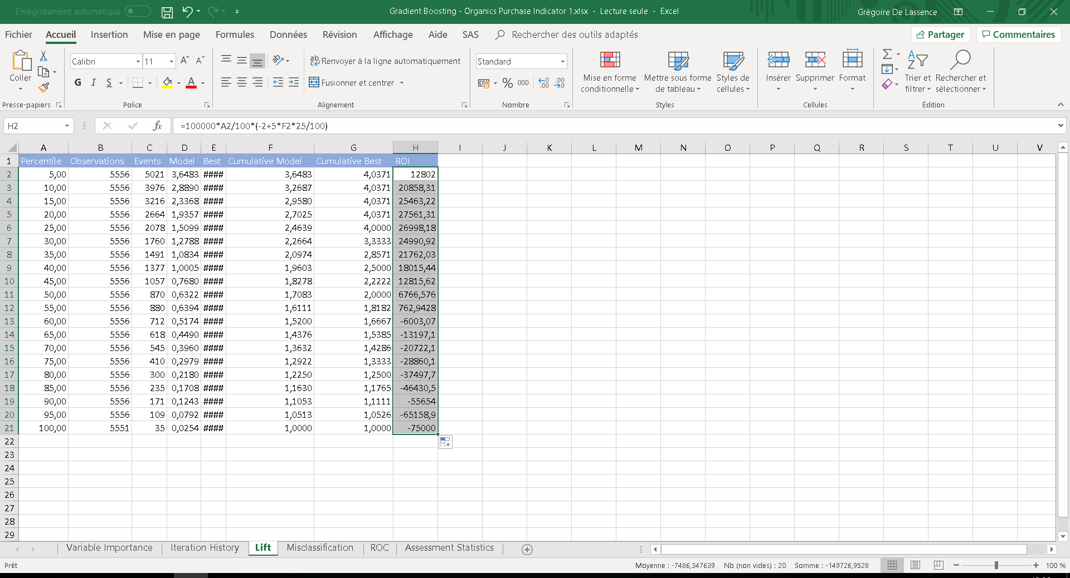

For the first cell, the formula (in cell H2) is

=100000*A2/100*(-**2**+**5**\*F2*25/100)

They is more than 100 000 customer in the Organics Table

25/100 : they is 25% of customer who by organic’s products. That the default base rate in this case.

The cost of sending a letter is **2**£. The Benefits is **5**£.

If we select the 5% who’ve got the highest probability to by a product and send an advertise, the default return rate from 25% will be multiply by the lift from the model (3,64[1] at 5%). The RoI will be 12 802£.

Use can use the RoI formula to the all column

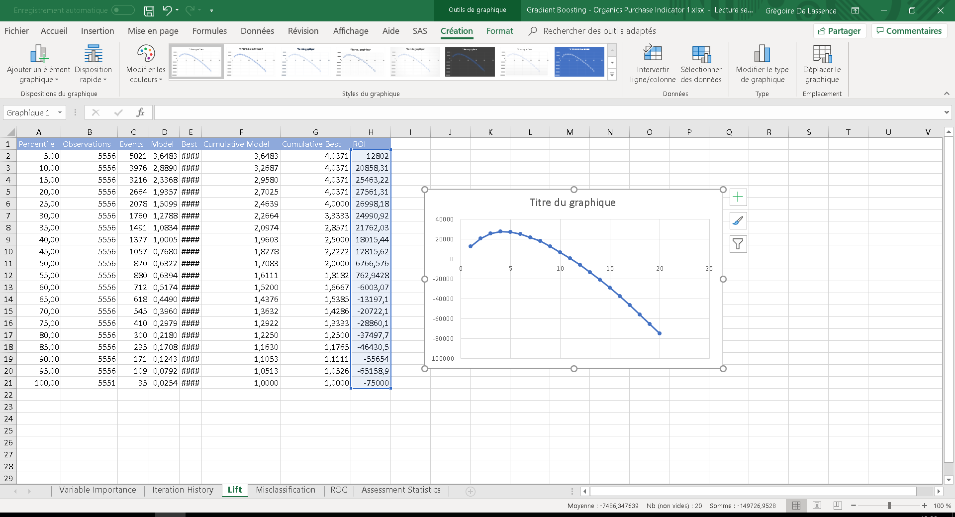

The maximum of the RoI is at 20%.

If we select the 5% who has the highest probability to by a product, we must get 12 802£ back.

If we select the 20% who has the highest probability to by a product, we must get 27 561£ back.

## Score today table

Go back to SAS Visual Analytics

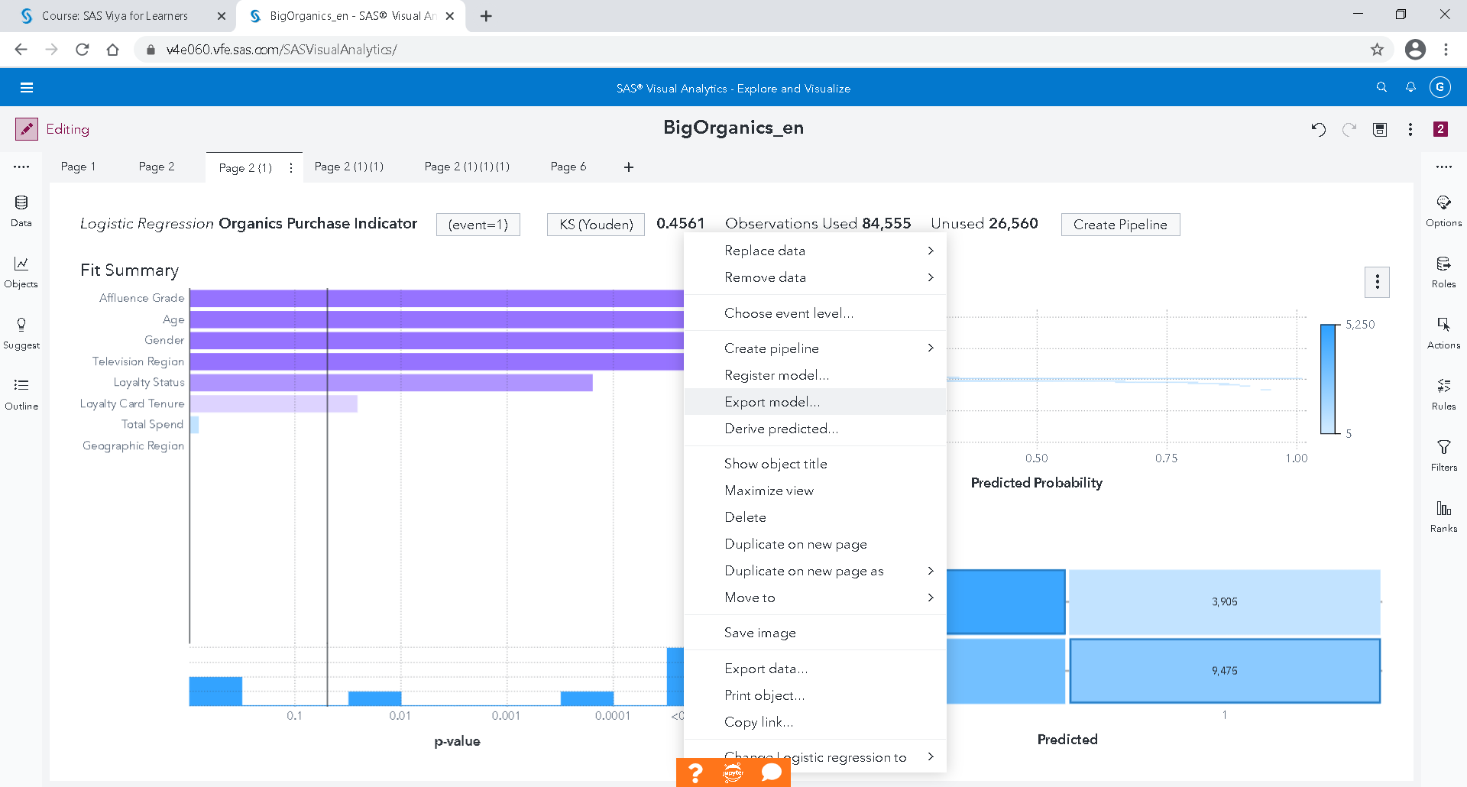

Go to page 2 (1): Logistic Regression

Right click in the middle 🡪 Export model

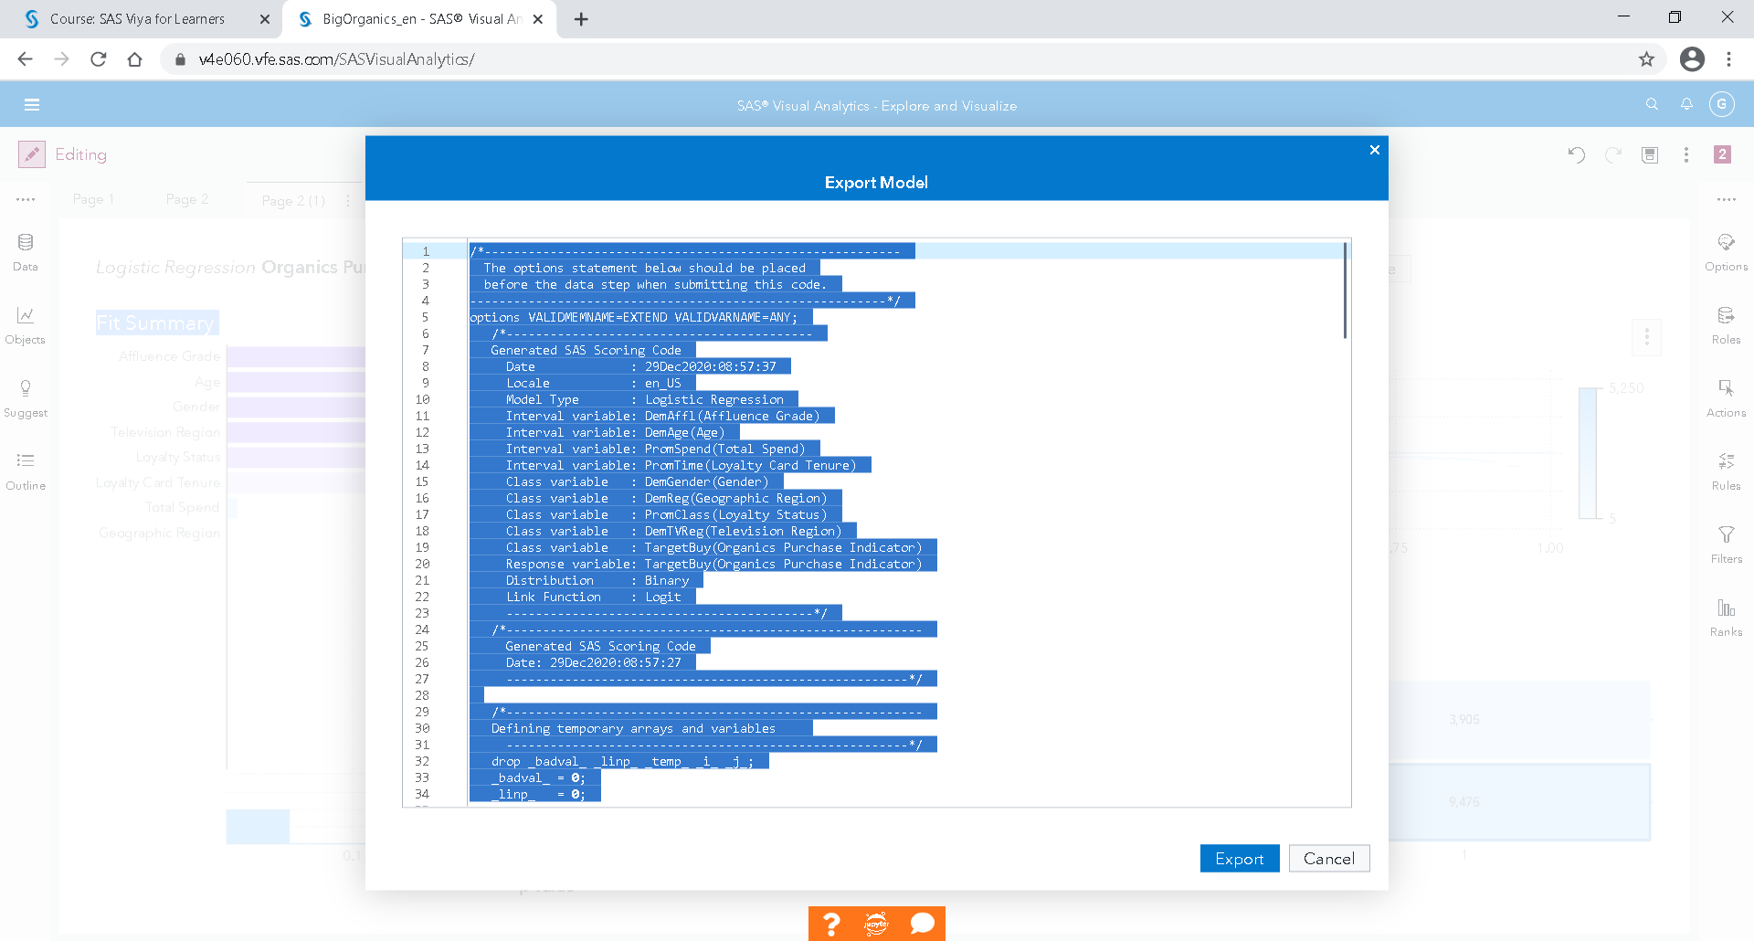

Select all (Ctrl + A)

Copy all (Ctrl + C)

Cancel

In the top left corner,

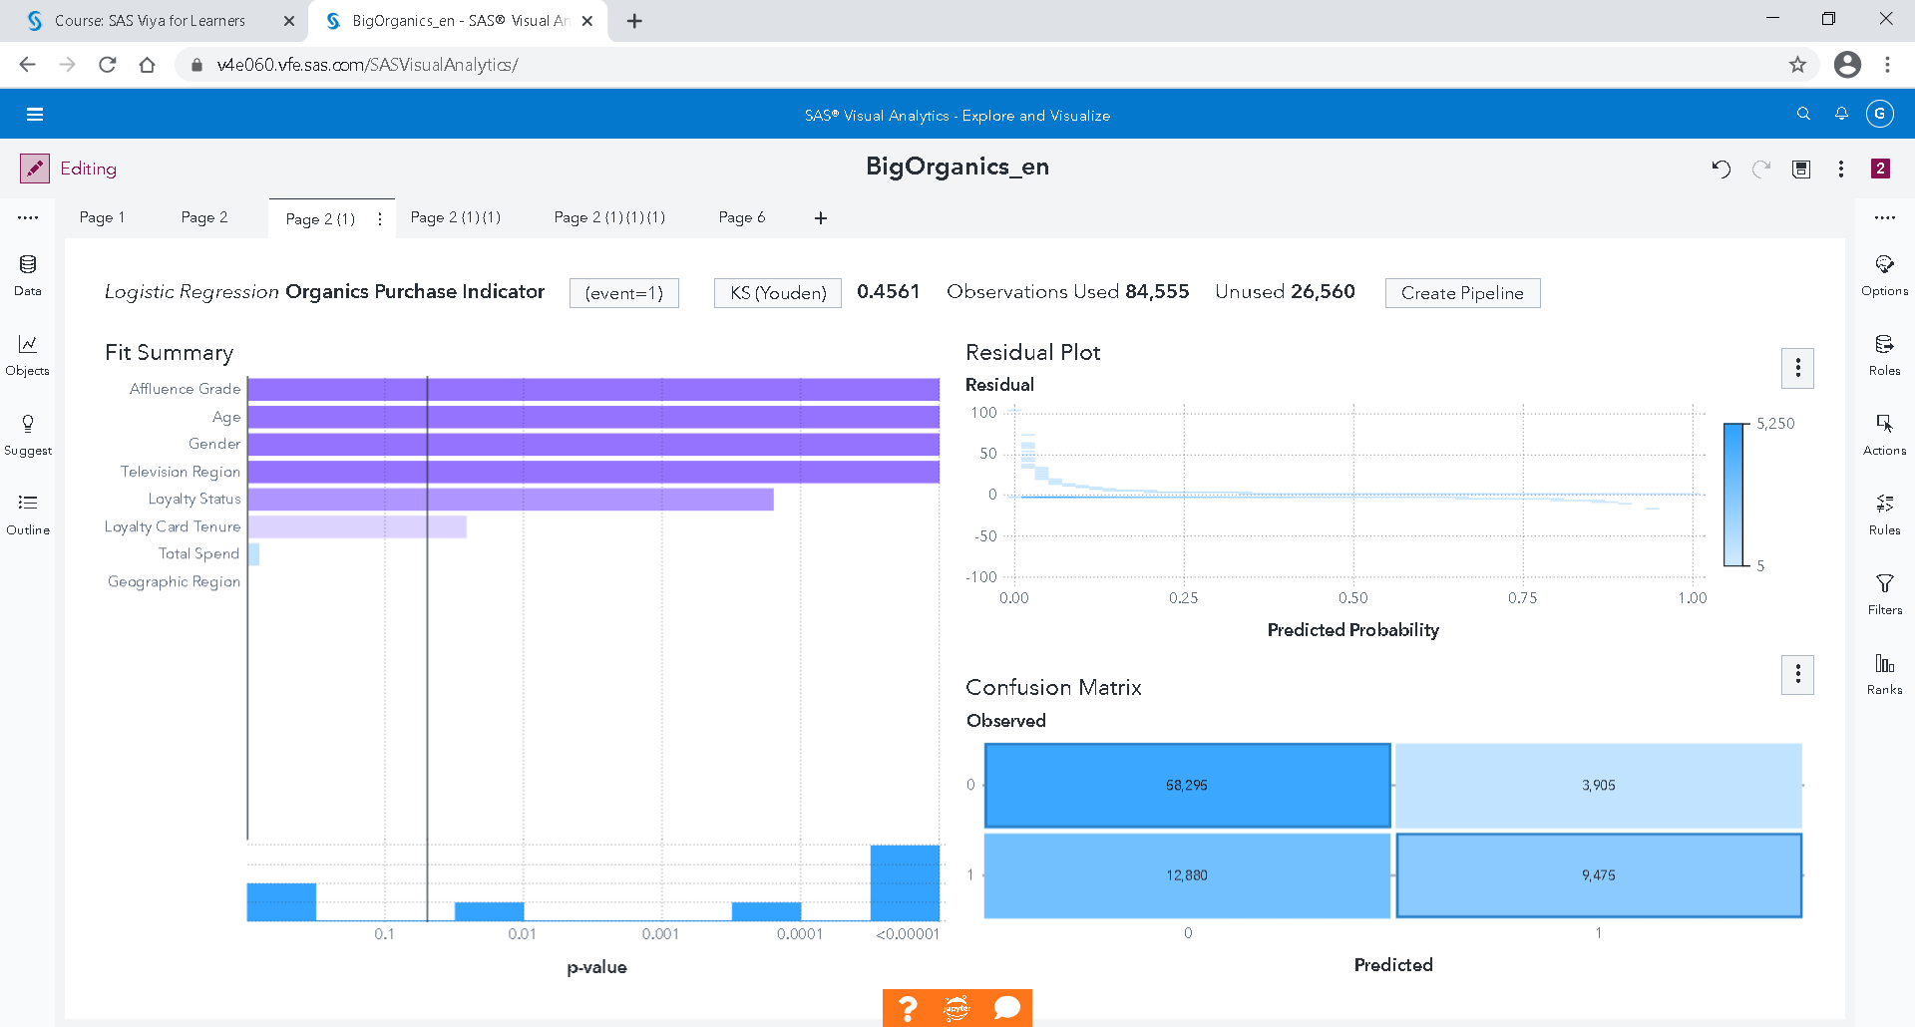

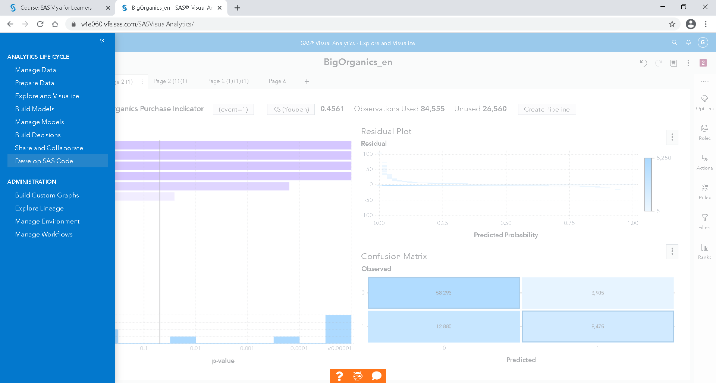

Select “Develop SAS code”

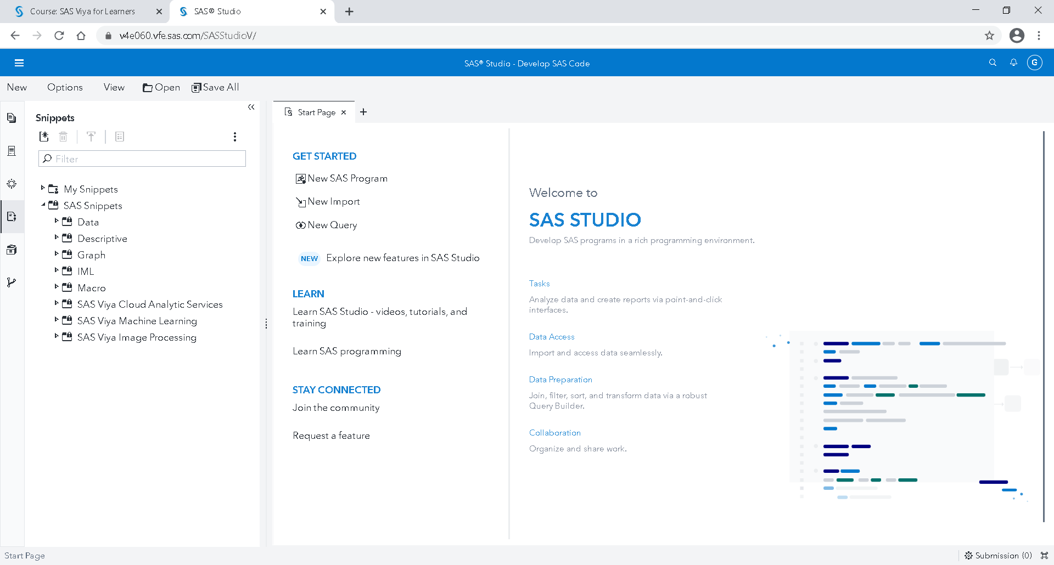

New SAS Program

Past the code you copy and before, copy the following code

“

cas;

caslib _all_ assign;

Data MyOrganicsTableScored;

set tundata.bigorganics;

“

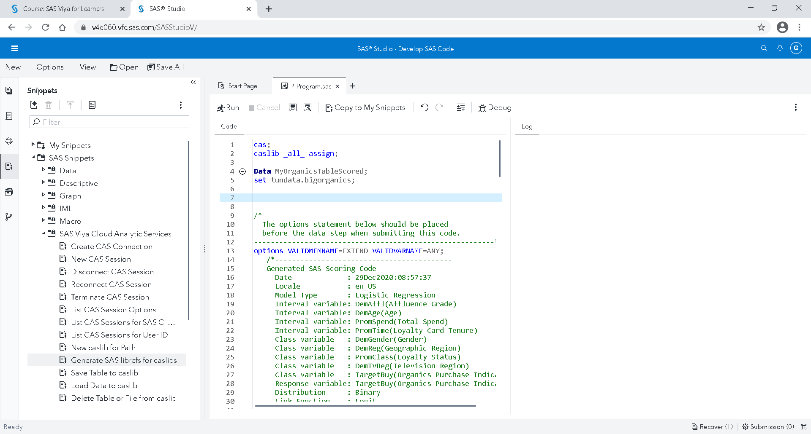

Go to the top bottom from the code, and tape

“

Run;

“

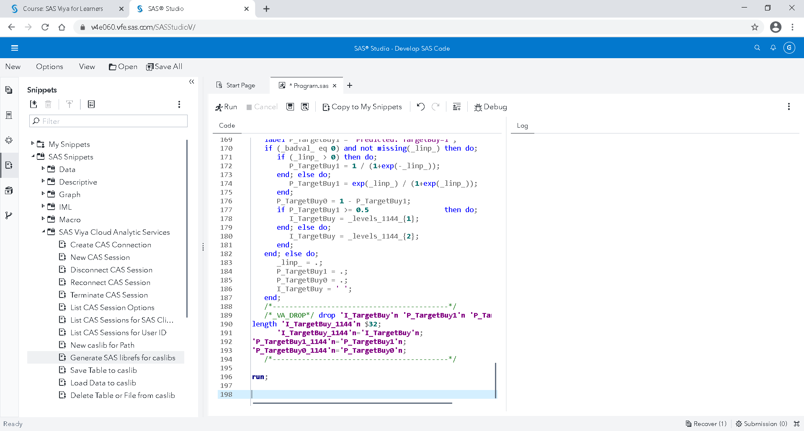

Then, click on run to Submit

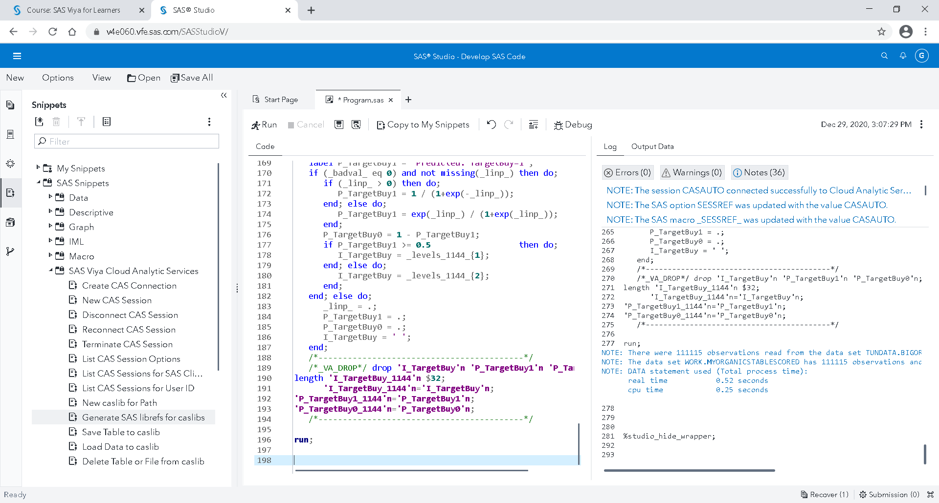

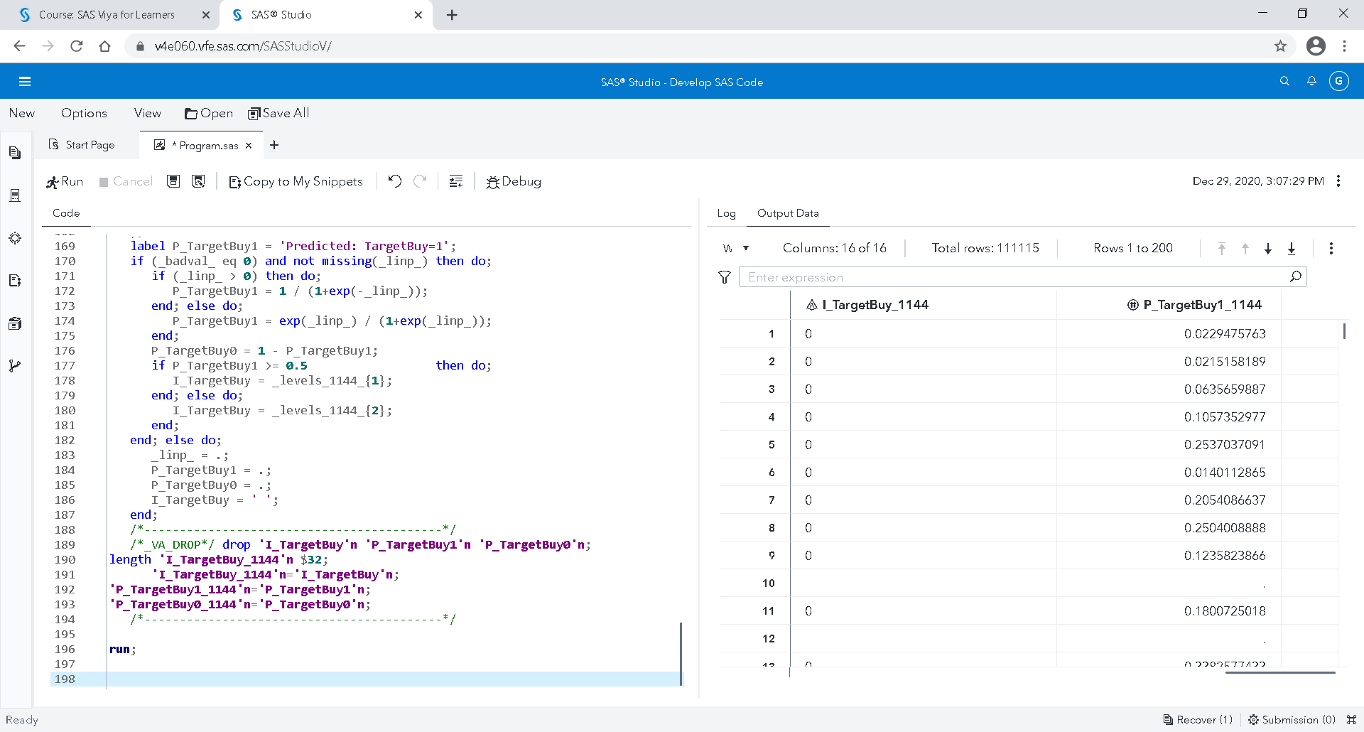

In the Output Data, you can sort the table descending by the P_TargetBuy1_xxx column

Right-click on P_TargetBuy1_xxx column name, sort 🡪 Descending

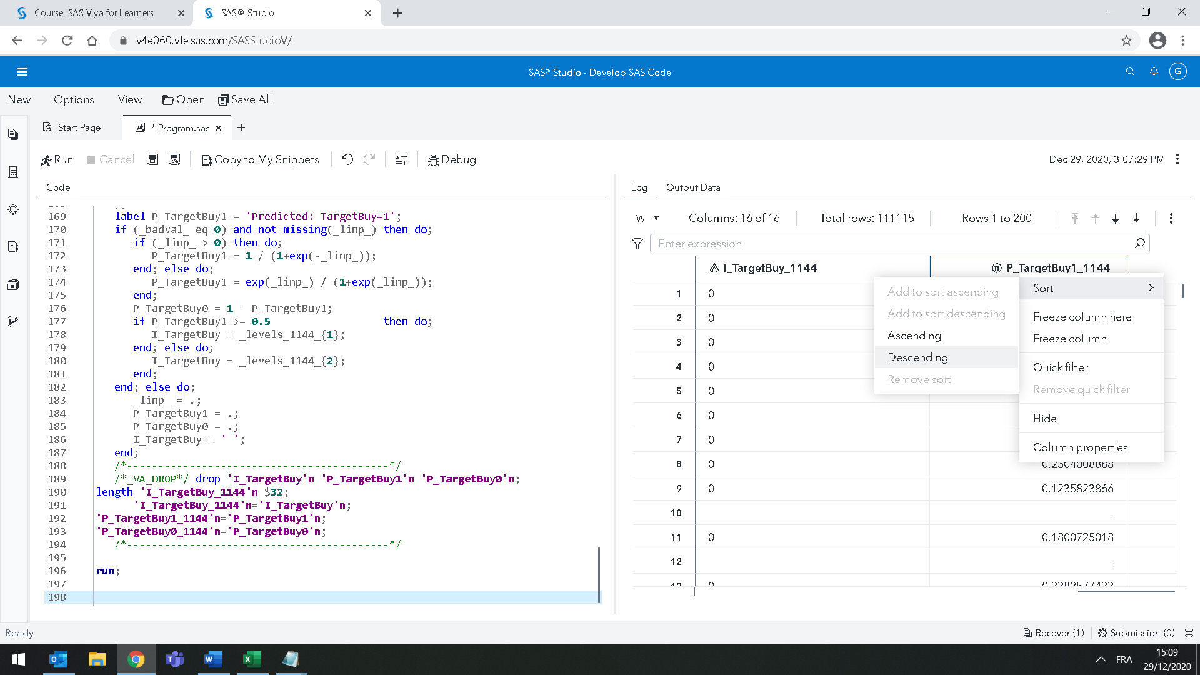

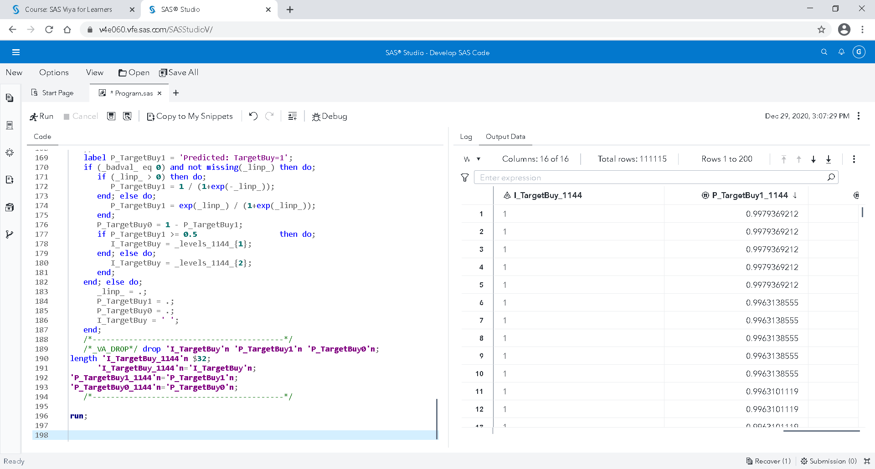

Go back to SAS Visual Analytics, on top left corner, click on “Explore and Visualize”.

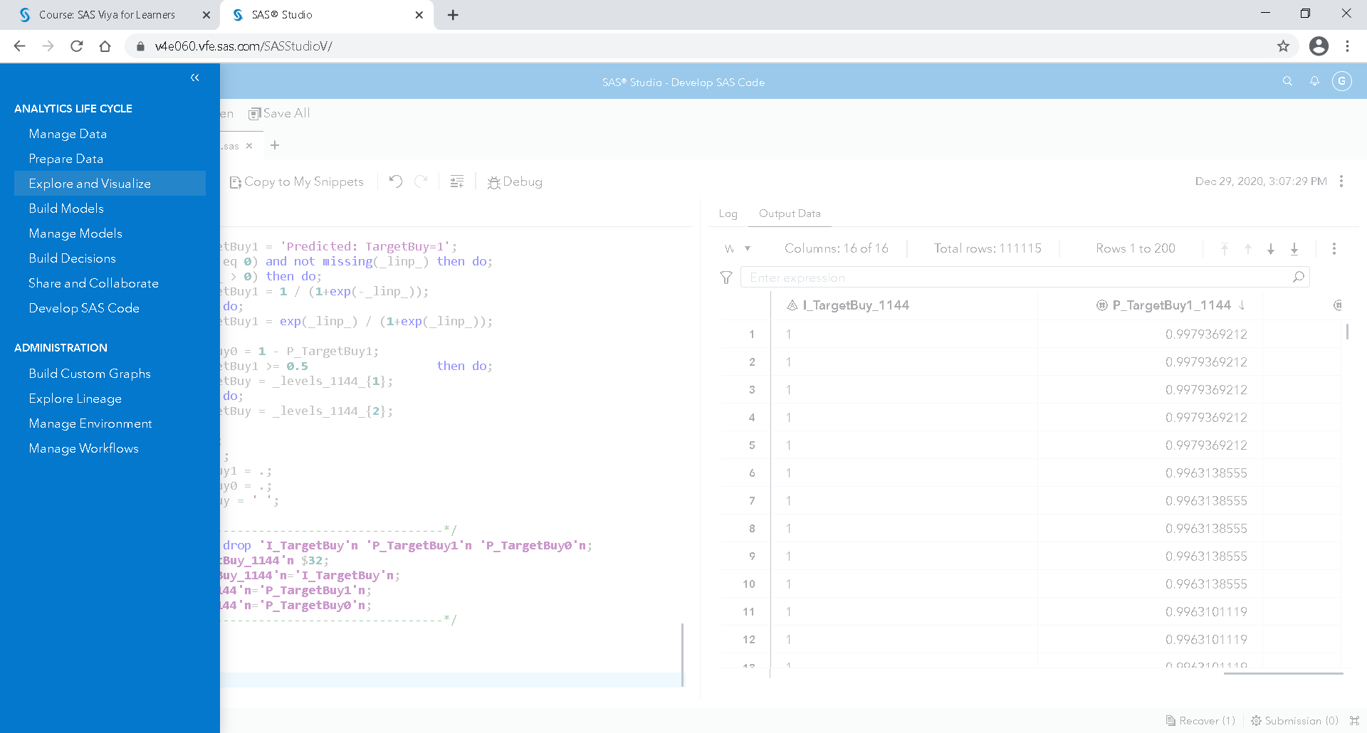

Save your report as

### Exercises

Create a new report on the table PVA and redo the same stuff as you do on Bigorganics.

A national veterans’ organization seeks to better target its solicitations for donation. By soliciting only the most likely donors, less money is spent on solicitation efforts and more money is available for charitable concerns. Solicitations involve sending a small gift to an individual and include a request for a donation. Gifts to donors include mailing labels and greeting cards.

|  |  |  |
| --- | --- | --- |
| **Name** | **Description** | **Role** |
| **DemAge** | Age | Predictor |
| **DemCluster** | Demographic Cluster | Predictor |
| **DemGender** | Gender | Predictor |
| **DemHomeOwner** | Home Owner | Predictor |
| **DemMedHomeValue** | Median Home Value Region | Predictor |
| **DemMedIncome** | Median Income Region | Predictor |
| **DemPctVeterans** | Percent Veterans Region | Predictor |
| **GiftAvg36** | Gift Amount Average 36 Months | Predictor |
| **GiftAvgAll** | Gift Amount Average All Months | Predictor |
| **GiftAvgCard36** | Gift Amount Average Card 36 Months | Predictor |
| **GiftAvgLast** | Gift Amount Last | Predictor |
| **GiftCnt36** | Gift Count 36 Months | Predictor |
| **GiftCntAll** | Gift Count All Months | Predictor |
| **GiftCntCard36** | Gift Count Card 36 Months | Predictor |
| **GiftCntCardAll** | Gift Count Card All Months | Predictor |
| **GiftTimeFirst** | Time Since First Gift | Predictor |
| **GiftTimeLast** | Time Since Last Gift | Predictor |
| **ID** | Control Number | Don’t use |
| **PromCnt12** | Promotion Count 12 Months | Predictor |
| **PromCnt36** | Promotion Count 36 Months | Predictor |
| **PromCntAll** | Promotion Count All Months | Predictor |
| **PromCntCard12** | Promotion Count Card 12 Months | Predictor |
| **PromCntCard36** | Promotion Count Card 36 Months | Predictor |
| **PromCntCardAll** | Promotion Count Card All Months | Predictor |
| **StatusCat96NK** | Status Category 96NK | Predictor |
| **StatusCatStarAll** | Status Category Star All Months | Predictor |
| **TARGET_B** | Target Gift Flag | Response |
| **TARGET_D** | Target Gift Amount | Don’t use |
| **TARGET_D_with zero** | Target Gift Amount with zero | Don’t use |

For the RoI,

average cost = 2$

Margin = 3$

Print your report: it will create a pdf. Save the pdf and the Excel file and send them by mail to our professor.

1. SAS Viya compute Algorithms on data in block in memory, in parallel. All results ca be a little different.